Lesson 2: Reasoning about the Standard Deviation

Overview:
This lesson encourages students to reason about the standard deviation. Students begin by visualizing and estimating average distances from the mean without introducing the mathematical formula. First this is done in an activity involving hand spans. The lesson also has students compare graphs of distributions and reason about which of two graphs would have more variability (higher standard deviation). This lesson is designed to help students improve their reasoning about and understanding of variability by thinking about what a standard deviation is and applying that knowledge to determine which of two graphs has a higher standard deviation.

Student Goals for the Lesson:
- Understand and informally estimate deviations from the mean and “typical” deviation from the mean.
- Understand standard deviation as a measure of spread
- Understand what makes standard deviations larger or smaller, what types of graphs reveal different amounts of variation.
- Reason about connections between measure of center and spread, and how they are revealed in graphical representations of data.

Handouts:

- Comparing Hand Spans
- What Makes the Standard Deviation Larger or Smaller?

Other Materials/Resources Needed:

- Fathom File of Hand Spans (from Body Measurements Data)

Note: Fathom is used here with data collected earlier in the semester from students in class. Instructors are encouraged to use data from their own classes and to use a software package of their choice if Fathom is unavailable.

1. Opening Discussion Question:

Are you a deviant? How do you deviate from average?

Why is variability so important in data analysis? Why is it the basis of statistical analysis? How do we represent and summarize variability? What are deviations and how do they relate to means? How do they relate to variability? Which is an average deviation from the center? What does that mean?

2. Activity #1: Comparing Hand Spans

3. Activity #2: What makes the standard deviation larger or smaller?

Note: On the student handout for this activity, five histogram pairs are given. Below, a full set of 12 pairs is presented and instructors can present other pairs to students if so desired. In the full set of histogram pairs shown below, please note that numbers 3, 4, 7, 10, and 11 are the pairs presented to students in the student handout.

1. | A μ = 2.57 σ = 1.365 B μ = 3.33 σ = 1.491  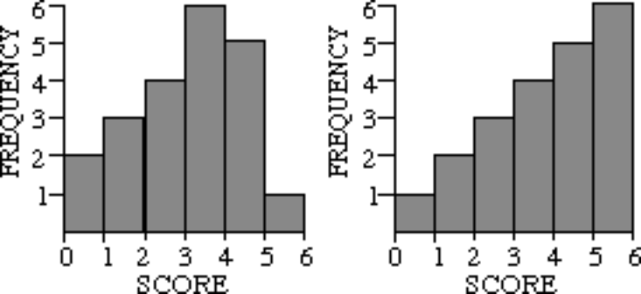 | A has a larger standard deviation than B  B has a larger standard deviation than A  Both graphs have the same standard deviation

2. | A μ = .33 σ = .471 B μ = 4.33 σ = .471  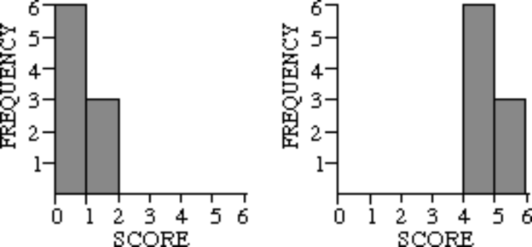 | A has a larger standard deviation than B  B has a larger standard deviation than A  Both graphs have the same standard deviation

3. | A μ = 2.50 σ = 1.708 B μ = 2.56 σ = 1.012  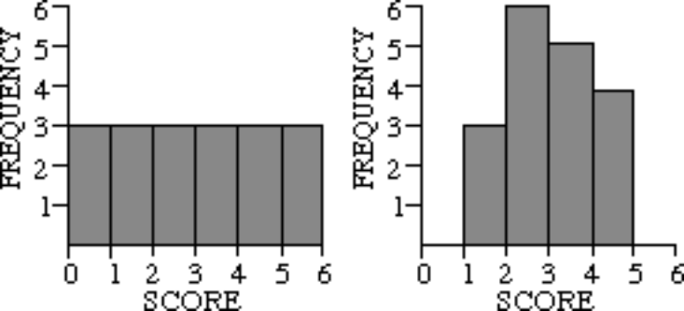 | A has a larger standard deviation than B  B has a larger standard deviation than A  Both graphs have the same standard deviation

4. | A μ = 2.50 σ = 1.708 B μ =2.50 σ = 2.500  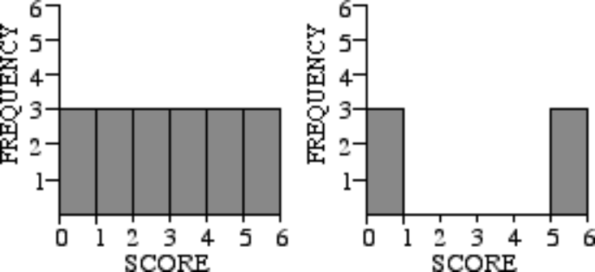 | A has a larger standard deviation than B  B has a larger standard deviation than A  Both graphs have the same standard deviation

5. | A μ = 2.50 σ = 1.803 B μ = 2.50 σ = 1.708  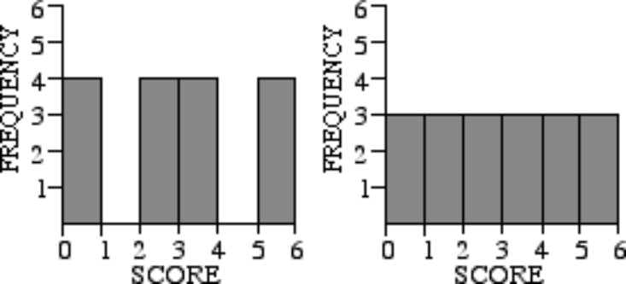 | A has a larger standard deviation than B  B has a larger standard deviation than A  Both graphs have the same standard deviation

6. | A μ = 2.00 σ = 1.000 B μ = 2.00 σ = 1.686  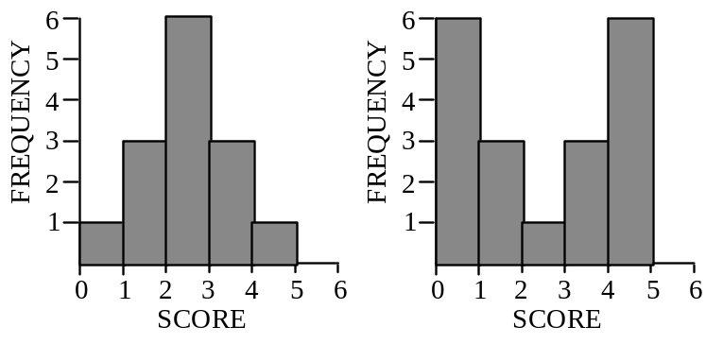 | A has a larger standard deviation than B  B has a larger standard deviation than A  Both graphs have the same standard deviation

7. | A μ = 1.93 σ = 1.280 B μ = 2.00 σ = 1.686  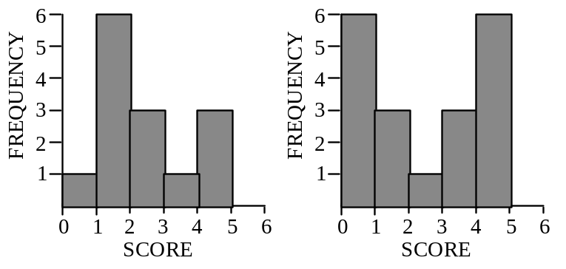 | A has a larger standard deviation than B  B has a larger standard deviation than A  Both graphs have the same standard deviation

8. | A μ = 1.93 σ = 1.280 B μ = 2.00 σ = 1.000  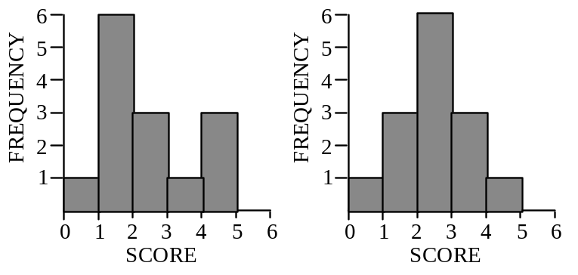 | A has a larger standard deviation than B  B has a larger standard deviation than A  Both graphs have the same standard deviation

9. | A μ = 5.43 σ = 1.400 B μ = 5.86 σ = 2.799  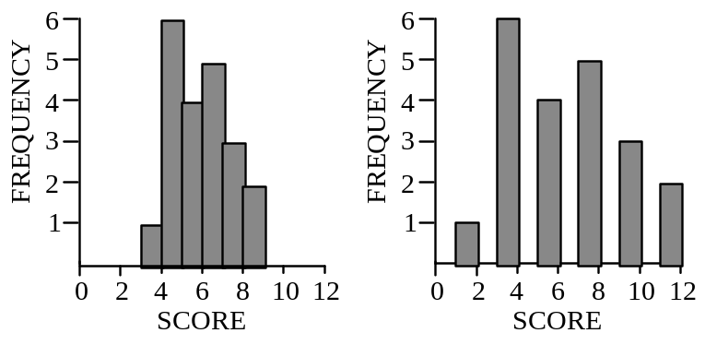 | A has a larger standard deviation than B  B has a larger standard deviation than A  Both graphs have the same standard deviation

10. | A μ = 5.43 σ = 1.400 B μ = 5.57 σ = 1.400  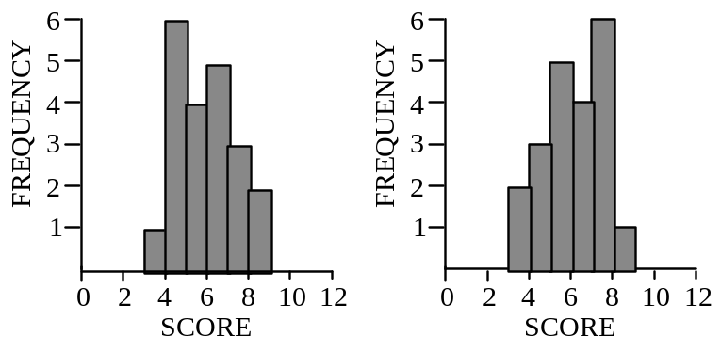 | A has a larger standard deviation than B  B has a larger standard deviation than A  Both graphs have the same standard deviation

11. | A μ = 5.33 σ = 1.743 B μ = 5.48 σ = 1.332  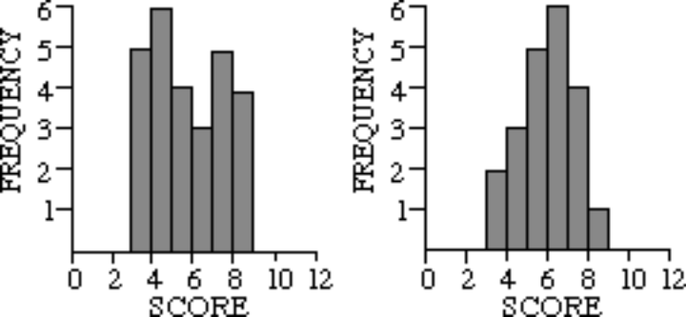 | A has a larger standard deviation than B  B has a larger standard deviation than A  Both graphs have the same standard deviation

12. | A μ = 5.86 σ = 3.126 B μ = 3.38 σ = 2.075  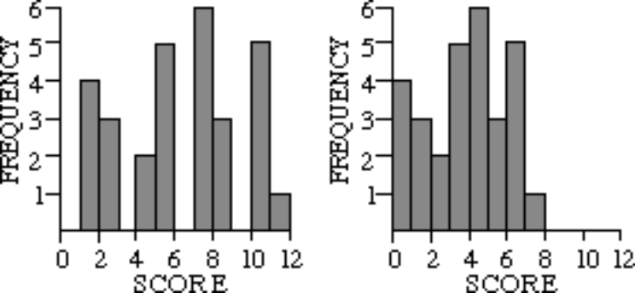 | A has a larger standard deviation than B  B has a larger standard deviation than A  Both graphs have the same standard deviation

4. Whole Class Discussion:
Discuss answers to the 12 questions (on the “What makes the standard deviation larger or smaller?” activity) as a class and compare them to the correct answers provided on the annotated student handout (e.g., the actual size of the standard deviation for each graph in the activity). Ask students to elaborate on which graphs were harder to compare, which were easier and why.
Wrap-up:
Ask students to comment on why we need measures of variability in addition to measures of center, and why variability is so important in data analysis. Why variability is the basis of statistical analysis and how we represent and summarize variability.

References

Comparing Hand Spans:
Watkins, A.E., Scheaffer, R.L., & Cobb, G.W. (2004). Statistics in action: Understanding a world of data. Emeryville, CA: Key Curriculum Press.

What makes the standard deviation larger or smaller?:
delMas, R.C. (2001b). What makes the standard deviation larger or smaller? STAR library. Retrieved October 21, 2007, from http://www.causeweb.org/repository/StarLibrary/activities/delmas2001/

