Lesson 1: Understanding Boxplots

Overview:
This lesson introduces the boxplot as a way to graphically compare two or more groups of data. It has students progress from comparing groups with dotplots, to using hat plots (a feature of TinkerPlots) and finally moving to boxplots. By using TinkerPlots, students are able to see the data values ‘hidden’ in a boxplot. Students are then asked to examine and compare two groups of data in a series of questions using boxplots.

Student Goals for the Lesson:
- Understand that a boxplot shows where certain percentages of data lie.
- Understand that a boxplot offers a good way to compare groups of data.
- Begin to reason about comparing groups using boxplots.
- Learn how to read and interpret boxplots.
- Become more fluent in comparing groups of data by comparing shapes, centers and spreads of two data sets given boxplots.

Handouts:

- How Many Raisins in a Box?

Other Materials/Resources Needed:

- TinkerPlots data file: RaisinsData.tp

1. Opening Discussion/Questions:

How do different brands of the same food product vary? Do all similar products (of the same size) give the same amount, e.g., number of M&M candies in a small bag? Does the same size bag of potato chips from two competing companies give the same amount of chips in each box?

How can you make an informed decision about which product to purchase?

2. Activity #1: How Many Raisins in a Box?

Open RaisinsData.tp with TinkerPlots. Ask students to complete the questions from the TinkerPlots demonstration section of their worksheet as you are demonstrating. Generate a dot plot like the one shown below.

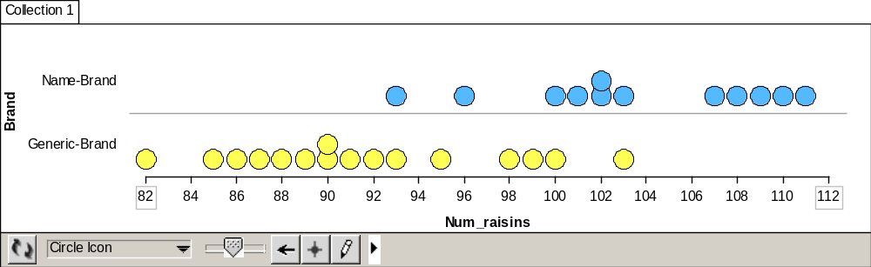

Next, click on the Hat Plot icon in the toolbar. This will put a Hat Plot over the data points. Click the small triangle to the right of the Hat Plot button and make sure the menu specifies Percentile Hat. (This is the default setting.)

An example hat plot is shown below:
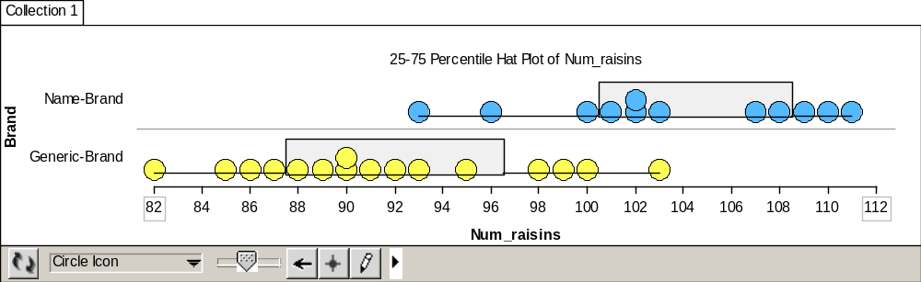

Add the median to the plot by clicking on the Median icon (Averages-Median) in the toolbar The Median icon appears in red:

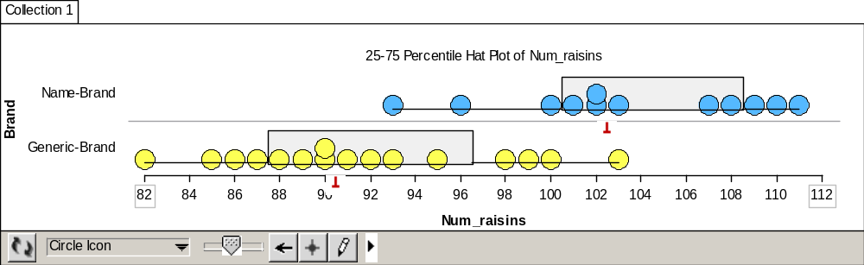

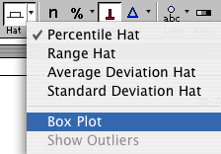
Change the Hat Plot to a Box Plot. In the toolbar, click the small triangle to the right of the Hats button and choose Box Plot from the menu

- Point out that the box on the box plot includes the same data points (boxes of raisins) as the hat on the Hat Plot did.
- Point out that the “whiskers” of each Box Plot also includes the same data points as the “brim” of the hat in the Hat Plot.
- Also, point out that the median is now included inside the box as well, and that this is the only important difference between the two plots.

Remove the medians from the bottom of the Box Plots by re-clicking on the Median icon in the toolbar. On the bottom of the plot (where it displays Circle Icons), scroll down to Hide Icons.

Point out to students that although the individual data points have disappeared, the Box Plot still represents the same number of data points (boxes of raisins) as it did. The median is still in the same place. There are equal numbers of boxes of raisins on either side of the median. Fifty percent (6 boxes) of the Name-Brand boxes of raisins have between 101 and 109 raisins.

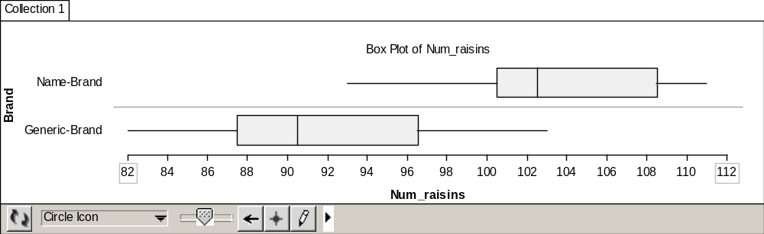

Use the Drag Value Tool (on the lower tool bar) to move the case at 96 to 94 and illustrate that the box plot will remain invariant. In this manner you can point out that we can’t answer questions about the number of cases if the value does not appear at a quartile. It may be helpful before moving cases to first set the axis minimum and maximum so that they won’t change. To do this, double-click the maximum value on the axis. You can then enter a larger value (e.g., 120). In a similar manner, set the minimum value to 70.

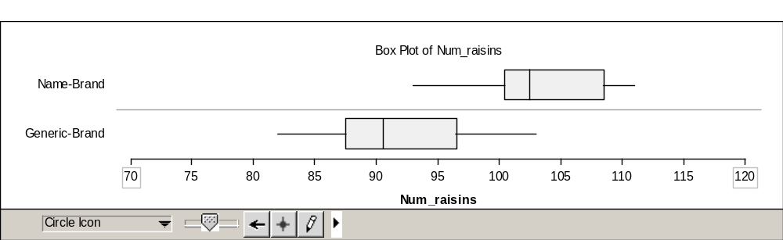

3. Whole Class Discussion:

How do box plots help us to compare the two brands of raisins? How do they show differences in the center and spread of the numbers of raisins per box? Why does this difference exist? Why is there variability from box to box? Come up with reasons for the two types of variability, within and between brands of raisins. Do you believe that the results from this sample represent what is true for the larger population of boxes of raisins for each brand?

Wrap-up:
Think about pairs of dotplots, histograms and boxplots: which type of graphical displays make it easier to identify shape, center and spread? Which type makes it easier to compare groups of data?

Reference

Garfield, J., Zieffler, A., & Lane-Getaz, S. (2005). EPSY 3264 Course Packet, University of Minnesota, Minneapolis, MN.

