Lesson 3: Describing the Predictable Pattern: The Central Limit Theorem

Overview:
This lesson moves students from noticing a predictable pattern when they generate distributions of sample statistics to describing that pattern using mathematical theory (i.e., the Central Limit Theorem, CLT). Students investigate the impact of sample size and population shape on the shape of the sampling distribution, and distinguish between sample size and number of samples. Students then apply (when appropriate) the Empirical Rule (68, 95, 99.7 percent within 1, 2 and 3 standard deviations from the mean) to estimate the probability of sample means occurring in a specific interval.

Student Goals for the Lesson:
- Discover the Central Limit Theorem by examining the characteristics of sampling distributions.
- See that the Central Limit Theorem describes the predicable pattern that students have seen when generating empirical distributions of sample means.
- Describe this pattern in terms of shape, center, and spread; contrasting these characteristics of the population to the distribution of sample means.
- See how this pattern allows us to estimate percentages or probabilities for a particular sample statistic, using the Normal Distribution as a model.
- Understand how the SPM Model represents the Central Limit Theorem.
- Understand how we determine if a result is surprising.

Handouts:

- Central Limit Theorem Activity
- Sheet of stickers.
To make the sticker sheets, copy the graphs on the last page of this lesson plan onto sheets of Avery labels so there is one sheet per student. (Avery 6490 labels: Removable White 3.5 inch Diskette Labels. They come 15 labels per sheet, 25 sheets in a package.)

Other Materials/Resources Needed:

- Sampling SIM software (available for Mac or Windows). May be downloaded from:
http://www.tc.umn.edu/~delma001/stat_tools/stat_tools_software.htm

1. Opening Discussion/Questions:

How good are you at predicting what a distribution of sample means will look like when we sample from different populations? In what cases does the predictable pattern emerge? Does it always occur when we build distribution of sample means, regardless of the population shape?

Review what has been learned so far (from Lessons 1 and 2, or from readings and class activities).
- There is VARIABILITY in individual values (e.g., body temperatures).
- Some values are more likely than others.
- To see if a value is more or less likely (or surprising) we need to look at where it is in the appropriate distribution.
- The number of standard deviations above and below the mean (z-scores) can tell us if an observation or value is unlikely or unusual.
- Sample means vary too, but they tend to vary less than individual values.
- Smaller samples vary more than larger ones. Why?
- There is a predictable pattern when we took larger samples and plotted their means. The predictable pattern was: symmetric, bell shaped, centered on µ, with decreasing spread (i.e., smaller values of standard deviation, less variability).
- To determine if a sample mean is unusual or surprising, we need to compare it to many other sample means, of the same size, from the same population. This is a distribution of sample means.

If the distribution of sample means is well modeled by a Normal Distribution, we can use z-scores to help us judge whether a sample mean value is unlikely or surprising.

2. Activity #1: Central Limit Theorem

Instructor Notes:

Students will continue to explore what distributions of sample means will look like in terms of center, shape and spread as we change the population shape and the sample size used when sampling from the population. They will use a constant number of samples (500) which gives a picture that is very close to what we would get if we took ALL possible samples. (Ideally, we would take ALL possible samples.)

In the activity students will make and test predictions about distributions of sample means sampled from three populations: a normal, a skewed, and a multimodal population. They will predict distributions for three sample sizes: size 2, size 9 and size 16, selecting from a set of stickers on a page, and placing the appropriate stickers in on a “Scrapbook” page.

Directions for obtaining and printing the stickers are at the “Tools for Teaching and Assessing Statistical Inference” Website (Garfield, delMas and Chance):
http://www.tc.umn.edu/~delma001/stat_tools/

The finished “Scrapbook” of sampling distributions provides a visual, permanent record of the results of this investigation. It allows students to see the progression of distributions for sample means from one population as the sample size is increased. This activity can be done individually by students but guided by the teacher for the first few rounds. We recommend the following sequence of activities (operational details will be provided later).

- Begin with the Normal population (N) and ask students to predict the first distribution of sample means (sample size 2) by circling their guess on the “Scrapbook” sheet.
- Have students then test the prediction by using Sampling SIM software to simulate a distribution of sample means from the Normal Distribution for samples of size 2.
- Evaluate the results. Ask students to compare their results to their prediction. Guide them in this evaluation by drawing their attention to the high and low values on each distribution (their predicted one and the one they simulated) as well as the center and the height of the bars.
- When the class agrees on the sticker from their sheet that best matches the simulation on their computer screens, that sticker is placed in their scrapbook.
- A new prediction is made for sample size 9. The same process is used to test the prediction and choose the appropriate sticker to place in the scrapbook.
- This process is repeated for sample size 16.
- Student may then total the number of correct predictions they made.
- Once students are comfortable with this process, they may continue on their own (or in pairs) making and testing predictions for the second and third distributions: Skewed (S) and Multimodal (M).

Working with the Sampling SIM Software
Have the students open three windows, one for the population, one to see the individual samples, and one that will accumulate the means of each sample taken. Select from the tool bar: Window → Population, Window → Samples, and Window → Sampling Distribution.
In Figure 1, one sample has been drawn, the sample is shown in the Samples window, and the mean appears on the Sampling Distribution window. Ask students to tie each window to the Simulation Process Model (SPM).

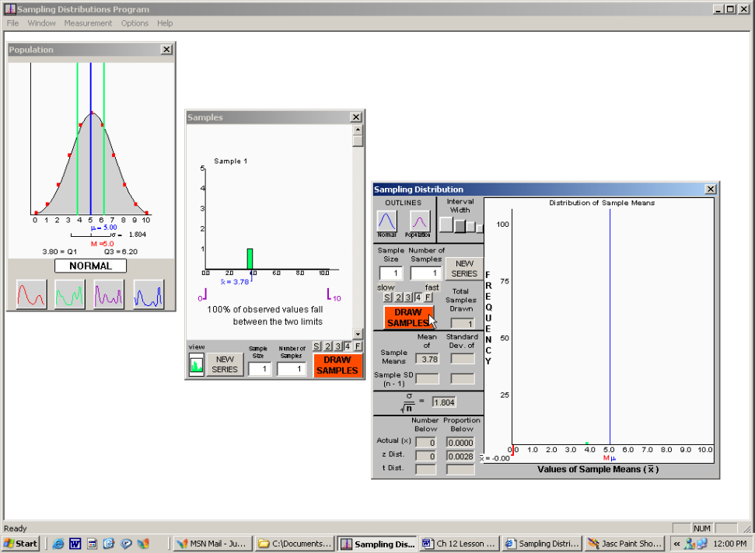
Figure 1: Screen shot from Sampling SIM software

Here is a sample of a sampling scrapbook at the end of the exercise.

Normal  Population  μ = 5.00  σ = 1.805 | 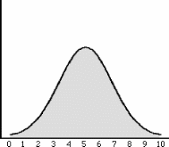 | Skewed  Population  μ = 6.81  σ = 2.063 | 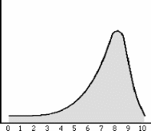 | Multimodal  Population  μ = 5.00  σ = 3.410 | 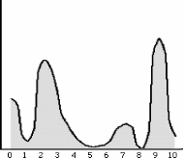
Distribution of Sample Means n = 2 |  | Distribution of Sample Means n = 2 |  | Distribution of Sample Means n = 2
Guess 1: A B C D E |  | Guess 4: A B C D E |  | Guess 7: A B C D E
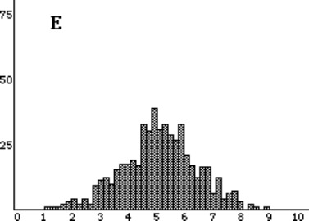 |  | 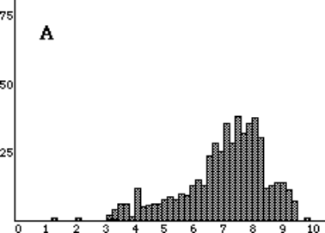 |  | 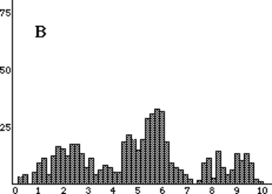
Mean of = 4.93; SD of = 1.244 |  | Mean of = 6.86; SD of = 1.480 |  | Mean of = 5.10; SD of = 2.403
Distribution of Sample Means n = 9 |  | Distribution of Sample Means n = 9 |  | Distribution of Sample Means n = 9
Guess 2: A B C D E |  | Guess 5: A B C D E |  | Guess 8: A B C D E
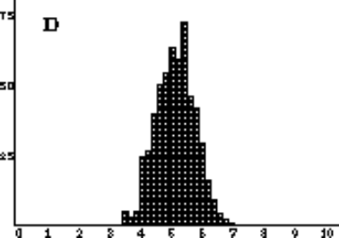 |  | 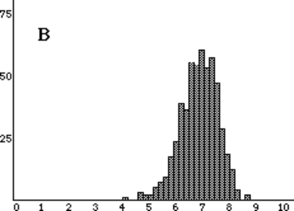 |  | 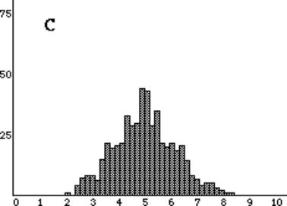
Mean of = 5.01; SD of = 0.578 |  | Mean of = 6.80; SD of = 0.694 |  | Mean of = 5.00; SD of = 1.125
Distribution of Sample Means n = 16 |  | Distribution of Sample Means n = 16 |  | Distribution of Sample Means n = 16
Guess 3: A B C D E |  | Guess 3: A B C D E |  | Guess 9: A B C D E
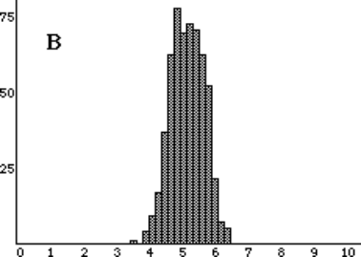 |  | 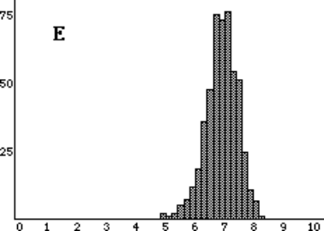 |  | 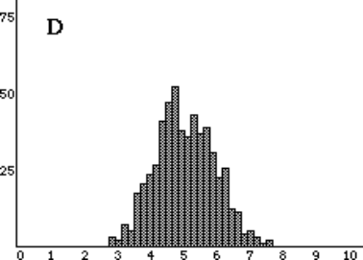
Mean of = 5.00; SD of = 0.454 |  | Mean of = 6.83; SD of = 0.500 |  | Mean of = 5.00; SD of = 0.845

Wrap-up:

- How can we distinguish between
- Populations, samples and sampling distributions?
- What’s similar, what’s different, and why?

- How can we distinguish between
- The Law of Large Numbers vs. the Central Limit Theorem?
- How are they related? How are they different?
- Locate where the Law of Large Numbers and the CLT related to the Simulation Process Model (SPM), e.g., Law of Large numbers relates to an individual sample (level 2) and CLT relates to all possible samples (level 3).

- How and why can we use the Central Limit Theorem and the 68, 95, 99.7% rule to assess the rareness of a particular sample statistic in the distribution of sample statistics?

- How can we describe the sampling distribution of sample means without running simulations?

- For random samples size 100 from population of human body temperatures, what would be the shape, center and spread of the distribution of sample means? And which would be more likely to be closest to 98.6: A mean temperature based on 9 people or a mean temperature based on 25 people?

Reference
Garfield., delMas, R., & Chance, B. (2000). Tools for Teaching and Assessing Statistical Inference (NSF project). http://www.tc.umn.edu/~delma001/stat_tools/

The following page includes the stickers for this activity.

Normal Population | Skewed Population | Multimodal Population
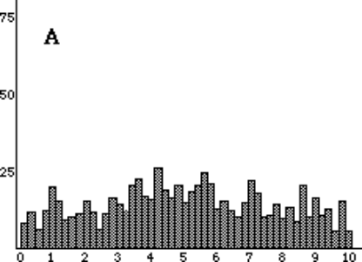 | 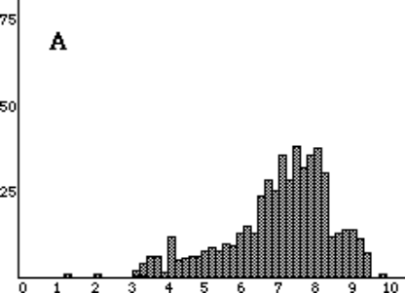 | 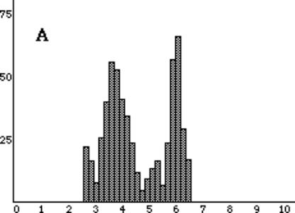
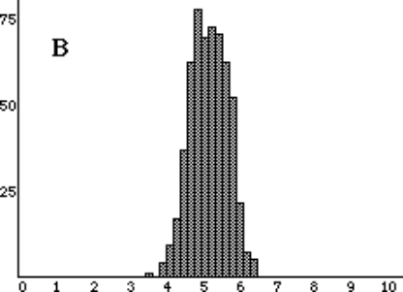 | 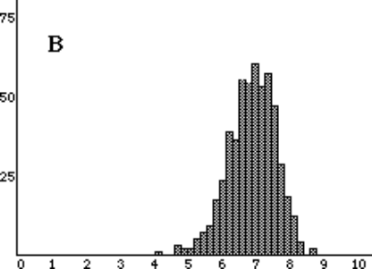 | 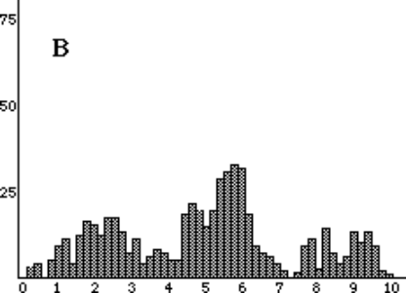
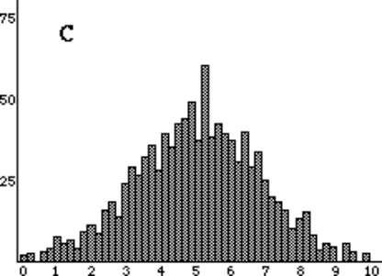 | 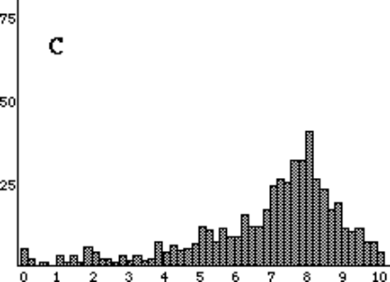 | 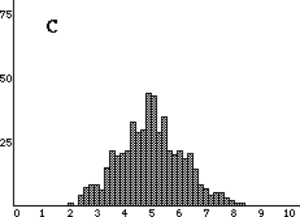
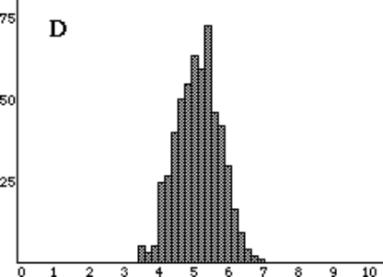 | 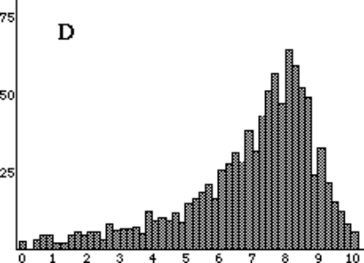 | 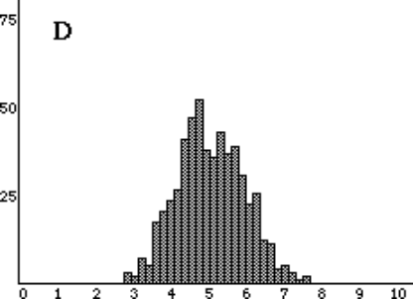
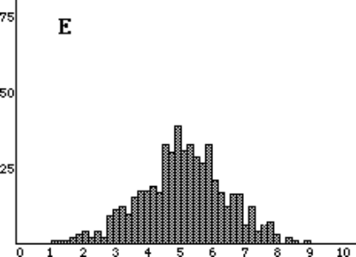 | 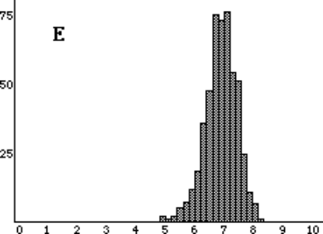 | 