Lesson 1: Testing Statistical Hypotheses

Overview:
This lesson uses the context of balancing a coin on its edge to introduce formal ideas of testing hypotheses. Students gather data for sets of 10 coins balanced on their edges to count the proportion of times they fall landing heads up. This proportion is used to test a null distribution based on equally likely outcomes. All of the ideas of tests of significance are introduced without any formulas or computations. The idea of the P-value is examined visually and conceptually, and then P-values are found using simulation software. The argumentation metaphor is used to explain the logic of testing hypothesis.

Student Goals for the Lesson:
- Connect informal to formal ideas of statistical inference.
- Introduce the process and language of significance tests.
- Use a normal density curve applet to conduct an informal test of significance.
- Understand the use of P-value in a test of significance.

Handouts:

- Modeling Coin Tosses
- Balancing Coins

Other Materials/Resources Needed:

- Normal density curve applet (such as the one available on http://bcs.whfreeman.com/bps3e/)

Note: This activity can also be used in conjunction with the Sampling SIM software (available for Mac or Windows). This may be downloaded from: http://www.tc.umn.edu/~delma001/stat_tools/stat_tools_software.htm

1. Opening Discussion/Questions:

Note: The instructor begins by holding up a penny.
For this penny, what do you expect when it is tossed?

Most people expect a fair penny to land heads up half the time and tails up half the time. How do we determine if a penny is “fair”?

2. Activity #1: Modeling Coin Tosses

Note: If Sampling SIM is used to model tossing a fair coin ten times, it is important to
set up the population to be a Binomial variable, with p = 0 .5 (the chance of getting heads is 0.5). Set the sample size to 10 (for 10 tosses) and simulate 500 sets of 10 tosses (number of samples = 500.) For each sample of ten, the proportion of heads will be displayed (e.g., for eight heads the proportion is 0.8 and 0.3 is the proportion for three heads). See the graph below for an example of what the screen should look like once these 500 samples of size 10 are drawn.

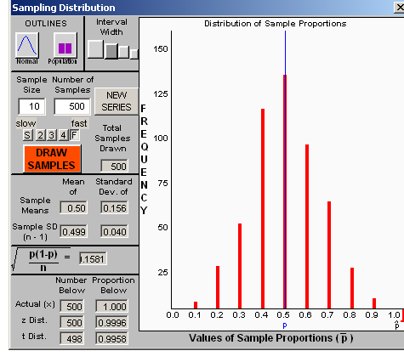

When students are asked to share in areas of the distribution that include surprising results, they can do so using the sliders that appear below the distribution of sample proportions. The shaded areas appear in green, just as in the figure below.

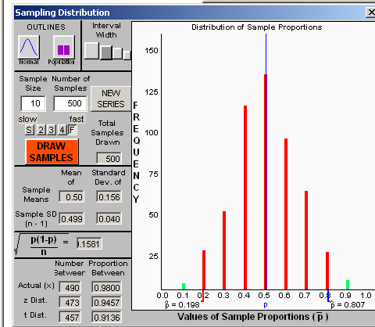

3. Whole Class Discussion:

Remind students that the sampling distribution is what we would expect if the process were indeed “fair.” Ask about likely and unlikely proportions of heads given the assumption that the process is “fair.”

4. Activity #2: Balancing Coins

Note: If Sampling SIM is used, students would need to be able to use the sliders to determine what percent of the distribution has values more extreme than what they observed. To do this:

- In the Options menu check Two Sliders Tandem
- Also, in the Options menu check Proportion Outside
- Move the slider in the sampling distribution window as close to your sample statistic as you can.

5. Whole Class Discussion (after Part 1 of Activity 2):

How many groups rejected the null hypothesis? What would this imply about the process? Did groups fail to reject the null hypothesis? What would this imply about the process? If you think the chances of getting heads is really NOT 0.5, why did some people FAIL to REJECT the null hypothesis? What can we do to make a better more informed decision?

6. Whole Class Discussion (after Part 2 of Activity 2):

Review the process of hypothesis testing (Hypotheses, Data-Sample Statistic, Sampling Distribution, Decision Rule) and how this process maps to making a convincing argument. Draw out the distinction of testing a population parameter in hypothesis testing. If, say, a person got six heads would you say the process is unfair? (The sample statistic is not 0.5, but the population parameter might be close enough.) Also, point out that our decision is based on evidence (data) and may be incorrect.

Wrap-up:

Revisit the Simulation Process Model (SPM) and use it to map the different levels of data: population, sampling distribution, and sample value.

References

Modeling Coin Tosses:

Garfield, J., & Zieffler, A. (2007). EPSY 3264 Course Packet, University of Minnesota, Minneapolis, MN.

Balancing Coins:
Scheaffer, R.L., Watkins, A. Witmer, J., & Gnanadesikan, M., (2004a). Activity-based statistics: Instructor resources (2nd edition, Revised by Tim Erickson). Key College Publishing.
Scheaffer, R.L., Watkins, A., Witmer, J., & Gnanadesikan, M., (2004b). Activity-based statistics: Student guide (2nd edition, Revised by Tim Erickson). Key College Publishing.

