Gettysburg Address

One of the most important ideas in statistics is that we can learn a lot about a large group (called a population) by studying a small piece of it (called a sample). Consider the population of 268 words in the following passage:

Four score and seven years ago, our fathers brought forth upon this continent a new nation: conceived in liberty, and dedicated to the proposition that all men are created equal.

Now we are engaged in a great civil war, testing whether that nation, or any nation so conceived and so dedicated, can long endure. We are met on a great battlefield of that war.

We have come to dedicate a portion of that field as a final resting place for those who here gave their lives that that nation might live. It is altogether fitting and proper that we should do this.

But, in a larger sense, we cannot dedicate, we cannot consecrate, we cannot hallow this ground. The brave men, living and dead, who struggled here have consecrated it, far above our poor power to add or detract. The world will little note, nor long remember, what we say here, but it can never forget what they did here.

It is for us the living, rather, to be dedicated here to the unfinished work which they who fought here have thus far so nobly advanced. It is rather for us to be here dedicated to the great task remaining before us, that from these honored dead we take increased devotion to that cause for which they gave the last full measure of devotion, that we here highly resolve that these dead shall not have died in vain, that this nation, under God, shall have a new birth of freedom, and that government of the people, by the people, for the people, shall not perish from the earth.

- Select a sample of ten representative words from this population by circling them in the passage above.

The authorship of several literary works is often a topic for debate. Were some of the works attributed to William Shakespeare actually written by Francis Bacon or Christopher Marlowe? Which of the anonymously published Federalist Papers were written by Alexander Hamilton, which by James Madison, which by John Jay? Who were the authors of the writings contained in the Bible? The field of “literary computing” began to find ways of numerically analyzing authors’ works, looking at variables such as sentence length and rates of occurrence of specific words.

The above passage is, of course, Lincoln’s Gettysburg Address, given November 19, 1863 on the battlefield near Gettysburg, PA. In characterizing this passage, we could have asked you to examine every word. Instead, we asked you to look at a sample of the words of the passage. We are considering this passage a population of words, and the 10 words you selected are considered a sample from this population. In most studies, we do not have access to the entire population and can only consider results for a sample from that population. The goal is to learn something about a very large population (e.g., all American adults, all American registered voters) by studying a sample. The key is in carefully selecting the sample so that the results in the sample are representative of the larger population (i.e., has the same characteristics).

The population is the entire collection of observational units that we are interested in examining. A sample is a subset of observational units from the population. Keep in mind that these are objects or people, and then we need to determine what variable we want to measure about these entities.

- Do you think the ten words in your sample are representative of the 268 words in the population? Explain briefly.

Responses may vary, e.g. “Yes, I picked them with my eyes closed.” or “No, I chose every fifteenth word.”

- Record the length for each of the ten words in your sample:

Word | 1 | 2 | 3 | 4 | 5 | 6 | 7 | 8 | 9 | 10
# letters | 7 | 5 | 2 | 9 | 6 | 4 | 4 | 2 | 4 | 9

- Determine the average (mean) number of letters in your ten words.

A reminder of the definition of mean may be necessary. In this case, the mean is (7+5+2+9+6+4+4+2+4+9)/10 = 4.6

Sketch the dot plot of the sample means we produced as a class. Remember that in this plot, each dot represents the average number of letters per word.

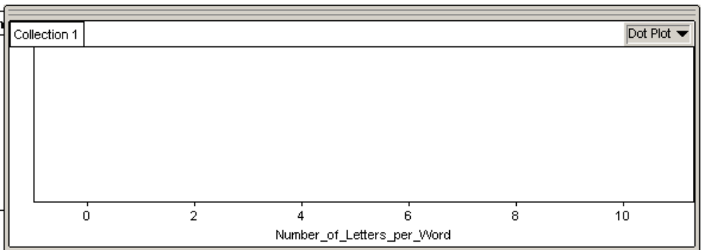

- The population average number of letters for all 268 words is 4.295 letters. Where does this value fall in the above dot plot? Were most of the samples’ means near the population mean? Explain.

Typically, data values are way above 4.295. There are many connectors such as “the” which tends to be ignored or not chosen.

- For how many students in your class did the sample average exceed the population average? What proportion of the class is this?

In this case 21 sample averages exceeded the population average. This is 21/24 of the class.

- If we were to repeat this exercise in different classes, do you think we would see similar results? Explain.

Responses vary depending on whether students thought the process they used were random. If the selection process was truly random, one would expect that the results would be similar. Otherwise, it is difficult to expect a reproduction of this class’ results.

- Explain why this sampling method (asking people to choose five words “at random”) is biased and how this bias is exhibited. Also identify the direction of the bias. In other words, does the sampling method tend to overestimate or underestimate the average length of the words in the passage?

Not every word has the same probability of being chosen – depending on what sampling scheme each student devised. An overestimation is a usual response.

A simple random sample (SRS) gives every observational unit in the population the same chance of being selected. In fact, it gives every sample of size n the same chance of being selected. In this example we want every set of ten words to be equally likely to be the sample selected. While the principle of simple random sampling is probably clear, it is by no means simple to implement.

The first step is to obtain a sampling frame where each member of the population can be assigned a number. Here we just need to number the words in the above passage. Open the link on the Resources page of the course webpage called: Gettysburg Address Sampling Frame

Now, click the link on the Resources page of the course website called Random Number Generator. Use that website to select a simple random sample of ten words without replacement. (See instructions at the end of this activity.)

- Record the words and their lengths as before:

 | 1 | 2 | 3 | 4 | 5 | 6 | 7 | 8 | 9 | 10
Word | 1 | 198 | 259 | 111 | 204 | 220 | 160 | 9 | 117 | 26
# letters | 4 | 5 | 6 | 2 | 4 | 4 | 4 | 7 | 4 | 3

Determine the average length: 4.3

While we don’t expect to match the population average exactly, we should see that we “err” equally on each side instead of systematically overestimating the population mean.

- This time how many students in your class obtained a sample average that was longer than the population average? What proportion of the class is this?

This proportion is expected to be closer to 0.5.

Now simulate taking many, many samples to better examine the long-term patterns of this sampling method:

- Open the link on the Resources page of the course webpage called Web Applet: Gettysburg Address
- The top right panels show the population distributions (including proportion of long words and proportion of nouns), the average number of letters per word in the population, the population proportion of “long words,” and the population proportion of nouns.
- We will focus on the lengths of words for now, so Unclick the boxes next to “Show Long” and “Show Noun,”

- Specify 5 as the sample size and click “Draw Samples”. Record the lengths of the words and the average for the sample of 5 words.

Word | 1 | 2 | 3 | 4 | 5 | Avg
# letters | 2 | 4 | 2 | 3 | 4 | 3

- Click “Draw Samples” again. Did you obtain the same sample of words this time?

No.

- Change the Number of samples from 1 to 98. Click the Draw Samples button. The applet now takes 98 more simple random samples from the population (for a total of 100 so far) and adds the sample results to the graph in the lower right panel. The red arrow indicates the average of the 100 sample averages. Record this value below.

Average of 100 sample averages: 4.29

- If the sampling method is unbiased the sample averages should be centered near the population average of 4.295 words. Does this appear to be the case?

This would usually be the case for 100 sample means or a large number of samples.

When a simple random sample is used, we can generalize results from our sample to the larger population. While we expect some variability in our results, there is a predictable pattern to the variation.

On the other hand, if the sampling method is biased, we can make no claims about the population. In this example, we were able to compare to the actual population values, but that is not usually the case. Thus, it is very important to determine whether or not the sample was selected at random before we can believe that the sample results are representative of the population.

- Change the sample size from 5 to 10.

- Uncheck the “Animate” button
- Click “Draw Samples”

Does the sampling method still appear to be unbiased? What has changed about the type of sample averages that we obtain? Why does this make sense? Explain.

Yes, it still appears to be unbiased. Expected mean should still be the same as the sampling method has not changed. Although the spread of the distribution is now reduced.

Average of 100 samples’ averages (with sample size 10): 4.34

- Produce a rough sketch of the distribution of these different averages.

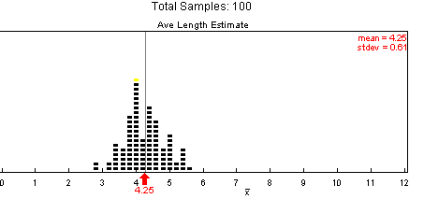

- How does this distribution (in black) compare to the previous (in green):

The distribution in black has more data points clustered around 4.25, and is therefore less spread out than the previous distribution.

- One common question is how the size of the population affects this precision.

- Click the “Reset” button.
- Further down on the page you will see a menu that currently says “address.” Pull down the menu and select “four addresses.” Now your population consists of 4 copies of the Gettysburg Address (4x268 = 1072 words) so that it is four times larger than it used to be (but the population characteristics are the same).
- Click the “Draw Samples” button.

How does this distribution compare to the one you sketched in the previous question?

As sample size gets larger, the variability of the distributions decreases.

A rather counter intuitive, but very crucial, fact is when determining how representative your sample is, and how close your sample results should be to the population result, the size of the population does not matter! This is why organizations like Gallup can state poll results about the entire country based on samples of just 1,000-2,000 respondents, as long as those respondents are randomly selected.

Three caveats about random sampling are in order:
- One still gets the occasional “unlucky” sample whose results are not close to the population even with large sample sizes.

- Second, the sample size means little if the sampling method is not random. In 1936 the Literary Digest magazine had a huge sample of 2.4 million people, yet their predictions for the Presidential election did not come close to the truth about the population.

- While the role of sample size is crucial in assessing how close the sample results will be to the population results, the size of the population does not affect this. As long as the population is large relative to the sample size (at least 10 times as large), the precision of a sample statistic depends on the sample size but not on the population size!

Drawing a Simple Random Sample (SRS) using http://www.random.org

Use the website (http://www.random.org) to select a simple random sample of ten words without replacement.
- Click on the link for Random Number Generator on the course website.
- Click on “Integer Generator”.
- You need to generate 10 random integers.
- Your integers should be between the smallest and largest values in your sampling frame (e.g. In the Gettysburg Address there are 268 words, thus you would enter 1 for the smallest value and 268 for the largest value.)
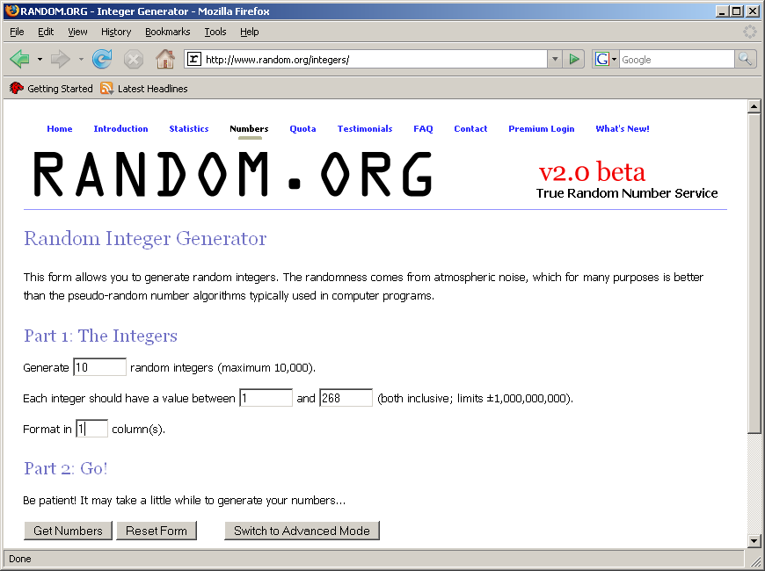
- Click on “Get Numbers”

Reference

Chance, B.L., & Rossman, A.J. (2006). Using simulation to teach and learn statistics. In A. Rossman & B. Chance (Eds.), Proceedings of the Seventh International Conference on Teaching Statistics. [CD-ROM]. Voorburg, The Netherlands: International Statistical Institute. Retrieved July 15, 2007, from http://www.stat.auckland.ac.nz/~iase/publications/17/7E1_CHAN.pdf

Please note the possible student answers may not, in some cases, be IDEAL student answers.

