Coke/Pepsi Taste Test

Part I: Designing the Study

- How could you design a study that would determine if someone could actually tell the difference between Coke and Pepsi? Explain.

Answers will vary. Note the actual design used in class is given below.

Assign Roles to Group Members:

Taster - Those students who think they can tell the difference between Coke and Pepsi.
Runner - Those students who deliver cups of soda from the pourer to the taster.
Recorder - Those students who record and report the results of the taster.
Pourer - They determine the order of the soda and also pour the soda.

Tasters, Runners, and Recorders will initially leave the room. Tasters get a Dixie Cup to fill with water. They are to cleanse their palette with a drink of water after each soda tasting. Recorders should bring a notebook and pencil with them to record the results of the test.

Pourers will use a coin to determine the pouring order of the five sodas. They will then pour the soda and prepare the five cups for distribution to their taster. After the Dixie cups of cola have been poured and laid out on the table by the pourers, the Runners are called to bring one cup at a time to their assigned subject. The Recorder writes down the results and reviews with pourer at end of test.

The study has the merit of the taster and recorder both do not know the type of soda that was served to the taster. Thus, if the taster could correctly identify the soda, we may tend to believe that he or she can tell the difference between Coke and Pepsi.

NULL MODEL: There is no difference in taste between Coke and Pepsi.

ALTERNATIVE MODEL: There is a difference in taste between Coke and Pepsi.

How many sodas did your taster correctly identify? __________

- Which model does your data support? Explain.

Answers may vary here.

Part II: Critiquing the Study
- Was this taste test an experiment or an observational study? Explain.

This was an observational study because people were not chosen at random to be tasters. People who think that they can tell the difference between Coke and Pepsi volunteered.

- Critique the study on each of the three elements of a good experiment (randomization, control, and replication). Which were met in our study? Which weren’t? Explain.

Tasters were not randomly assigned from amongst the students in the class. We tried to control all other variables except for the Coke and Pepsi – including randomizing the order of appearance of the Coke and Pepsi cups. There was replication with the other groups in this class that were held contemporaneously.

- What are three ways in which we could improve our study for next time? How would each of these suggestions improve the study?

We could have used a true random number generator as opposed to having the pourer “use a coin to determine the pouring order”. This is because different pourers could use different techniques that could bias the result. Also, water may not adequately dilute or get rid of the taste of the previous drink – one may use bland crackers instead to make sure that the palate “forgets” the taste of the previous drink. Perhaps more cups of soda could be used to reduce the chances that the taster correctly identified the sodas.

Part III: The Guessing Model

- What if your taster really couldn’t tell the difference between Coke and Pepsi, how many would you expect him/her to correctly identify? Explain.

If the taster was truly guessing, then the chance of correctly identifying the soda is ½. We would expect the taster to correctly identify half of the time. Since 2.5 is not a whole number, then 2 and 3 seems to be the likely outcomes.

- If we replicated the experiment many times, and each time our taster tried the soda he/she was guessing, what would the distribution of correct identifications look like? Sketch a picture.

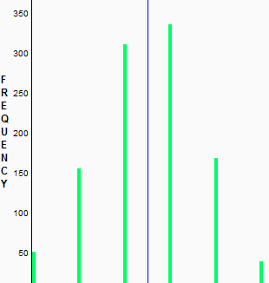
0 1 2 3 4 5

- Could a student correctly identify all five sodas just by guessing? Explain.

Yes, but the probability of that happening is remote as we can see from the distribution above (the bar corresponding to 5 is small in comparison to the other frequencies.

- How does the graph of the results that Sampling SIM produced compare with the sketch you created earlier?

They both have the same shape, but the earlier sketch shows the number of correct guesses as opposed to the proportion of correct guesses.

- How many sodas are likely to be correctly identified if our taster was guessing each time? What are likely values?

From our sketch, the likely values are 2 and 3, with 1 and 4 being less likely.

- What are unlikely values (the number of correct identifications that don’t occur as often if they were guessing)?

The unlikely values, as we can see from our sketch, are 0 and 5.

- Where does your taster’s actual result fit in on the graph produced by Sampling SIM? In the tails? In the middle?

My taster’s results actually fit in the middle of the graph produced by Sampling SIM.

- Based on your answer to Question 11, is it likely or unlikely that your taster would have gotten the result he/she did if he/she was just guessing? Explain.

It is quite likely that my taster just guessed as the result is in the middle of the distribution and not at the tails.

Reference

Snell, L., Peterson, B., Moore, T., & Garfield, J. (1998). Teaching Chance: An instructor guide for teaching a chance course. Retrieved October 21, 2007, from http://www.dartmouth.edu/~chance/teaching_aids/teaching_aids.html

Levels of Data | The Simulation of Samples (SOS) Model  Coke Pepsi Taste Test | The Sampling and Inference Process
Level 1:  Population | 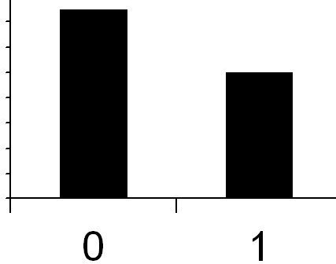  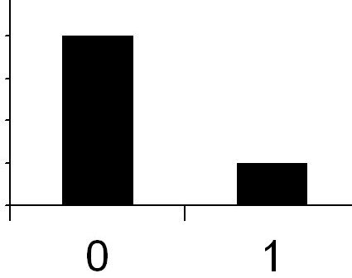  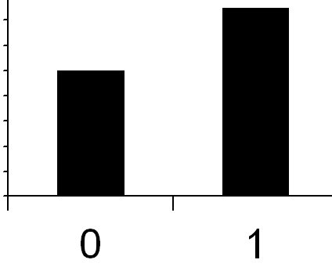  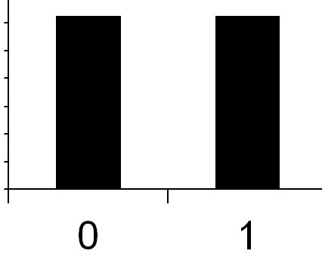  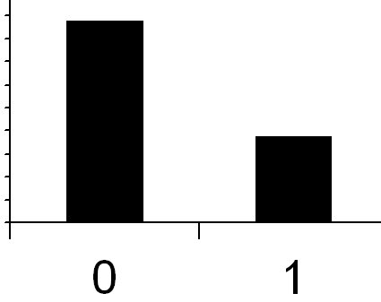  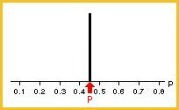  …  Sample 1:  Sample 2:  Sample 3:  Sample 4:  Sample 5:  Sample k: | 1. Assume no one can really tell the difference, and is just guessing each time they taste a soda.
Level 2:  Samples & sample statistics |  | 2. Generate data based the model that everyone is guessing and can’t really tell the difference. How many would they get right just by chance? How many would they get wrong?
Level 2:  Samples & sample statistics |  | 3. Compute the proportion of correct guesses for each sample of 5 guesses.
Level 3:  Distribution of sample statistics | 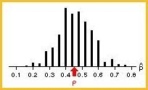  Sampling distribution | 4. Graph these proportions (show the distribution).
Level 3:  Distribution of sample statistics |  | 5. Show your result compared to the distribution of guesses. Does it seem likely that you were just guessing?

Please note the possible student answers may not, in some cases, be IDEAL student answers.

