Coke/Pepsi Taste Test

Part I: Designing the Study
- How could you design a study that would determine if someone could actually tell the difference between Coke and Pepsi? Explain.

NULL MODEL:

ALTERNATIVE MODEL:

How many sodas did your taster correctly identify? __________

- Which model does your data support? Explain.

Part II: Critiquing the Study
- Was this taste test an experiment or an observational study? Explain.

- Critique the study on each of the four elements of a good experiment (random sample, randomization, control, and replication). Which were met in our study? Which weren’t? Explain.

- What are three ways in which we could improve our study for next time? How would each of these suggestions improve the study?

Part III: The Guessing Model
- What if your taster really couldn’t tell the difference between Coke and Pepsi, how many would you expect him/her to correctly identify? Explain.

- If we replicated the experiment many times, and each time our taster tried the soda he/she was guessing, what would the distribution of correct identifications look like? Sketch a picture.

- Could a student correctly identify all ten sodas just by guessing? Explain.

- How does the graph of the results that SamplingSIM produced compare with the sketch you created earlier?

- How many sodas are likely to be correctly identified if our taster was guessing each time? What are likely values?

- What are unlikely values (the number of correct identifications that don’t occur as often if they were guessing)?

- Where does your taster’s actual result fit in on the graph produced by SamplingSIM? In the tails? In the middle?

- Based on your answer to Question 11, is it likely or unlikely that your taster would have gotten the result he/she did if he/she was just guessing? Explain.

Reference
Snell, L., Peterson, B., Moore, T., & Garfield, J. (1998). Teaching Chance: An instructor guide for teaching a chance course. Retrieved October 21, 2007, from http://www.dartmouth.edu/~chance/teaching_aids/teaching_aids.html

Levels of Data | The Simulation of Samples (SOS) Model  Coke Pepsi Taste Test | The Sampling and Inference Process
Level 1:  Population | 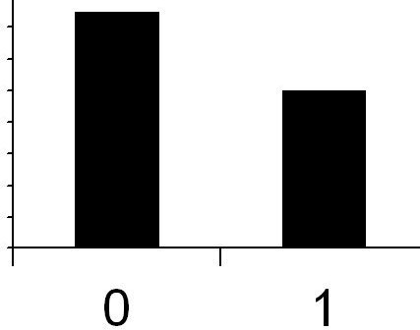  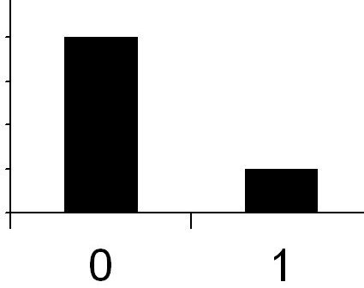  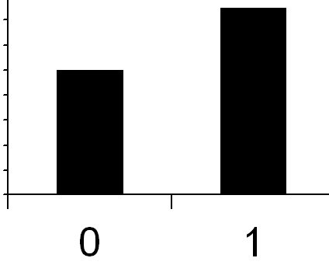  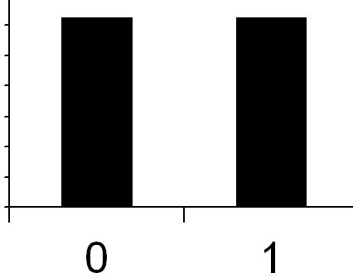  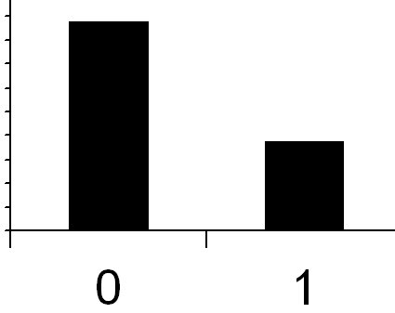  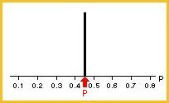  …  Sample 1:  Sample 2:  Sample 3:  Sample 4:  Sample 5:  Sample k: | 1. Assume no one can really tell the difference, and is just guessing each time they taste a soda.
Level 2:  Samples & sample statistics |  | 2. Generate data based the model that everyone is guessing and can’t really tell the difference. How many would they get right just by chance? How many would they get wrong?
Level 2:  Samples & sample statistics |  | 3. Compute the proportion of correct guesses for each sample of 5 guesses.
Level 3:  Distribution of sample statistics | 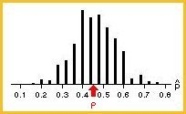  Sampling distribution | 4. Graph these proportions (show the distribution).
Level 3:  Distribution of sample statistics |  | 5. Show your result compared to the distribution of guesses. Does it seem likely that you were just guessing?

