Coins, Cards, and Dice

COINS

- You will toss a coin 5 times and count the number of heads. Repeat this 10 times, making a frequency distribution for the number of heads that show up on each toss of 5 coins, as shown below. The possible values for number of heads are 0, 1, 2, 3, 4, or 5. Each time you toss the 5 coins, check the value of X (number of heads showing) in the table below. After you have tossed the coins ten times, find the relative frequency probability for each value of X and fill in the table below.

HHHHT
HTTTT
HTHHT
THTTH
THHHT
HTHTH
TTTHH
THTHT
HHHTT
HHHHH

X Frequency Relative Frequency (f/10) Simulated % (n=10) Simulated % (n=500)
0 .0 .05

1  .10 .20

2    .30 .25

3    .40 .30

4  .10 .20

5  .10 .05
- Modeling on the computer:

- Open the Fathom file FiveCoins.ftm (located in File > Open Sample Document > Math > Probability > FiveCoins). The probability of success is 0.5 for each coin. Click on the “Collect More Measures” to run the simulation. See below.
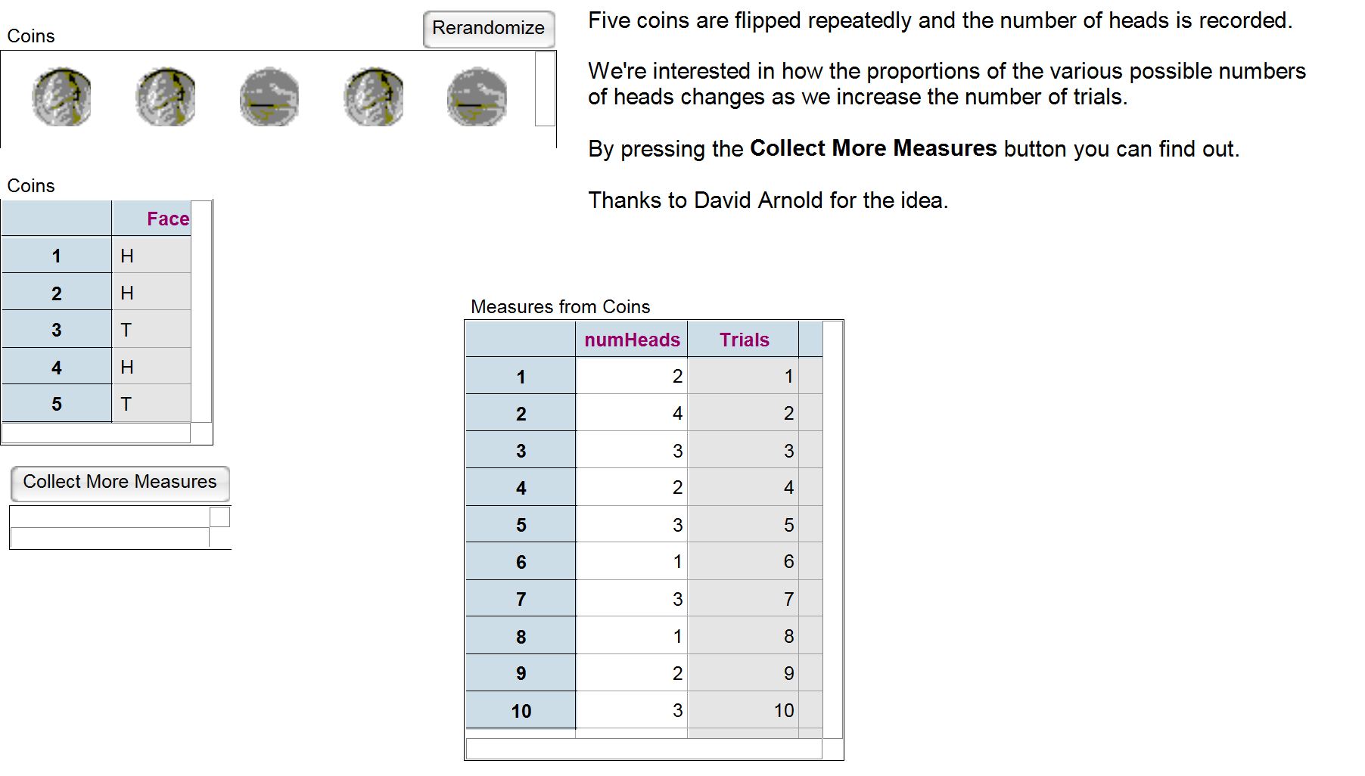

- Right click on the “Collect More Measures” button and select “Inspect Collection”, uncheck “Animation on”, check “Replace existing cases” and put in 10 in the measures box. Click “Collect More Measures.”
- With “Collect More Measures” selected, drag a Table from the Toolbar.
- Record the proportion or percentage of Heads (“numHeads”) in the table in step 1.

- How do the simulated data compare to the data you generated in step 1, physically tossing coins? Do you expect that they will be similar for all students in the class? Why or why not?

Answers vary.

- Repeat this simulation, this time simulating the tossing of 5 coins 500 times (put in 500 in the measures box after you right-click on the “Collect More Measures” button and select “Inspect Collection”), and record your relative frequencies in the column in Step 1. Compare these results as a group. Would you expect them to be pretty similar for all students in this class? Why or why not?

Answers vary.

- Make a histogram of your data that resulted from 500 flips. Describe its shape, center and spread.

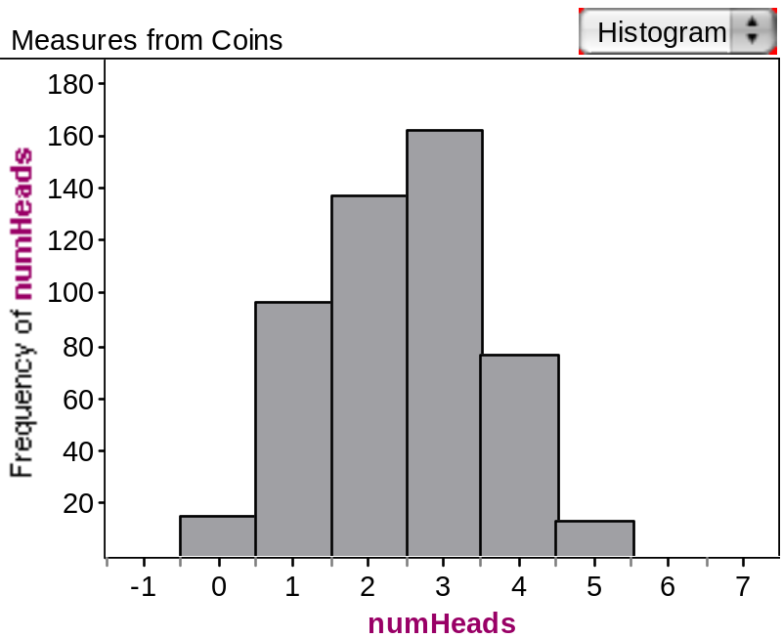

- What is the expected number of heads?

2.5 heads

CARDS

- Take a deck of cards. Shuffle, draw a card, and replace it, draw, and replace. Repeat this procedure 3 more times. Count the number of Hearts that showed up in sample of 5.

- Instead of repeating this 10 times, use Fathom file DeckOfCards.ftm located at File > Open Sample Document > Fathom Techniques > DeckOfCards.

- Simulate this activity, repeated 10 times. Right click on the “Poker Hand” graphic and select “Inspect Collection”, and then selecting the “Sample” tab. Check “With replacement, uncheck “Animation on”, check “Replace existing cases,” and put in 5 in the cases box. Now, select the “Measures” tab, and replace the second “Measure” with “hearts” and replace the formula count (suit = “hearts”) by double clicking on the formula. Click on the “Sample More Cases” button.

- Success is getting a Heart. Let us denote Y as the variable representing the number of Hearts that appear in our samples of size 5. As we are using a full deck with 52 cards, the probability of a success (getting a Heart) is ¼ or 0.25. Right click on the “Poker Hand” graphic and select “Collect Measures”. Now highlight the “Measures from Poker Hand” icon and right-click on it to “Inspect Collection.” Uncheck “Animation on”, check “Replace existing cases,” check “Re-collect measures when source changes,” and put in 10 in the measures box. Click the “Collect more measures” button. Lastly, select the “Measures from Poker Hand” icon, and then grab a “Table” icon from the tool bar.

- In order to have 500 samples, change the number in the measures box to 500 after right-clicking on the “Measures from Poker Hand” icon and choose “Inspect Collection.” Uncheck “Animation on”, check “Replace existing cases,” check “Re-collect measures when source changes,” and put in 500 in the measures box. Click the “Collect more measures” button.
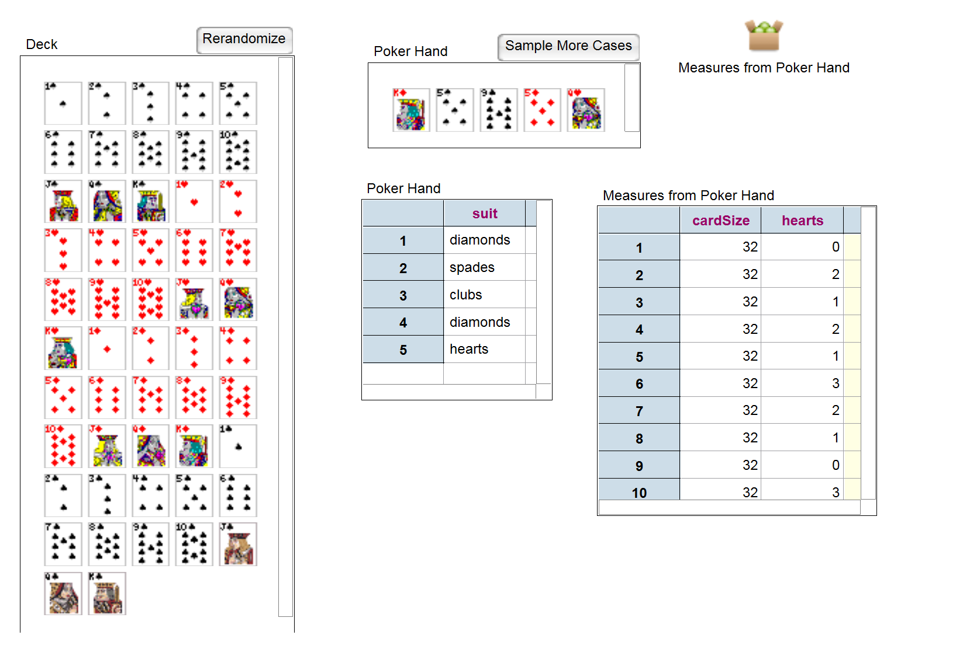

- Make a probability distribution as you did for coins and fill it in below:

Y Simulated % (n=10) Simulated % (n=500)
0 ~10% ~25%

1 ~40% ~40%

2 ~ 0% ~25%

3 ~10% ~9%

4 ~0% ~1%

5 ~10% ~0%

- Make a histogram of your data when you simulated 500 samples. Describe its shape, center and spread.

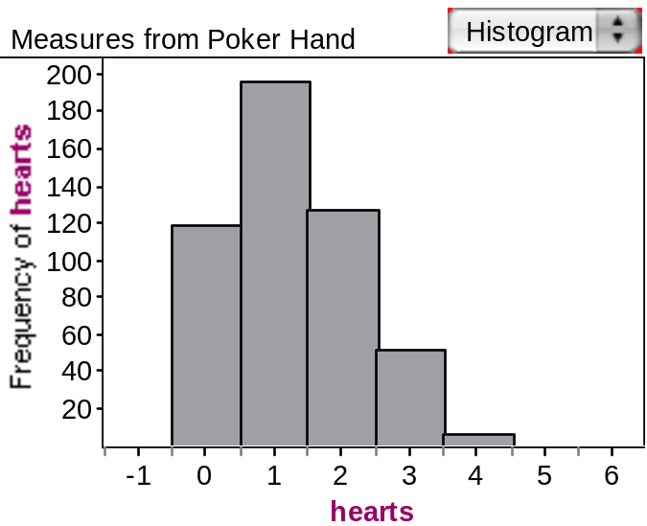

- What is the expected number of hearts?

1.4 hearts

DICE

- Take a die and roll it five times, counting the number of twos.

- Simulate this activity using Fathom file RollingDice.ftm, which can be found at File > Open Sample Document > Teaching Math with Fathom > Statistics > RollingDice. Then, right-click on “Sample of Single Die” and check “With replacement, uncheck “Animation on”, check “Replace existing cases,” and put in 5 in the cases box. Now, select the “Measures” tab, and click on “<new>” to create a new “Measure” called “numTwos” and use the formula count (face = 2) by double clicking on the formula line. Then, choose the “Collect Measures.” Let Z represent the number of 2’s in any one sample.

- To do this for 10 trials, right-click on the “Measures from Sample of Single Die” icon and choose “Inspect Collection.” Uncheck “Animation on”, check “Replace existing cases,” check “Re-collect measures when source changes,” and put in 10 in the measures box. Click the “Collect more measures” button. Repeat with 500 trials, and fill in the data below:

Z Simulated % (n=10) Simulated % (n=500)
0 .20 .40

1 .70 .40

2 .10 .15

3 .0 .05

4 .0 .00

5 .0 .00

- Make a histogram for the 500 rolls and describe its shape, center and spread.

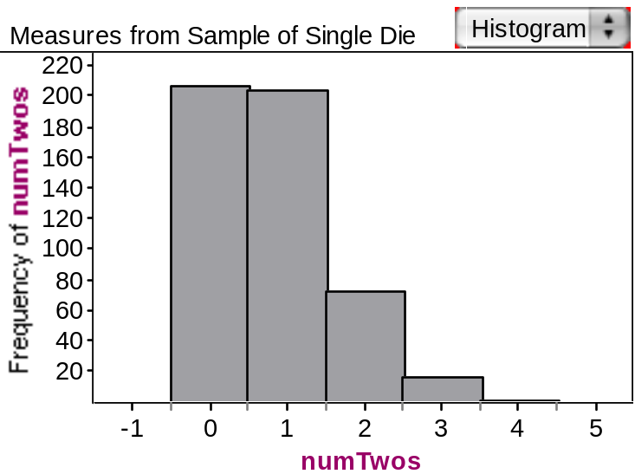

5. What is the expected number of 2’s?

.8

Comparison of Data

Be prepared to discuss these results in a large group discussion.

- Look at the results of your three experiments. What was the same and what was different across the three experiments?

Answers vary.

- How do the differences in the experiment reveal themselves in the probability histograms?
Answers vary.

- For each experiment, compare the expected value of the outcome of interest. How do they compare and why?

Answers vary.

4. Using the histograms, find the probability of getting:

a. a value of 3 for X, Y, and Z?

Answers vary.

b. a value more than 4?

Answers vary.

c. a value less than 3?

Answers vary.

Reference
Garfield, J., Zieffler, A., & Lane-Getaz, S. (2005). EPSY 3264 Course Packet, University of Minnesota, Minneapolis, MN.

Please note the possible student answers may not, in some cases, be IDEAL student answers.

