Normal Distribution Applications

A standardized measure of achievement motivation is normally distributed, with a mean of 35 and a standard deviation of 14. Higher scores correspond to more achievement motivation.

- Draw a picture of this distribution. (Be sure to label the mean and three standard deviations in each direction.)

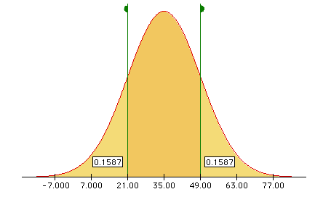

- Gerry scored 49 on this exam. Mark Gerry’s score on the distribution you drew in Question 1.

See above

- Gerry scored higher than what proportion of the population?

.84

- 2.5% of the students scored higher than Elaine. What was her achievement motivation score?

~63

- The distribution of heights of adult men is approximately normal with a mean of 69 inches and a standard deviation of 2 inches. Bob's height has a z-score of -0.5 when compared to all adult men. Which of the following is true?

A. Bob is shorter than 69 inches tall.
B. Bob's height is half of a standard deviation below the mean.
C. Bob is 68 inches tall.
D. All of the above.

- Chris is enrolled in a college algebra course and earned a score of 260 on a math achievement test that was given on the first day of class. The instructor looked at two distributions of scores, one for all freshmen who took the test, and the other for students enrolled in the algebra course. Both are approximately normally distributed & have the same mean, but the distribution for the algebra course has a smaller standard deviation. A z-score is calculated for Chris' test score in both distributions (all freshmen & all freshmen taking algebra). Given that Chris' score is well above the mean, which of the following would be true about these two z-scores?

A. The z-score based on the distribution for the algebra students would be higher.
B. The z-score based on the distribution for all freshmen would be higher.
C. The two z-scores would be the same.

- Explain your answer to Question 6.

Dividing by a smaller std deviation makes the z-score higher.

The average height for all females in the U.S. in inches is 65 with a standard deviation of 2.5 inches. Kylee is 68 inches tall, and Michelle is 62 centimeters tall.

- What proportion of U.S. females are taller than Kylee?

~.12

- What proportion of U.S. females are shorter than Michelle?

~.12

- What proportion of U.S. females has a height between Michelle and Kylee?

.76

- SAT I math scores are scaled so that they are approximately normal and the mean is about 511 and the standard deviation is about 112. A college wants to send letters to students scoring in the top 20% on the exam. What SAT I math score should the college use as the dividing line between those who get letters and those who do not?

~605

Reference
Garfield, J., Zieffler, A., & Lane-Getaz, S. (2005). EPSY 3264 Course Packet, University of Minnesota, Minneapolis, MN.

Please note the possible student answers may not, in some cases, be IDEAL student answers.

