Distinguishing Distributions

Below are a series of dot plots that depict the distributions of hypothetical exam scores in various classes.

- For classes A, B and C, what is the main characteristic that distinguishes these three graphs from each other? What might explain this difference?

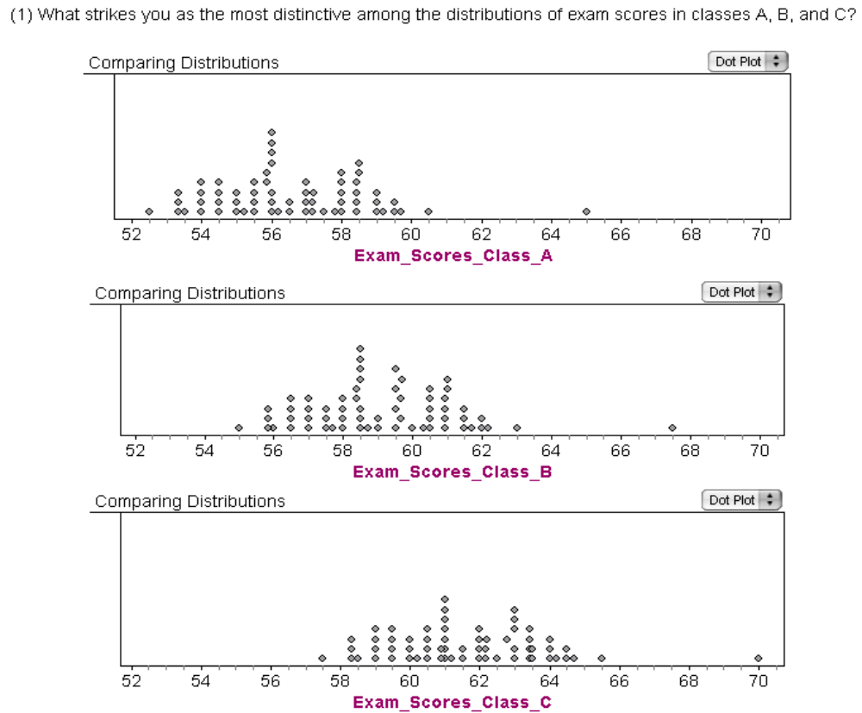

The main characteristic is that the center of the distribution is different for the three classes. This may be because the students are tracked into classes based on ability.
What is the main characteristic that distinguishes the distributions of exam scores in classes D, E, and F? What might explain these differences?

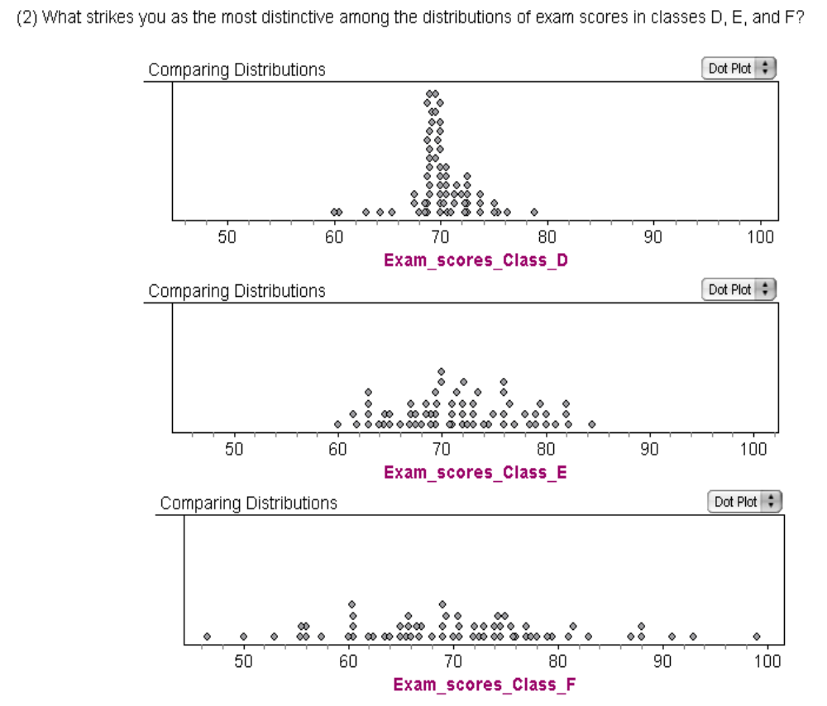

The spreads of these three distributions are very different. This could be due to the fact that different material was taught to these 3 classes.

- What is the main characteristic that distinguishes the distributions of exam scores in classes G, H, and I? What might be an explanation for the distinguishing feature you find?

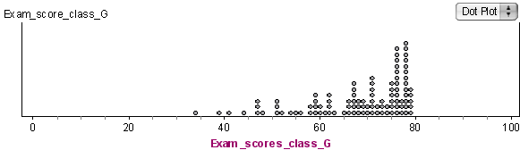

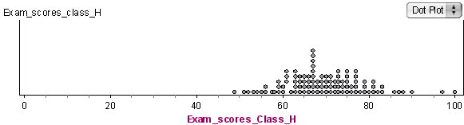

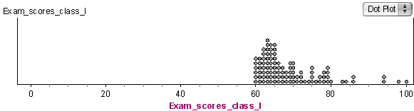

The shapes of the distributions are different. Most of the students in Class G may have found the exam to be easy whereas most of the students in Class I may have found the exam difficult.

- What strikes you as the most distinctive features of the distribution of exam scores in class J? What might be an explanation for this characteristic?

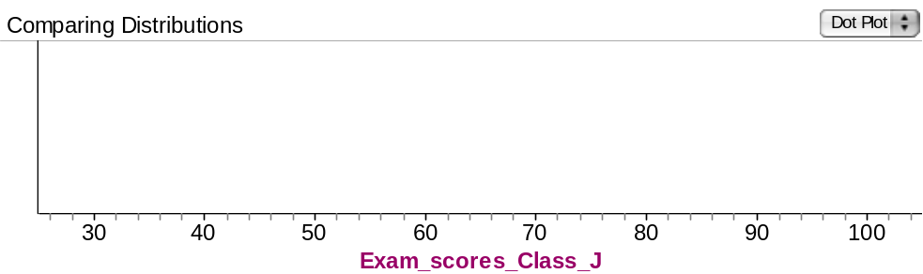

The scores are located in two clusters or clumps, one centered around 50 and the other centered around 80. Students either found the exam easy or difficult.

- What strikes you as the most distinctive feature of the distribution of exam scores in class K? What might be an explanation for this characteristic?

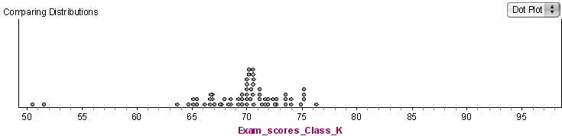

While most of the scores are located around 70 with very little spread (ranges from about 65 to 75), there are two very low value around 50 and 51. These scores are very different from most of the values (there is a large gap) and may represent outliers. Perhaps these two students did not prepare as well as the others.

- What strikes you as the most distinctive feature of the distribution of exam scores in class L? What might be an explanation for this characteristic?

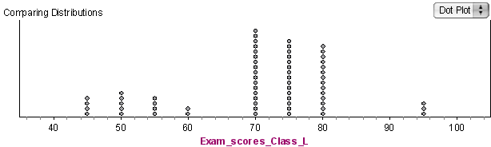

The fact that many students scored the same values in increments of five. This could be because the exam was scored in multiples of five, or there were 20 items on the exam and the score is percent correct.

- Look again at the graph for class D. If you wanted to tell someone about how the students did on this exam, what would you say?

Most students scored around 70 – and the variation around 70 is small. The shape is approximately symmetrical.

- What if we tried to look at the “bulk” of the data? Now, what would you say?

The bulk of the data seems to be concentrated between 68 and 72.

- What about the graph for class E?

The distribution of scores for class E ranges from 60 to 84, and the values are spread out somewhat evenly throughout that range (or the bulk of the data is from about 65 to 75), so it is much more spread out than for class D.

- What if you were told that most exam scores for a class were between 65 and 85, and that the overall range of scores for that class was between 30 and 100? Can you imagine what that distribution would look like? Sketch it below.

- What features of a graph are important to examine when comparing distributions or describing a distribution?

Center, Spread and Shape.

- What characteristics might be present or absent, depending on the data set?

Skewness and outliers.

- What is a helpful strategy for looking at and describing a distribution to someone?

Describing the Center, Spread and Shape. Then looking for data that may not belong to this group: by examining gaps, clusters and/or outliers.

Reference

Rossman, A., & Chance, B. (2002). A data-oriented, active-learning, post-calculus introduction to statistical concepts, applications, and theory. In B. Phillips (Ed.), Proceedings of the Sixth International Conference on Teaching of Statistics, Cape Town. Voorburg, The Netherlands: International Statistical Institute. Retrieved September 28, 2007, from http://www.stat.auckland.ac.nz/~iase/publications/1/3i2_ross.pdf

Please note the possible student answers may not, in some cases, be IDEAL student answers.

