Growing a Distribution

Part I
With your group, discuss and answer the questions below.
How many hours do you think that students in this class tend to study each week? (Be sure to define what you include as time spent studying.)

Now, give a range where most of the values would be:

0 to 20 hours a week doing homework or doing the required reading outside of all their classes.

What do you think is a typical value for the number of hours studied per week (for statistics) for a student in this class?

One might expect that a student in this class spends a little more than 3 hours a week doing homework outside of this class.

Part II
Ask five students in the class to estimate the typical number of hours per week that they study. Use Fathom to make a dot pot of the data. Draw the graph below.

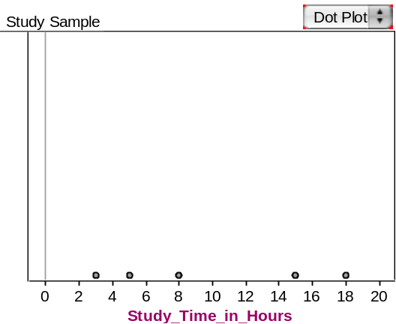

How would you describe this distribution in terms of shape, center and spread?

The values range from 3 hours to 18 hours (which is a large range of 15 hours). Three of the students study between 3 and 8 hours, but the other two study 15 or 20 hours per week. The mean of the distribution is around 10 hours.

How does it compare to your prediction?

It does not reflect what I thought the amount of time that students spent studying. However, this is a very small sample and may not really reflect how much time the other students spend each week studying for this class.

Write the typical number of hours per week that you study on the board.

Questions:
- What would you expect to see if you collected and graphed the data for the entire class?

We would expect more variability and perhaps reveal a data cluster between 3 and 7 hours and expect a few outliers for students who spend a larger amount of time on studying.

- In what ways might this look different than your first graph?

The shape, location and spread may be different.

Part III
In your group, discuss and complete the following questions.

Using your class’ data (on the board) on study hours per week, use Fathom to graph the data for students in your class. Draw the graph below.

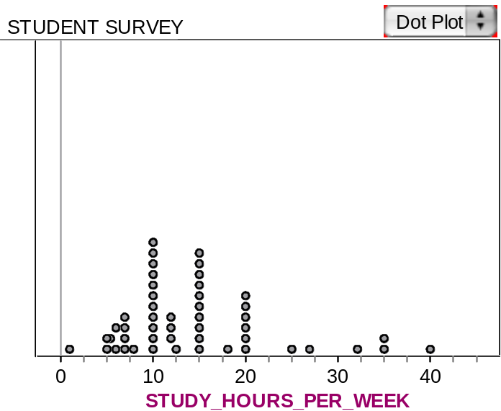

Describe the distribution in terms of shape, center, and spread.

The distribution seems to be skewed to the right with an average of about 15 hours and a large spread as shown by the range from nearly 0 to 40 hours.

What features of this distribution look different when compared to your first graph of five data values?

One can more easily see clusters of data in this distribution.

Next, imagine if four classes of students were combined. Sketch the graph you would expect to see for these 120 students for the number of hours per week they typically study.

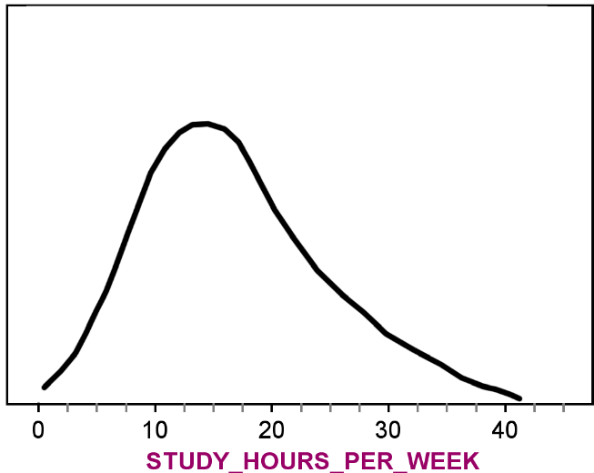

In what ways would you expect to see this graph differ from the one for your class of about 30 students?

Might expect it to have about the same shape, center, and spread as sample of n=30, but with fewer gaps. Or, it could be quite different because 30 is not big enough to get a good idea of the whole population.

Questions:
- What kinds of graphs did you draw?
- How do they compare to each other?
- What did you consider when you drew your graphs?

Part IV
Open the class survey data file in Fathom and make a graph of students’ hours of study per week. How close is this graph in terms of shape, center, and spread to what you predicted? Explain.

They were pretty much what I expected.

Finally imagine all students at this school. That is way too many dots to draw. This time, draw a smooth curve to represent the population distribution of typical number of hours per week studied.

Answers will vary

Choose three other variables from our student survey.
For example:

- Time Spent Exercising

- Age of Students

- Number of Credits Taken This Semester

Use Fathom to make dotplots of these three variables for your class’ data.
Look at your graphs, then imagine what the graphs would look like if we included the data for all students at this school. Draw brief sketches of smooth curves to show what you would expect these distributions to look like.

Reference
Bakker, A. (2004b, November). Reasoning about shape as a pattern in variability. Statistics Education Research Journal, 3(2), 64-83. Retrieved July 15, 2007, from http://www.stat.auckland.ac.nz/~iase/serj/SERJ3(2)_Bakker.pdf

Please note the possible student answers may not, in some cases, be IDEAL student answers.

