Creating Graphs for Variables without Data!

In groups, discuss and sketch what you expect for the general shape of the distribution for each of these data sets. Label each graph with the statistical term for its shape. Write down your reasons for why you expect the distribution of the data set to have a particular shape.
- The salaries of all persons employed at the University of Minnesota.
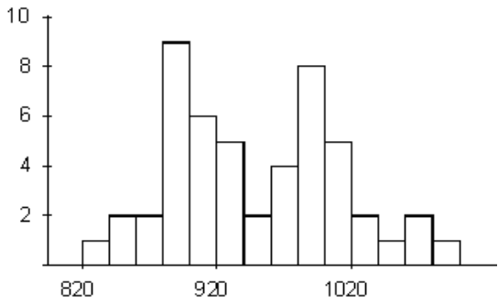

The salaries for all persons employed at the University of Minnesota may be expected to be nearly multimodal in shape because there will be a group of highly-skilled employees who will be making a lot more money versus another group of employees who are performing non-academic related jobs.

- The scores on an easy test.
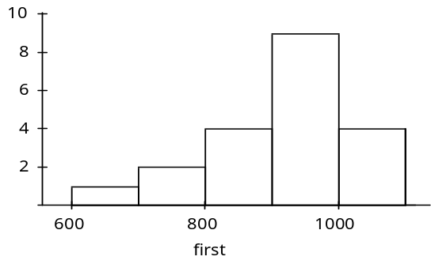

We expect most people to have high scores on an easy test.

- The scores on a difficult test.

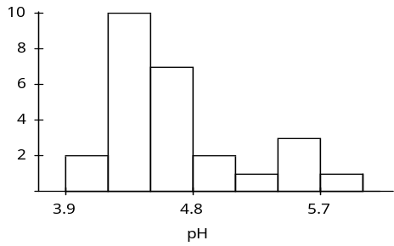

Most students are expected to score on the lower end of the scale.
- The amounts of time freshmen students study during the first week of class.

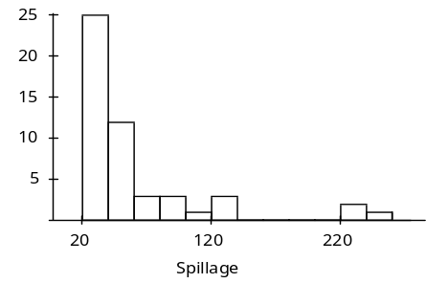

We do not expect freshmen students to study very much in the first week of class, but however, there are always exceptional students who take the time to prepare for the second week of classes.

- The age of cars on a used-car lot.
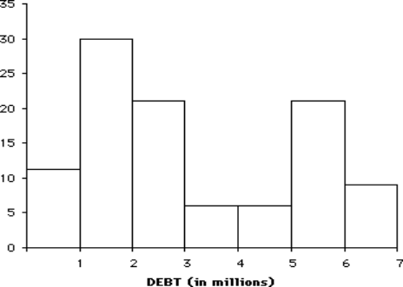

Cars in a used-car lot could consist primarily of newer cars and a group of older ones.

- The amounts of time spent by students on a difficult test (maximum time allowed is 50 minutes).

Most students will stay for the maximum time allowed but some may give up early because they believe they cannot answer the items on the test.

- The heights of students in the University of Minnesota marching band.

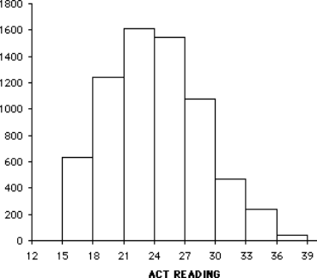

We expect that students in the marching may be representative of the population in general and therefore reflect the heights of the general student body. Another possible answer is a bimodal distribution taking into account differences between females and males.

Reference

Garfield, J., Zieffler, A., & Lane-Getaz, S. (2005). EPSY 3264 Course Packet, University of Minnesota, Minneapolis, MN.

Please note the possible student answers may not, in some cases, be IDEAL student answers.

