Exploring Different Representations of the Same Data

Part I: The Same data different graphs
Open the survey data for your section of the course. Use Fathom to create three different histograms for the variable called Exercise by changing the bin widths and the number of bars. (See the directions below.)
- Create a histogram by plotting the data.
- Use the mouse to grab the side of any bar in the histogram. (The icon will change from the hand to a double-sided arrow.)
- Click and drag the side of the histogram to the desired bin width.

Sketch each of the three graphs below.

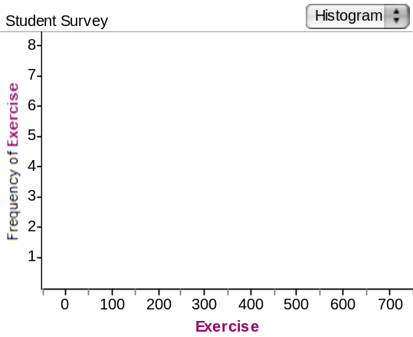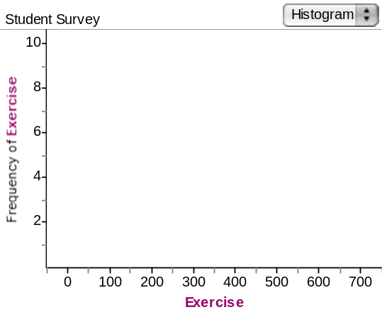

Which histogram do you like best? Explain.

Various explanations may be offered such as liking a larger bin width in order to see the shape better or having narrower bars to get a more accurate count of the number of minutes students reported exercising.

What is an advantage to having more bars?
With more bars, each bar represents a narrower interval of exercise times.

What is an advantage to having fewer bars?

Having fewer bars allows the outline of the distribution to be made more prominent.

Describe briefly what happens to the shape of the distribution as you create histograms with fewer bins and more bins.

The shape does not change dramatically. The size of gaps between bars and the number of gaps may increase when you have more bins, and the bars are much larger and taller with fewer bins.

Part II: Comparing Data Representations
Create a new set of data that has 10 values. Now, create each of the following four types of graphical representations. Draw each of them in the space provided.

- Case Value Plot (Note: In a case value plot each bar represents one data point and the height represents the value. Fathom will not create this graph.)

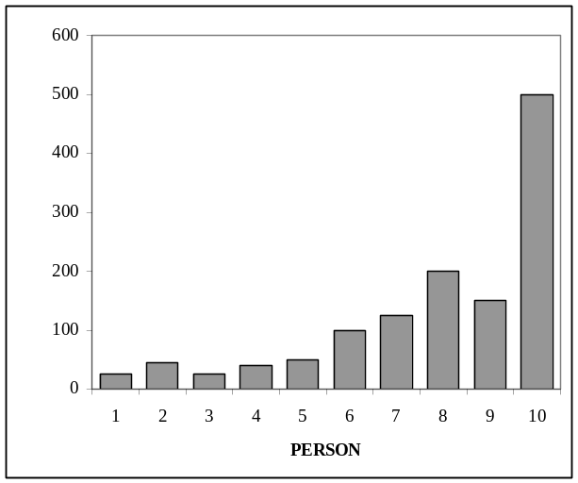

- Dot Plot

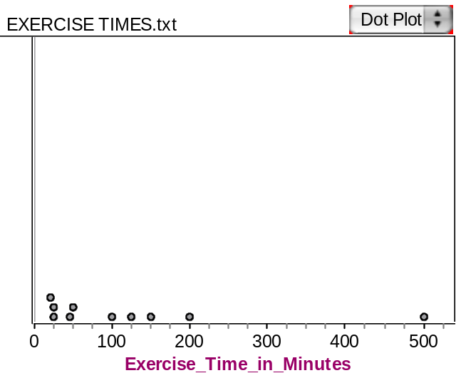
- Histogram
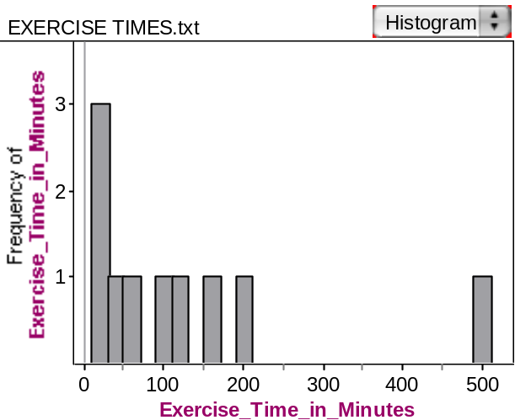

- Smooth Curve (Note: A smooth curve is a “smoothed” sketch of the general shape of the distribution. Fathom will not create this graph.)
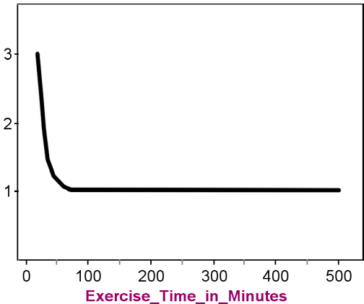

Use the four graphs you just created to help answer the following questions.

- Which graph(s) best helps you identify the individual cases?

Case Value Plot
- Which graph(s) best helps you see where “most” of the data are concentrated (to locate a central grouping or cluster)?

Dot Plot and Histogram
- Which graph(s) best helps you approximate the middle or typical value?

Histogram and Dot Plot

- Which graph(s) do not let you identify actual data values?

Histogram and Smooth Curve

- Which graph(s) best helps you see the spread or variability of the data?

Dot Plot, Smooth Curve and Histogram

- Which graph(s) help you identify the shape of the data?

Smooth Curve and Histogram

- What are the main differences between a case value plot and a histogram of the same data set?

The horizontal axis of the histogram represents the different lengths, not the different cases.

- Which is better for identifying individual cases, a case value plot or a histogram?

Case Value Plot

- Which is better for identifying the shape, center and spread of the data, a case value plot or a histogram?

Histogram
- Examine the axes for each of the four graphs. What is the same about the axes for the set of graphs? What is different?

The horizontal axes of the histogram, dot plot, and smooth curve represent the different lengths, not the different cases as in the case value plot. Similarly the vertical axes represent the frequency (count) of the number of cases with that length except for the case value plot, where the vertical axis represents the value of the case.

Reference

Garfield, J., Zieffler, A., & Lane-Getaz, S. (2005). EPSY 3264 Course Packet, University of Minnesota, Minneapolis, MN.

Please note the possible student answers may not, in some cases, be IDEAL student answers.

