Instructor’s Tinkerplots Demonstration Guide

Computer file:
TinkerPlots data file: Kneeling Heights.

Part 1: Display the Kneeling Heights Data in TinkerPlots

- Open the Kneeling Heights dataset in TinkerPlots.
In the plot window on the right, you will see a scattering of points (see Figure 1). Each point is called a case and represents one student in the data set. The “Data Cards” on the left side of the screen shows the different attributes (the TinkerPlots name for variables) in this data set. There are two attributes in this data set: Height and kneeling height ("Kneelht") measured both in centimeters.
- Select the attribute of interest (kneeling heights) by clicking on it in the Data Cards. When you select an attribute, the case icons in the plot are shaded based on this attribute. Mix up the cases on the screen using the circular arrows button at the bottom of the screen (). Notice there are no axes in this display, just a random arrangement of the 91 cases.
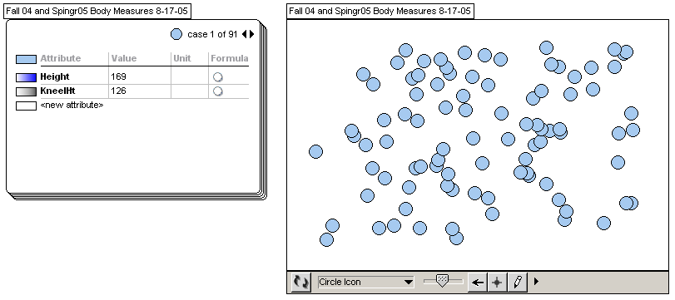
Figure 1: TinkerPlots’s Data Card and Plot window showing scattered cases

- Describe how color is being used in the representation you made, e.g., what the darker shades represent and what the lighter shades represent. Note: you may want to look through the cards of the individuals to see who is lighter and who is darker and how that corresponds to their kneeling height values.
E.g., When you select the kneeling heights attribute in the card (Figure 2), the icons in the plot are filled in with that attribute's color (gray). The shading goes from light to dark corresponding to short (light) to tall (dark) kneeling heights.

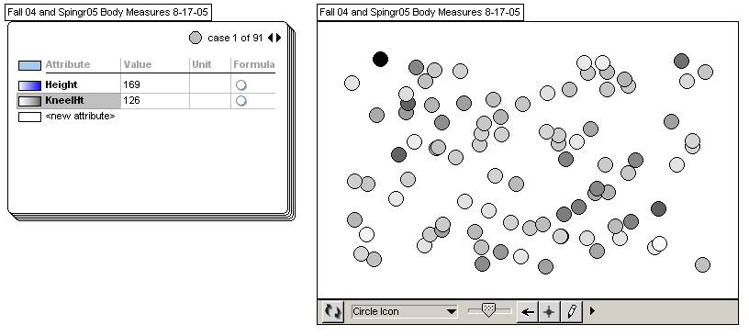
Figure 2: Card and kneeling heights scattered dots in TinkerPlots.

Part 2: Explore Different Representations of the Kneeling Heights Data

- Use TinkerPlots’ various tools to structure and organize the data graphically. Explore first with the three main data organization options: Separate, Order and Stack using the buttons on the top menu:
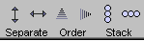

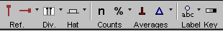

Reference Lines: You can add one or more reference lines to any kind of plot. You can use these to help you sight to a point on an axis, mark a critical cutoff point, or call attention to a particular part of the graph or case.
Dividers: You can use dividers on graphs with fully separated numeric attributes to divide the graph into sections. You can also use dividers along with counts or percents to see the number or proportion of cases in each section.

Part 3: Grouping the Data – Histogram

Now use the Separate button to separate the data into several height categories as described below.

- Mix up your plot.
Drag a case (a dot to the right until additional categories are created. Notice that the dots are automatically regrouped into groups that are more similar in kneeling height values, but that you still have some “mixing” of shade colors. Continue dragging the case to the right, subdividing the data points until you have more groups (or categories) that consist of primarily one color shade. Remember to UNDO (Ctrl+Z) any action that doesn’t take you where you expected to go!

Note: There are three ways to separate icons into groups: 1) drag an attribute name to an empty axis; 2) with an attribute selected, drag a case icon to the right or up; 3) with an attribute selected, click on of the Separate buttons in the top menu.

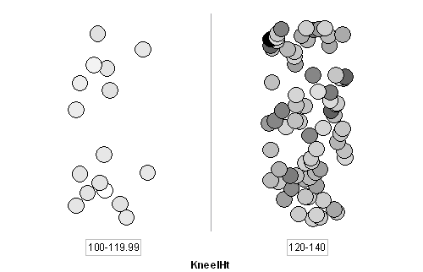 | 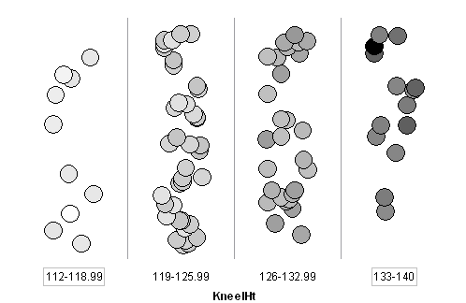
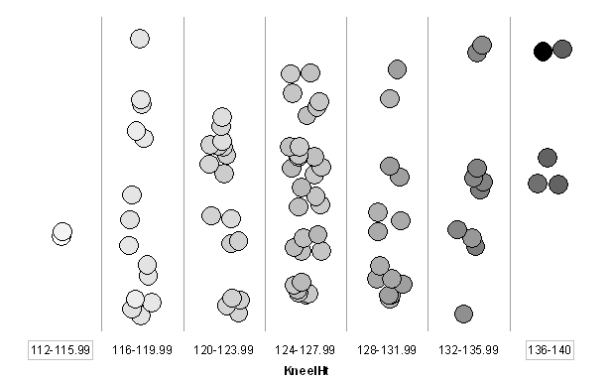
Figure 3: Three different grouping of the kneeling height data in TinkerPlots.

What does it mean that the colors are not exactly the same in each bin (group)?
There is variability in each bin: not all values (kneeling heights (are the same in that bin. Although we have simplified the graph into groups of about the same shared color, there is still variability within each group.

- Make the graph more readable by stacking the dots, using the vertical Stack button on the top menu (). This makes it easier to count how many cases are in each category Next, use the "n" button ("Case Count") in the top menu to add frequencies (number of cases in each interval).

Sample output:
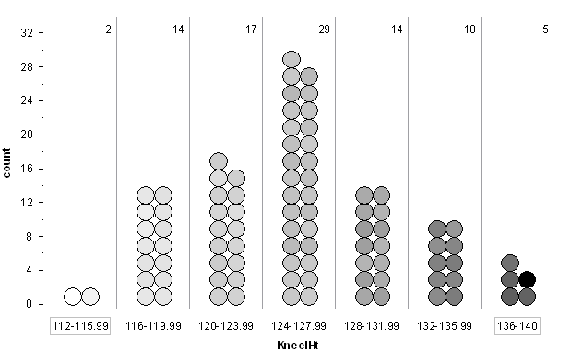
Figure 4: Stacked kneeling height data with frequencies noted in each interval in TinkerPlots.

- How many dots are displayed in the three middle groups of the kneeling heights distribution? In the five middle groups?
The three middle groups (120–131.99 cm) contain 60 out of 91 cases (66%).
The five middle groups (116–135.99 cm) contain 84 out of 91 cases (92%).

- Next, use the "Fuse Rectangular" feature to fuse the dots in each group into rectangles or bars to produce a histogram (as shown below).

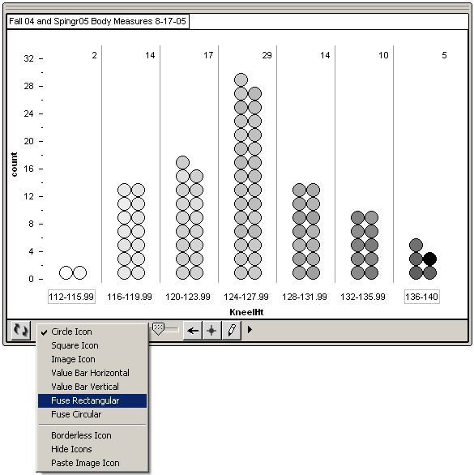
Figure 5: Creating a histogram plot in TinkerPlots by using the "Fuse Rectangular" option.

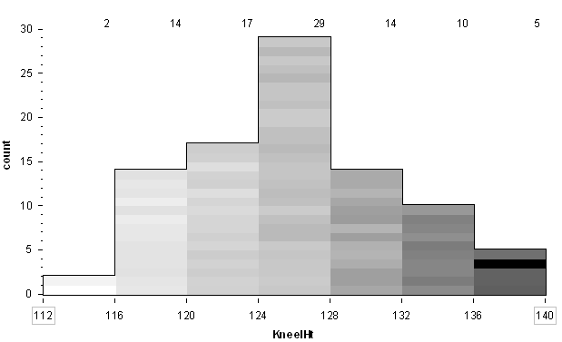
Figure 6: A histogram displaying the kneeling heights in seven bins in TinkerPlots.

The histogram spreads each case across the entire range of the bin it is in. The height of a bar corresponds to the number of data values it contains (Figure 6). Change the interval width by simply dragging the bin lines. Try this a few times to produce more bins and fewer bins.

- Describe what happens to the distribution shape as you create histograms with fewer bins and more bins.
E.g., When we had more bins (e.g., 10 bins), the distribution looked more symmetric. When we had only about four bins the distribution looked more left-skewed.

Part 5: Comparing Data Representations

Now let’s compare the types of representations we used to display the heights data.
How many ways could we display the same set of data in general?
- The random scatter of dots
- The separated columns of dots
- The fused vertical bars: histogram.

- Why might we use one representation rather than another to display data?
It depends on what we want to use the data for and what we want to look for in the data set. So the question we are asking about the data leads to the choice of a graph, and often we look at more than one graph to answer our questions.

Before using this demo, it is good to become familiar with the basic features of Tinkerplots Software. Please see the guide that comes with the software.

