Distinguishing Distributions

Below are a series of dot plots that depict the distributions of hypothetical exam scores in various classes.

- For classes A, B and C, what is the main characteristic that distinguishes these three graphs from each other? What might explain this difference?

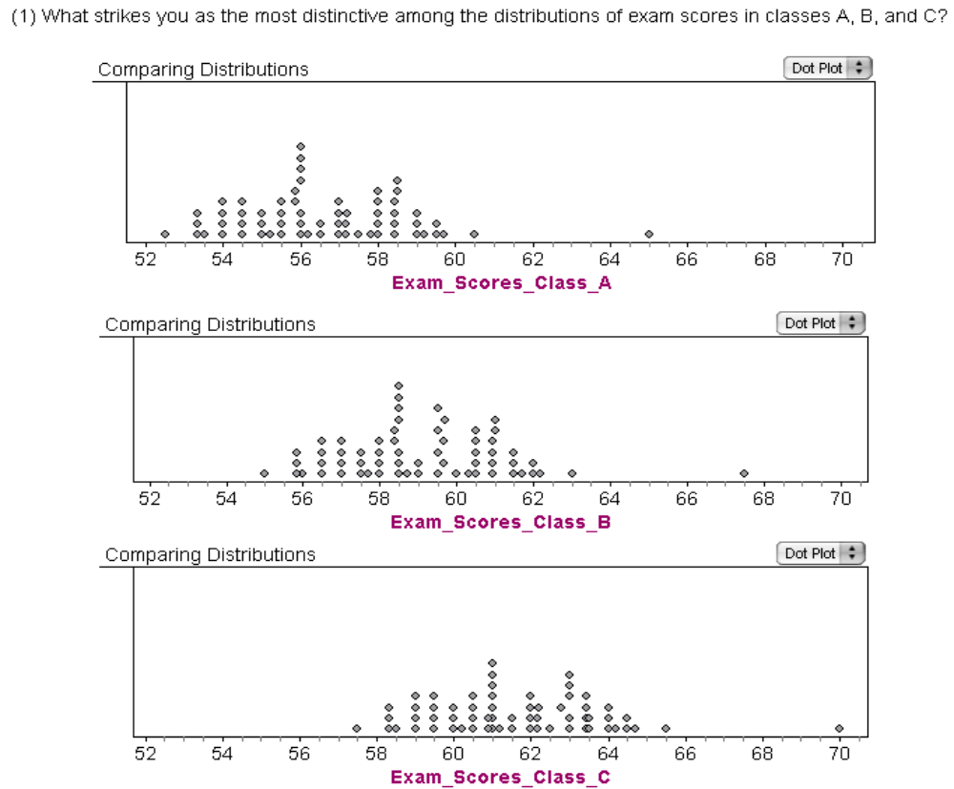

What is the main characteristic that distinguishes the distributions of exam scores in classes D, E, and F? What might explain these differences?

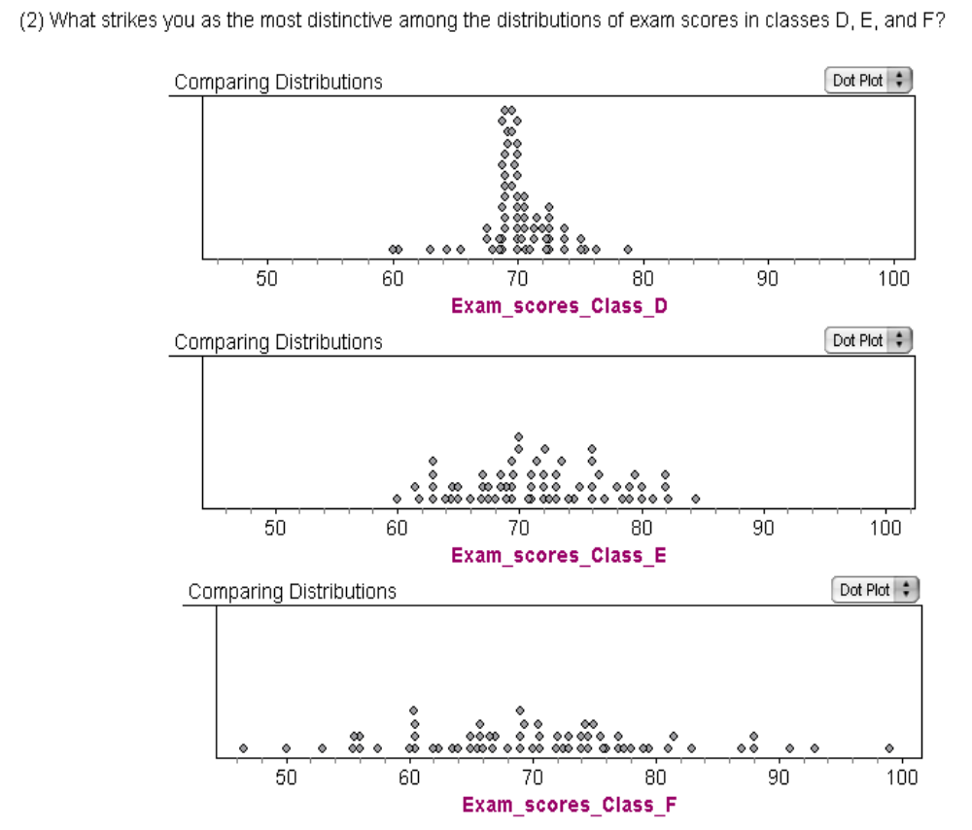

- What is the main characteristic that distinguishes the distributions of exam scores in classes G, H, and I? What might be an explanation for the distinguishing feature you find?

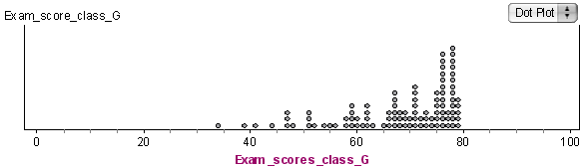

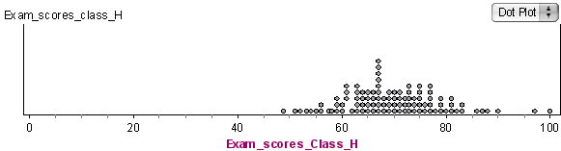

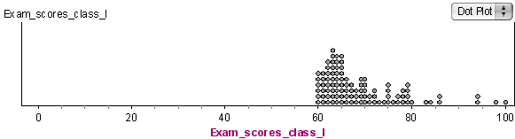

- What strikes you as the most distinctive features of the distribution of exam scores in class J? What might be an explanation for this characteristic?

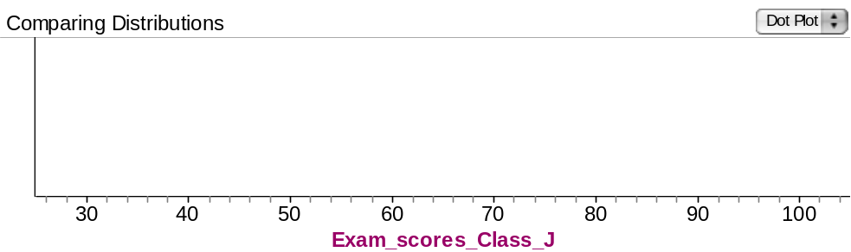

- What strikes you as the most distinctive feature of the distribution of exam scores in class K? What might be an explanation for this characteristic?

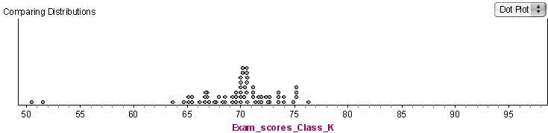

- What strikes you as the most distinctive feature of the distribution of exam scores in class L? What might be an explanation for this characteristic?

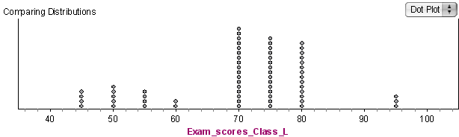

- Look again at the graph for class D. If you wanted to tell someone about how the students did on this exam, what would you say?

- What if we tried to look at the “bulk” of the data? Now, what would you say?

- What about the graph for class E?

- What if you were told that most exam scores for a class were between 65 and 85, and that the overall range of scores for that class was between 30 and 100? Can you imagine what that distribution would look like? Sketch it below.

- What features of a graph are important to examine when comparing distributions or describing a distribution?

Center, Spread and Shape.

- What characteristics might be present or absent, depending on the data set?

Skewness and outliers.

- What is a helpful strategy for looking at and describing a distribution to someone?

Describing the Center, Spread and Shape. Then looking for data that may not belong to this group: by examining gaps, clusters and/or outliers.

Reference

Rossman, A., & Chance, B. (2002). A data-oriented, active-learning, post-calculus introduction to statistical concepts, applications, and theory. In B. Phillips (Ed.), Proceedings of the Sixth International Conference on Teaching of Statistics, Cape Town. Voorburg, The Netherlands: International Statistical Institute. Retrieved September 28, 2007, from http://www.stat.auckland.ac.nz/~iase/publications/1/3i2_ross.pdf

