Matching Histograms to Variable Descriptions

Part I: Warm-Up Example
Below are two histograms (the scales have been left off intentionally). One corresponds to the age of people applying for marriage licenses, the other corresponds to the last digit of a sample of social security numbers. Label the horizontal axis of each graph with either AGE or LAST DIGIT, and write an explanation of why you made each choice.
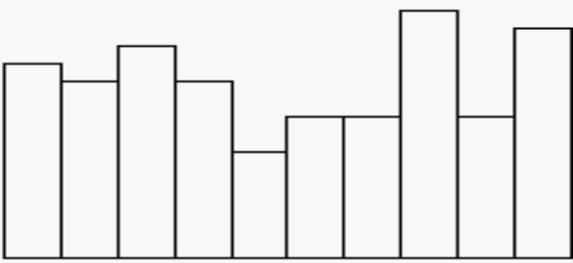
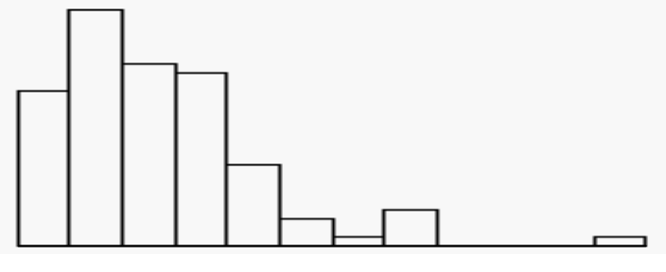

Part II
After completing the warm-up example, match each of the following variable descriptions with one of the histograms given below. Give your reason for each of your matches. You may find that your own knowledge may give you additional clues about the expected distribution of the variables. Discuss your answers and justifications with other students in your group.

(a) The height of college students in a class.

(b) Number of siblings of college students in a class.

(c) Amount paid for last haircut by college students in a class.

(d) Students’ guesses of their professor’s age on the first day of class.

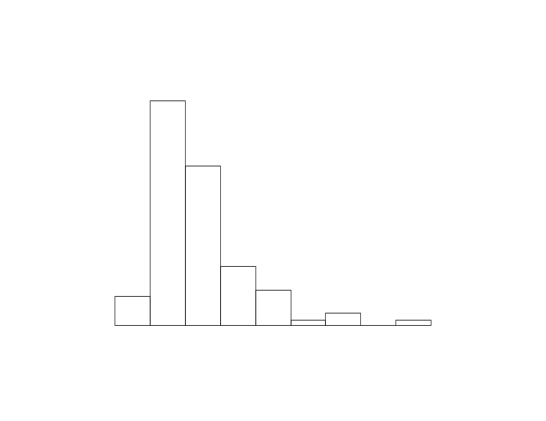 | 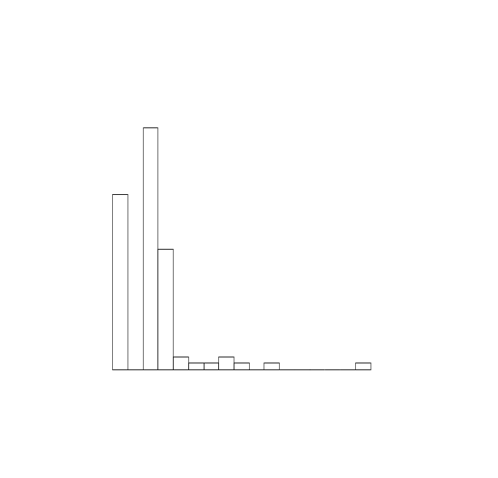
(1) | (2)
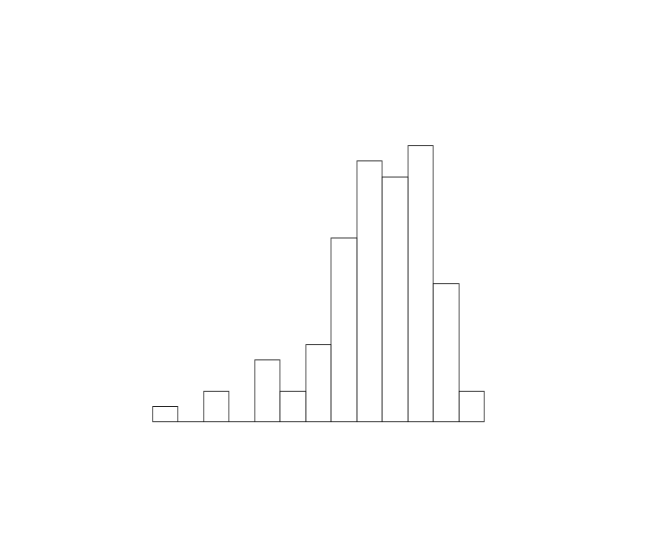 | 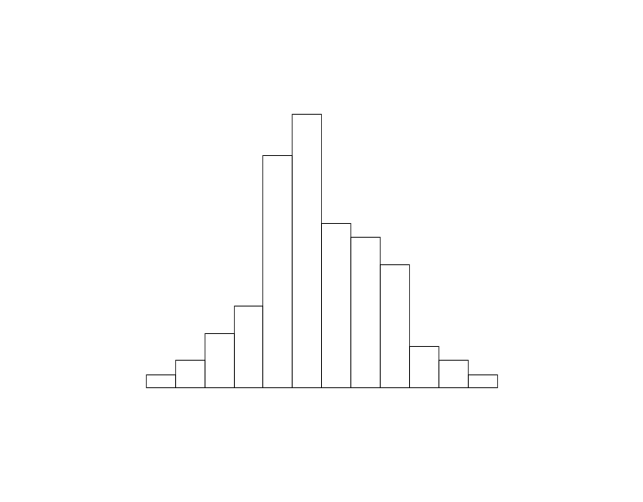
(3) | (4)

References

Rossman, A., Chance, B., & Lock, R. (2001). Workshop statistics: Discovery with data and Fathom. Emeryville, CA: Key College Publishing.

Scheaffer, R.L., Watkins, A. Witmer, J., & Gnanadesikan, M., (2004a). Activity-based statistics: Instructor resources (2nd edition, Revised by Tim Erickson). Key College Publishing.

