What does a Mean Mean?

Things to Think About
- Suppose the average age (mean) for students in the class is 21 years. Then what do we know about the distribution of students’ ages for this class (e.g., Are they all about 21 years old?)? Explain.

All the students could be about 21 or there could be a wide range of ages. For example, the mean age of 3 students who are 19, 21, 23 is 21, yet the 3 students are not all 21 years old.

- Where does that number (21) come from? Explain.

The number 21 comes from adding up all the ages of the students in the class and then dividing by the number of students in the class.

Part I: Post-It® Note Dot Plots

In your small group, you will take 10 Post-It® Notes and stack them on the Age Scale (p. 5) to form a dot plot according to the directions provided. Each dot plot will be created so that the 10 ages (Post-It® Notes) average to 21 years.

- Of course, the easiest way to do this is to stack them all above the value of 21. If we do this first, what does the plot look like in terms of shape, center, and spread?

The plot will be unimodal centered at 21 years and there would not be any spread.

- Move one Post-It® Note to 24 years. How can you move one or more of the other Post-It® Notes so that you keep the mean at 21 years? Is there more than one way to do this? Explain.

By moving one Post-It® Note 3 years up to 24 years, we can ensure that the mean stays at 21 years by moving another Post-It® Note 3 years down to 18. There are many ways to keep the mean at 21, for example moving three Post-It® Notes 1 year down. The idea is to make sure that the sum of the years of all the Post-It® Notes up from 21 years is the same as the sum of the years of all the Post-It® Notes down from 21 years.

- Next, move one Post-It® Note to 17 years. Describe what else you had to do to keep the mean at 21 years.

One way would be to move another Post-It® Note to 25 years.

- Next, move all the Post-It® Notes so that none of the ages are 21 years, yet the mean age is still 21 years. Describe what you did.

We can apply the principle outlined in 2 above, to make sure that the sum of the years of all the Post-It® Notes up from 21 years is the same as the sum of the years of all the Post-It® Notes down from 21 years.

Part II
Draw graphs of two different dot plots below such that:
- Each graph has 10 values (10 dots).
- The mean of the values in each dot plot is 21.
- One dot plot has a little spread and the other dot plot has a lot of spread.

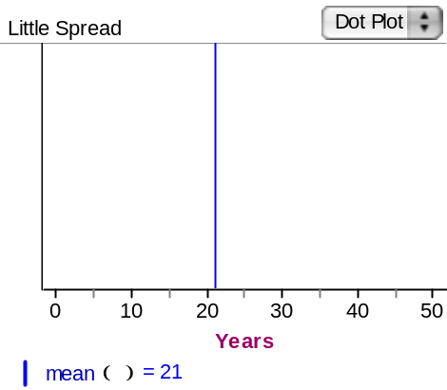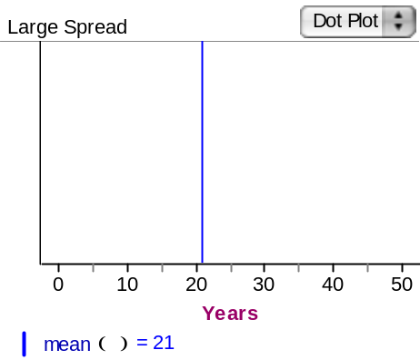

Things to Consider
- What strategies did you use to keep a mean of 21 in each plot?

I made sure that the sum of the years of all the years above 21 years is the same as the sum of the years of all the years below 21 years.

- Was it important to pay attention to the distance of each Post-It® Note from the mean value of 21? How did this help you to keep the mean of 21 years?

Yes. This is the way to keep the mean value at 21 years.

Part III

We will use the term “deviation” to represent the distance of each data value from the mean. This can also be viewed as the number of units to the left or right of the mean for each data value.

- Look at your last Post-It® Note plot, and write down the deviations for each data point on the graph.

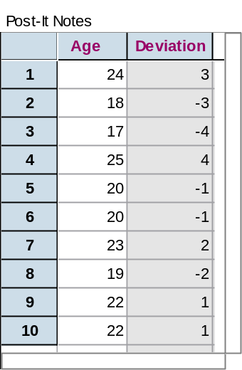
- If you change one value so it has a deviation of -3, what do you have to do one or more values to keep the mean at 21 years?

You have to make sure that the sum of one or more values you change have deviations that add up to +3.

Reference
Garfield, J., Zieffler, A., & Lane-Getaz, S. (2005). EPSY 3264 Course Packet, University of Minnesota, Minneapolis, MN.

18 19 20 21 22 23 24

Age

Please note the possible student answers may not, in some cases, be IDEAL student answers.

