What does a Median Mean?

Part I

Let’s go back to the Post-It® Notes. This time, only use 9 of them.

- Arrange them on the plot (p. 36) so that the median is 21 years. What did you have to do to achieve a median of 21?

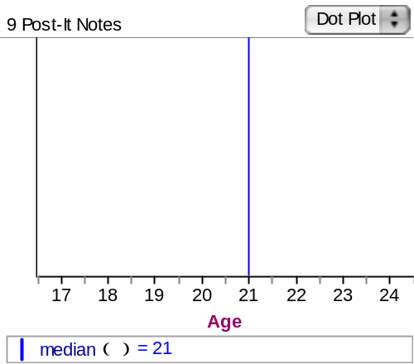

I made sure that the 5th Post-It® Note lies on 21 years.

- Now change one of the values that is currently higher than 21 years. If you move it higher or lower than it is right now, but keep the value higher than 21 years, is the median affected? Explain.

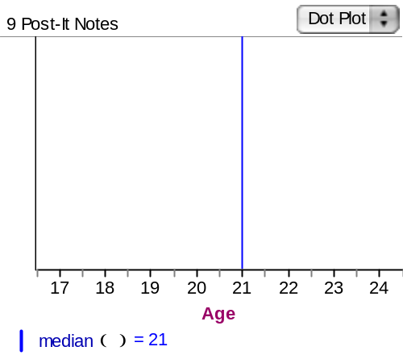

The median is not affected since the position of the 5th Post-It® Note has not changed.

- Now move all of the values that are above 21 years so that each one has a higher value than it does currently. Did this have any effect on the median? Explain.

No. Again, the position of the 5th Post-It® Note has not changed.

- Now move all of the values that are lower than 21 years so that each one has a lower value than it does currently. Did this have any effect on the median? Explain.

No. Again, the position of the 5th Post-It® Note has not changed.

- What would you have to do with a data value to change the median? Explain.

You could either move the position of the 5th Post-It® Note or you can move one of the Post-It® Notes up or down past the5th Post-It® Note. There are many other possibilities.

Things to Consider
- What factors affect the median for a data set? Using our set of 9 Post-It® Notes, under what conditions does the median change or stay the same?

The median would not change if other data points are not moved past the 5th Post-It® Note. Otherwise, the median could change.

- What would change if we used 10 Post-It® Notes and tried to find the median?

We would average the values of the 5th and 6th Post-It® Notes.

- What are the properties of the median? How do those differ from properties of the mean?

The median indicates the value of the middle data point when the data is ordered numerically for an odd-numbered data set or the average value of the two middle data points for an even-numbered data set. The computation of the median does not need to take into account the actual values of the other values in a data set, but tends to focus on just the middle of the ordered data set. In contrast, we need to weight every data point equally when computing the mean.

- When does a median seem to be a better measure of what is typical about a data set?

The median may be more appropriate when a data set has atypically high or low outliers.

- If we think of the mean as a “balance point” of the deviations, what would the median balance?

The median would represent the balance point for the number of data points above and below.

Reference
Garfield, J., Zieffler, A., & Lane-Getaz, S. (2005). EPSY 3264 Course Packet, University of Minnesota, Minneapolis, MN.

Please note the possible student answers may not, in some cases, be IDEAL student answers.

