What is Typical?

Part I: Making Predictions
For each of the following variables measured on the Student Survey (your section), work in pairs to make a prediction for a typical value for all students enrolled in your statistics class this term. A typical value is a single number that summarizes the class data for each variable.

- Write that prediction in the First Prediction column.

Attribute from Student Survey | First Prediction | Revised Prediction | Statistics from Fathom
Attribute from Student Survey | First Prediction | Revised Prediction | Mean | Median
Age | 25 | 24 | 22.78 | 21
Number of statistics courses you are taking this semester | 1 | 1 | 1 | 1
Credits registered for this semester | 14 | 16 | 15.29 | 16
Total college credits completed | 70 | 75 | 76.32 | 65
Cumulative GPA | 3.0 | 3.2 | 3.12 | 3.15
Hours a week you study | 20 | 15 | 13.7 | 13
Number of emails you send each day | 5 | 2 | 2.45 | 2
Number of emails you receive each day | 10 | 5 | 7.05 | 5

Open the student survey data for your section from the course website. Now use Fathom to create dot plots of each variable to see if your original predictions seem reasonable. Based on the graphs, make revised predictions for the typical value for each of the variables.

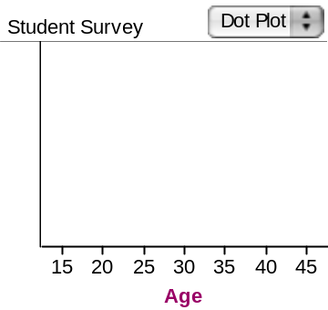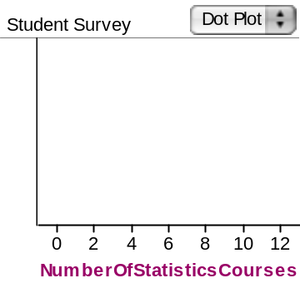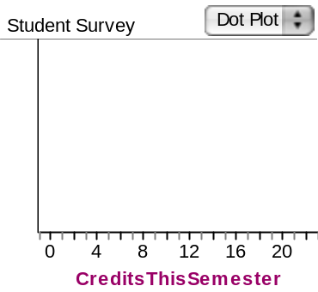
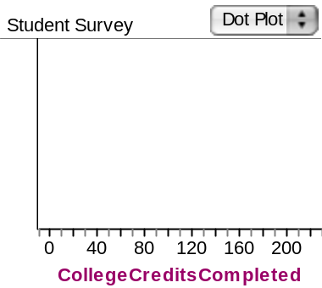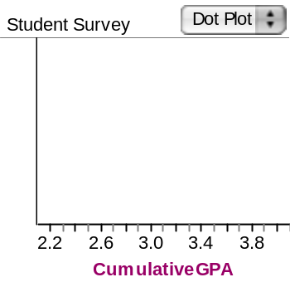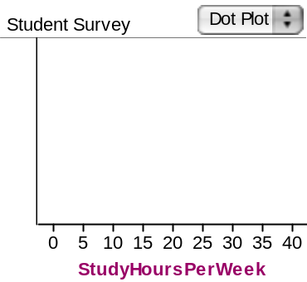
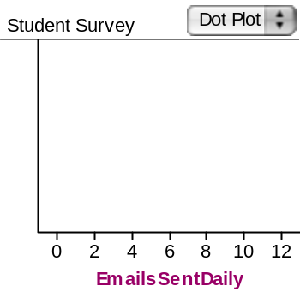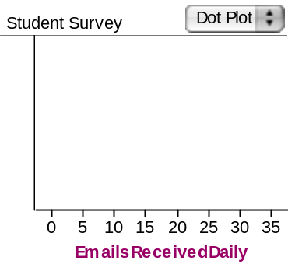

- Write these new predictions in the Revised Prediction column.

Shown in the table above.

Part II: Test Your Conjectures
Use Fathom to find the mean and median for each of these variables. (Follow the directions below.)

- Grab a Summary Table from the shelf (a spreadsheet with an “S” in it).
- Drag and drop each of the attributes you are interested in over an arrow in the Summary Table. The mean values are displayed automatically.
- To add the median, right-click on the Summary Table and type Median() in the formula editor. (See screen shots for an example.) The median values appear under the mean values in the Summary Table.

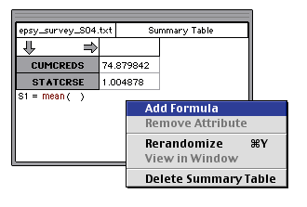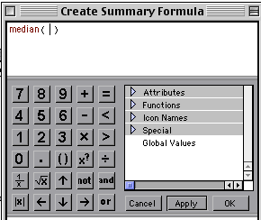

- Fill in the values for the mean and median in the last two columns of the table above.

Shown in the table above.

- How close were your revised predictions to the “typical” values produced in Fathom? For which attributes were your predictions most accurate?

My revised values were quite close to the “typical” values produced in Fathom. For the following attributes, my predictions were quite accurate:
- Number of statistics courses you are taking this semester
- Credits registered for this semester
- Total college credits completed
- Cumulative GPA
- Hours a week you study
- Number of emails you send each day

- What was most surprising to you? Why?

I was surprised at how few hours people devote to studying each week because I need to study much more than that.

- In general, were your revised predictions closer to the means or medians?

In general, my revised predictions were closer to the means.

Things to Consider
- How close were your predicted typical values?

Except for the attribute “Number of emails you receive each day”, my revised predictions are within 1.5 of the means. For 4 of the variables, my revised prediction is exactly the same as the medians.

- Which measure of center were your guesses closer to, the mean or median?

In general, I was closer to the mean for most of the attributes, but for 4 attributes my revised prediction was exactly the median.

- What information do means and medians tell us about a distribution?

The mean tells us the average value of all the data in a data set whereas the median gives us the middle data value (or the average of the two middle values if there is an even number of data points) in a data set.

- How do we decide whether to use the mean or median to summarize a data set?

This would depend on the purpose of using a number to summarize a data set and the context. For instance, to summarize ticket sales at a movie theater for a whole month, we may choose to use the mean if there were no special events. If for instance, the theater had an opening night with a lot of celebrities, and there is a lot of publicity surrounding that movie, then the average will not reflect the typical attendance at the movie theater. In the latter case, the median may be a more appropriate measure to use to summarize ticket sales for the month.

- In statistics, what do we mean by what is typical?

Typical can refer to either the mean, median or mode in most cases in statistics.

Reference
Garfield, J., Zieffler, A., & Lane-Getaz, S. (2005). EPSY 3264 Course Packet, University of Minnesota, Minneapolis, MN.

Please note the possible student answers may not, in some cases, be IDEAL student answers.

