What is Typical?

Part I: Making Predictions
For each of the following variables measured on the Student Survey (your section), work in pairs to make a prediction for a typical value for all students enrolled in your statistics class this term. A typical value is a single number that summarizes the class data for each variable.

- Write that prediction in the First Prediction column.

Attribute from Student Survey | First Prediction | Revised Prediction | Statistics from Fathom
Attribute from Student Survey | First Prediction | Revised Prediction | Mean | Median
Age
Number of statistics courses you are taking this semester
Credits registered for this semester
Total college credits completed
Cumulative GPA
Hours a week you study
Number of emails you send each day
Number of emails you receive each day

Open the student survey data for your section from the course website. Now use Fathom to create dot plots of each variable to see if your original predictions seem reasonable. Based on the graphs, make revised predictions for the typical value for each of the variables.

- Write these new predictions in the Revised Prediction column.

Part II: Test Your Conjectures
Use Fathom to find the mean and median for each of these variables. (Follow the directions below.)

- Grab a Summary Table from the shelf (a spreadsheet with an “S” in it).
- Drag and drop each of the attributes you are interested in over an arrow in the Summary Table. The mean values are displayed automatically.
- To add the median, right-click on the Summary Table and type Median() in the formula editor. (See screen shots for an example.) The median values appear under the mean values in the Summary Table.

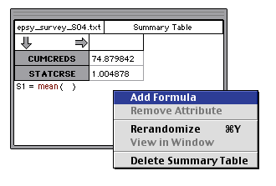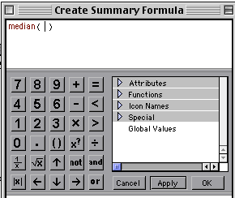

- Fill in the values for the mean and median in the last two columns of the table above.

- How close were your revised predictions to the “typical” values produced in Fathom? For which attributes were your predictions most accurate?

- What was most surprising to you? Why?

- In general, were your revised predictions closer to the means or medians?

Things to Consider
- How close were your predicted typical values?

- Which measure of center were your guesses closer to, the mean or median?

- What information do means and medians tell us about a distribution?

- How do we decide whether to use the mean or median to summarize a data set?

- In statistics, what do we mean by what is typical?

Reference
Garfield, J., Zieffler, A., & Lane-Getaz, S. (2005). EPSY 3264 Course Packet, University of Minnesota, Minneapolis, MN.

