What makes the standard deviation larger or smaller?

Part I
Before we begin the attached worksheet, we are going to think about the meaning of typical, or standard, deviation from the mean. First, examine the following dot plot which has the mean marked in the plot. Think about how large the deviations would be for each data point (dot).
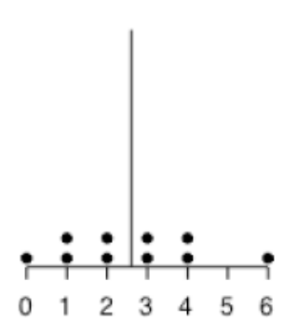
Next we will draw in each deviation from the mean.
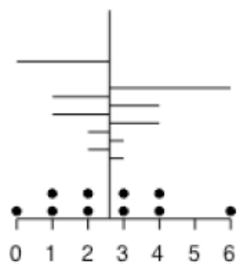

Now, think about the average size (length) of all of those deviations, and use this as an estimate for the size of the Standard Deviation. Don’t worry about whether the deviation is to the left or right of the mean. Just consider all of the lengths. Draw the length of the standard deviation below.

Based on the scale in the graph, estimate a numerical value for the length of the line you drew above.
My estimate is 1.5.
Repeat the process with this dot plot to help you draw and estimate the length of the standard deviation.
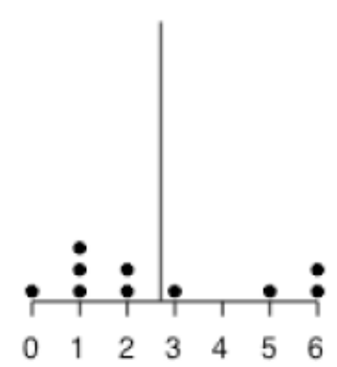

It looks like the length of the standard deviation is about 2.

Now, try to draw and estimate the length of the standard deviation with the following histogram. The mean of the scores is 2.5. (Hint: Sketch in the appropriate number of dots in each bar of the histogram to make sure you have the appropriate number of deviations.)
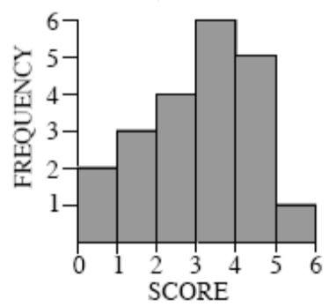

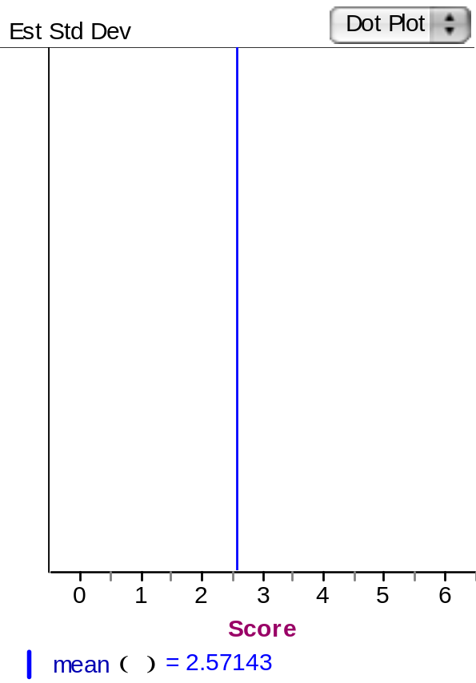

It looks as if the length of the standard deviation for the histogram is about1.5.

Part II: Comparing Standard Deviations

Below, you will find five pairs of graphs. The mean for each graph (μ) is given just above each histogram. For each pair of graphs presented,
- Indicate which one of the graphs has a larger standard deviation or if the two graphs have the same standard deviation.
- Explain why. (Hint: Try to identify the characteristics of the graphs that make the standard deviation larger or smaller.)

1. | A μ = 1.93 B μ = 2.00  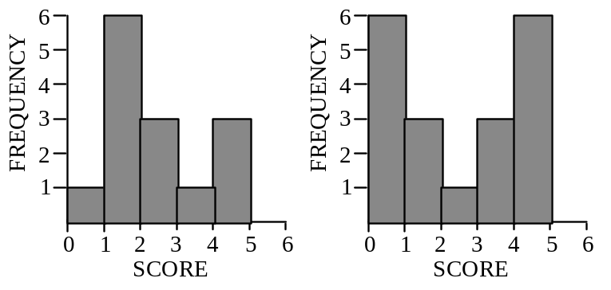 | A has a larger standard deviation than B  B has a larger standard deviation than A  Both graphs have the same standard deviation

Explain.

2. | A μ = 5.33 B μ = 5.48  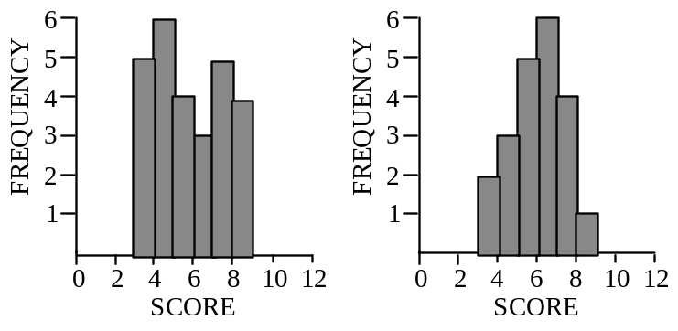 | A has a larger standard deviation than B  B has a larger standard deviation than A  Both graphs have the same standard deviation

Explain.

3. | A μ = 5.43 B μ = 5.57  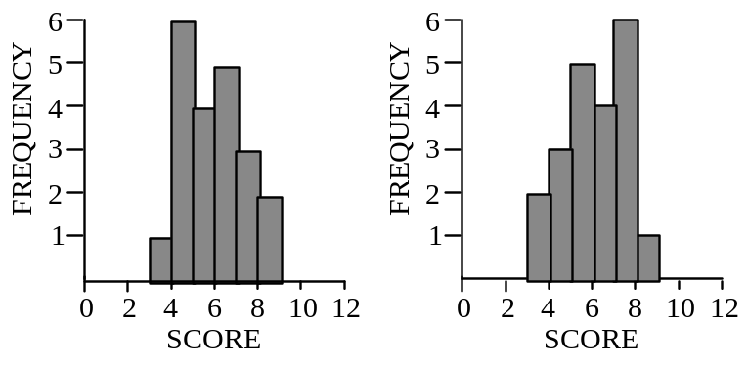 | A has a larger standard deviation than B  B has a larger standard deviation than A  Both graphs have the same standard deviation

Explain.

4. | A μ = 2.50 B μ = 2.56  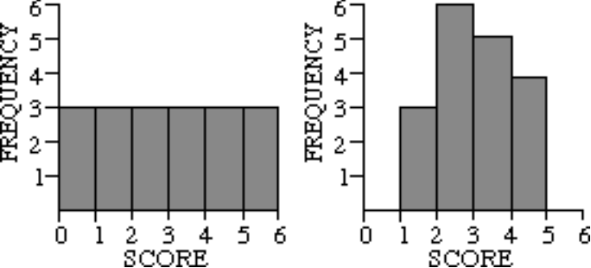 | A has a larger standard deviation than B  B has a larger standard deviation than A  Both graphs have the same standard deviation

Explain.

5. | A μ = 2.50 B μ =2.50  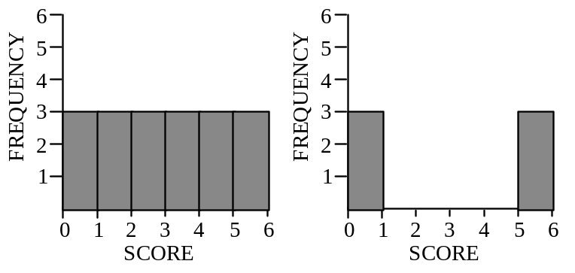 | A has a larger standard deviation than B  B has a larger standard deviation than A  Both graphs have the same standard deviation

Explain.

Reference
delMas, R.C. (2001b). What makes the standard deviation larger or smaller? STAR library. Retrieved October 21, 2007, from http://www.causeweb.org/repository/StarLibrary/activities/delmas2001/

Please note the possible student answers may not, in some cases, be IDEAL student answers.

