Gummy Bears

We are going to study variability by conducting an experiment on gummy bears! You will launch gummy bears using tongue depressor and a rubber band, and will measure the distances that they travel. We will compare distances for two different conditions to try and answer the following research question:

Will gummy bears travel a farther distance if they are launched from a steeper height or a lower height? (A stack of 4 books or one book).

Part I
You will be assigned, using randomization, to a group that will gather data for one of the two conditions. Why do we use randomization?

This ensures that we can eliminate group as a variable that influences the results.
Record the data for each of 10 trials for your group in the table below:
Launch Condition (circle one): 1 Book 4 Books

Launch | 1 | 2 | 3 | 4 | 5 | 6 | 7 | 8 | 9 | 10
Distance  (inches) | 4 | 8 | 24 | 29 | 27 | 16 | 11 | 17 | 26 | 42

Find the mean distance the gummy bear traveled for your data: 20.4 inches
sample mean = 20.4 inches

Plot your mean on the board for the graph that corresponds to the appropriate condition (1 or 4 books).

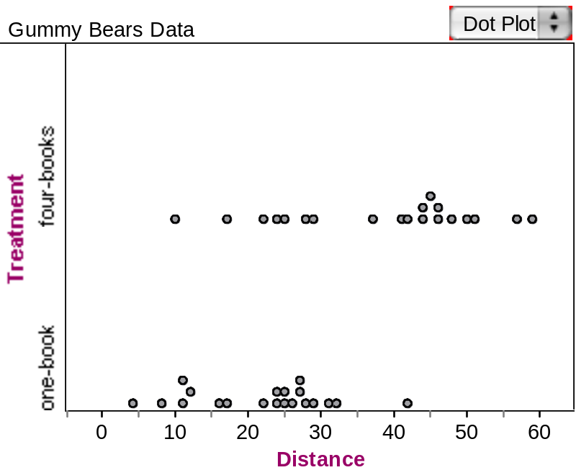

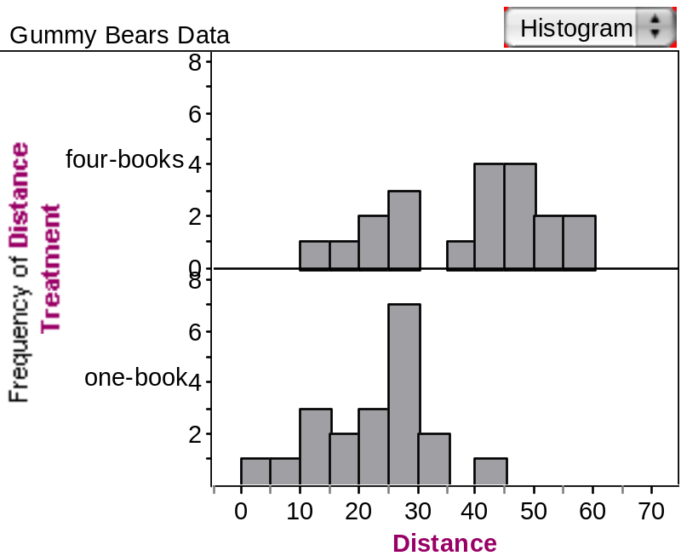

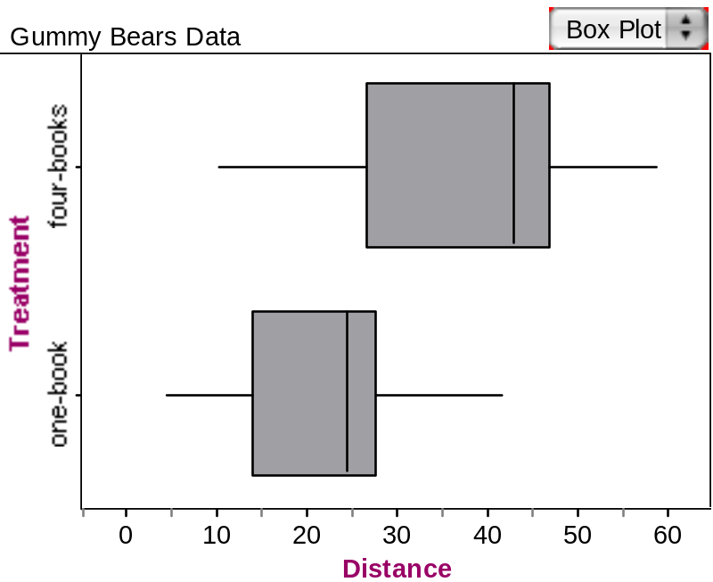

Things to Consider
- How can we summarize the difference in distances between the two conditions?

- Is there variability in the measurements for one condition? How do we show that variability?

- Is there variability between the two groups (conditions)? How do we look at and describe that variability?

- Why did we get different sample means for each group within a condition?

- We often talk about signal and noise when analyzing data resulting from a repeated process. What represents the signal and what represents the noise for each condition?

- How could we get the signal clearer? What would we have to do? (e.g., Add more teams to each condition? Have each team launch more bears?)

- If we made a plot of the sample means from each group, how much variability would you expect to see in the distribution? Why?

- Based on our experiment, are we willing to say that a steeper launch ramp caused the gummy bears to go farther? What are important parts of an experiment that are needed in order to show causation?

Reference

Scheaffer, R.L., Watkins, A., Witmer, J., & Gnanadesikan, M. (2004a). Activity-based statistics: Instructor resources (2nd edition, Revised by Tim Erickson). Key College Publishing.

Please note the possible student answers may not, in some cases, be IDEAL student answers.

