Comparing Box Plots

Examine the following box plots to help compare the number of raisins per box for two different brands. All boxes of raisins from both brands were ½ ounce boxes.

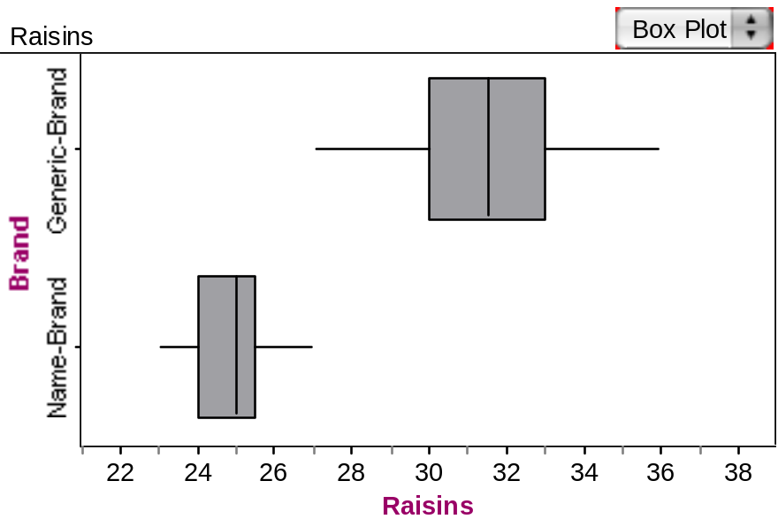

Part I: Comparing the two distributions

- Compare the two measures of center between the two brands. How does the typical number of raisins per box for one brand compare to the other brand? Explain.

The box plot at the top (let’s suppose it represents Brand A) has a median of about 31.5 and a mean of about 31.5 too since the box plot is symmetrical. The box plot on the bottom (let’s say it represents Brand B) has median of about 25.0 and a mean of about 24.5 since the box plot tells us that the distribution is skewed to the left.

The typical number of raisins per box for Brand A is about 5 more than for Brand B when we use our measures of center as a basis for comparison.

- Compare the variability between the two brands. How does the middle 50% of the data differ between the two brands? How about the ranges? Explain.

Brand A looks to have more variation because both the box and the whiskers are longer than the box and whiskers for Brand B. The middle 50% of the data is represented by the width of the box. Thus, for Brand A we know that the middle 50% of the ½ ounce boxes of raisins has between 30 and 33 raisins per box. For Brand B, the middle 50% of the ½ ounce boxes of raisins has between 24 to 26 raisins per box. Brand B is less variable when we look at the middle 50% of the data.

The range for Brand A is 36 – 27 = 9 while the range for Brand B is 27 – 23 = 4. Brand B has a smaller range.

- Which brand of raisins would you prefer to purchase? Why? Be sure to use the statistical and graphical evidence to justify your decision.

If both brands cost the same and because I like a larger number of raisins, I would prefer to buy Brand A because it seems that we can rely on Brand A to have more raisins per ½ ounce box than a comparable size of Brand B. I can make this conclusion based on comparing the median, middle 50% and the range for the two brands. Brand A has a larger number on each of these 3 measures.

- These Box Plots represent a sample of the boxes of raisins from the two different brands. What do you believe about the population of boxes of raisins from these two brands in general? What is the typical number of raisins per box for these companies? How about their consistency in putting the similar numbers of raisins per box? Explain.

If this sample of boxes of raisins from Brands A and B is a fair representation of the boxes of raisins from those brands in general, then based on our sample, we have good reason to believe that Brand A will tend to have more raisins in a ½ ounce box than Brand B.

From our data, the “typical” number of raisins per box (as measured by the median) for Brand A is 31.5 while for Brand B, it is only 25.

Brand B seems to be more consistent in putting similar numbers of raisins per box. This is because we measure consistency by the spread of the data: the middle 50% and the range for Brand A is more than that for Brand B in our sample.

Part II: Gummy Bears

Will gummy bears travel a farther distance if they are launched from a steeper height or a lower height (a stack of four books or one book)? We will try to answer this research question by examining and comparing a sample of launch distances from each of the two treatments (one book and four books).

- Open the gummybears.ftm data from the course website. Create graphs that will allow you to compare the data from the two groups. Be sure you compare the typical distance traveled, as well as the variability for the two treatments.

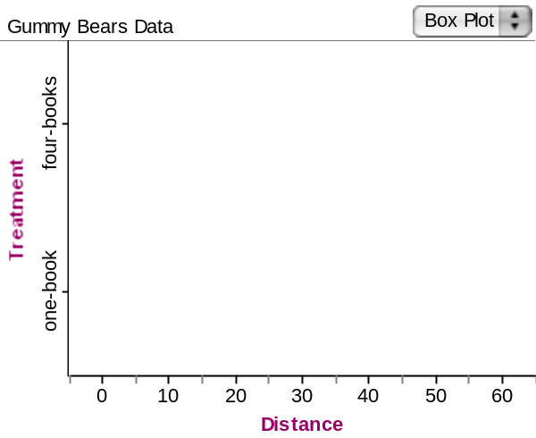

I have created side-by-side box plots for the two treatments against a common scale for the distance traveled by the gummy bears.

For launches from a stack of four books, we can see from the box plot that the median distance traveled is 43, the middle 50% of distances traveled lie between 26.5 and 47 while the range of distance traveled is 59 – 10 = 49.

When launched from a lower height, elevated by only one book, the median distance traveled is 25, the middle 50% of distances traveled are between 14 and 27.5, and the range of distance traveled is 42 – 4 = 38.

On all 3 measures, the “typical” distance, the middle 50% and the range traveled for the gummy bears when launched from a stack of four books is larger when compared to the distance the gummy bears traveled when launched from just one book.

- Use your comparisons to help provide an answer to the research question: Will gummy bears travel a farther distance if they are launched from a steeper height or a lower height?

It seems that gummy bears do travel further if they are launched from a steeper height (in this case a stack of four books) when we look at the median distance traveled. However, gummy bears launched from a stack of four books tend to vary more in the distance traveled when compared to gummy bears launched from just one book. This means that we cannot always say that gummy bears launched from a steeper height will always travel farther. It is just that we expect those gummy bears to travel further when we consider our data.

Reference

Garfield, J., Zieffler, A., & Lane-Getaz, S. (2005). EPSY 3264 Course Packet, University of Minnesota, Minneapolis, MN.

Please note the possible student answers may not, in some cases, be IDEAL student answers.

