How many raisins in a box?

Part I

What does each dot in the plot represent?

How many boxes of raisins are there for each of the two brands?

Name-Brand: ________ Generic-Brand: ________

After the instructor has put the hat plot over the data for the Name-Brand and the Generic-Brand, fill in the table below to indicate how many boxes of raisins appear in each of the three different parts of the hat-plots for the two brands of raisins?

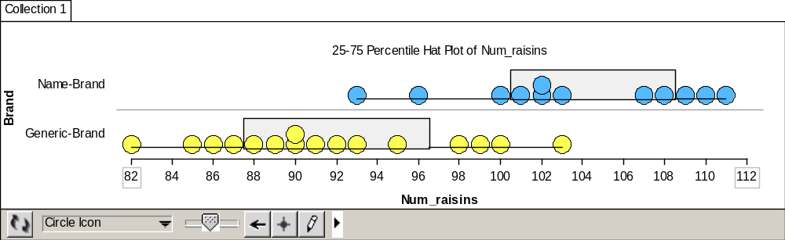

COUNTS | Left “Brim” of Hat | In the Hat | Right “Brim” of Hat
Name-Brand
Generic-Brand

Next, use the counts from the previous table to fill in the table below with the percentages of the data that is in each part of the hat-plots for both brands.

PERCENTS | Left “Brim” of Hat | In the Hat | Right “Brim” of Hat
Name-Brand
Generic-Brand

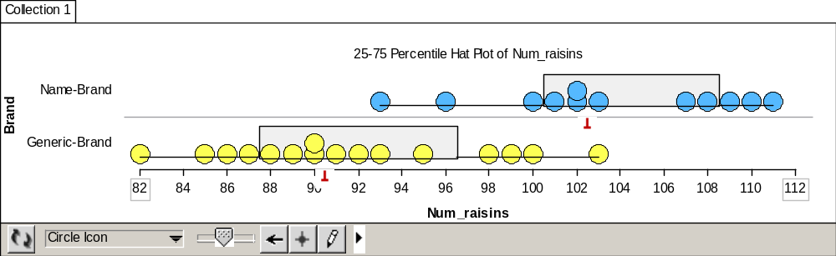

COUNTS | Left of the Median | Right of the Median
Name-Brand
Generic-Brand

COUNTS | Left of the Median In the Hat | Right of the Median In the Hat
Name-Brand
Generic-Brand

Next, use the counts from the previous table to fill in the table below with the percentages of the data that is in each part of the hat-plots for both brands.

PERCENTS | Left of the Median In the Hat | Right of the Median In the Hat
Name-Brand
Generic-Brand

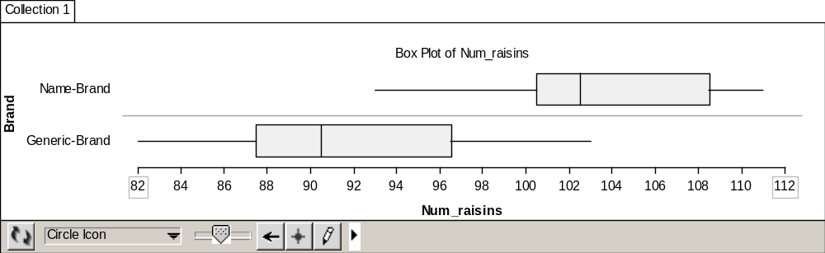

What percentage of the Generic-Brand raisins contains more than 95 raisins?

How many actual boxes of raisins is that? Can you tell by examining the Box Plot, without the data being shown?

How many boxes of the Name-Brand raisins have fewer than 96 raisins?

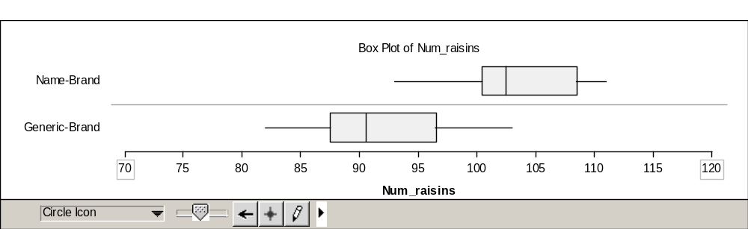

Part II: Questions About Box Plots

What percentage of all boxes of raisins is represented inside the box of the Box Plot?

What percentage of all boxes of raisins is represented inside the box, but to the left of the median in the Box Plot?

What percentage of all boxes of raisins is represented inside the box, but to the right of the median in the Box Plot?

What percentage of all boxes of raisins is represented in the left whisker of the Box Plot?

What percentage of all boxes of raisins is represented in the right whisker of the Box Plot?

Reference

Garfield, J., Zieffler, A., & Lane-Getaz, S. (2005). EPSY 3264 Course Packet, University of Minnesota, Minneapolis, MN.

