Comparing Box Plots

Examine the following box plots to help compare the number of raisins per box for two different brands. All boxes of raisins from both brands were ½ ounce boxes.

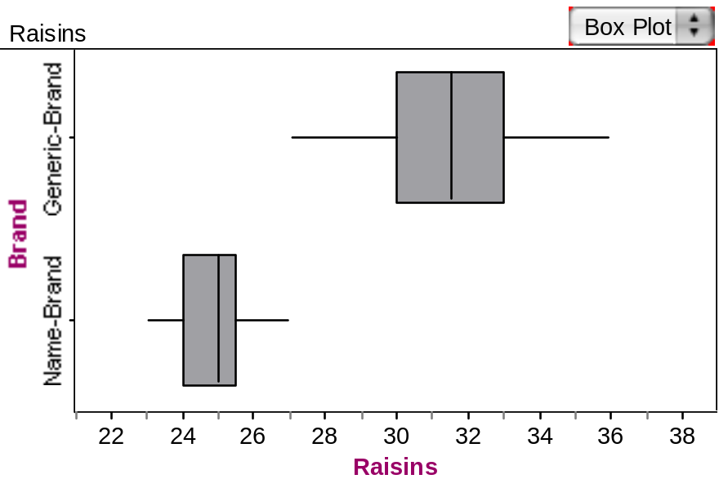

Part I: Comparing the two distributions

- Compare the two measures of center between the two brands. How does the typical number of raisins per box for one brand compare to the other brand? Explain.

- Compare the variability between the two brands. How does the middle 50% of the data differ between the two brands? How about the ranges? Explain.

- Which brand of raisins would you prefer to purchase? Why? Be sure to use the statistical and graphical evidence to justify your decision.

- These Box Plots represent a sample of the boxes of raisins from the two different brands. What do you believe about the population of boxes of raisins from these two brands in general? What is the typical number of raisins per box for these companies? How about their consistency in putting the similar numbers of raisins per box? Explain.

Part II: Gummy Bears

Will gummy bears travel a farther distance if they are launched from a steeper height or a lower height (a stack of four books or one book)? We will try to answer this research question by examining and comparing a sample of launch distances from each of the two treatments (one book and four books).

- Open the gummybears.ftm data from the course website. Create graphs that will allow you to compare the data from the two groups. Be sure you compare the typical distance traveled, as well as the variability for the two treatments.

- Use your comparisons to help provide an answer to the research question: Will gummy bears travel a farther distance if they are launched from a steeper height or a lower height?

Reference

Garfield, J., Zieffler, A., & Lane-Getaz, S. (2005). EPSY 3264 Course Packet, University of Minnesota, Minneapolis, MN.

