Interpreting Boxplots

Part I

The following graph shows the distribution of ages for 72 recent Academy Award winners split up by gender (36 females and 36 males).
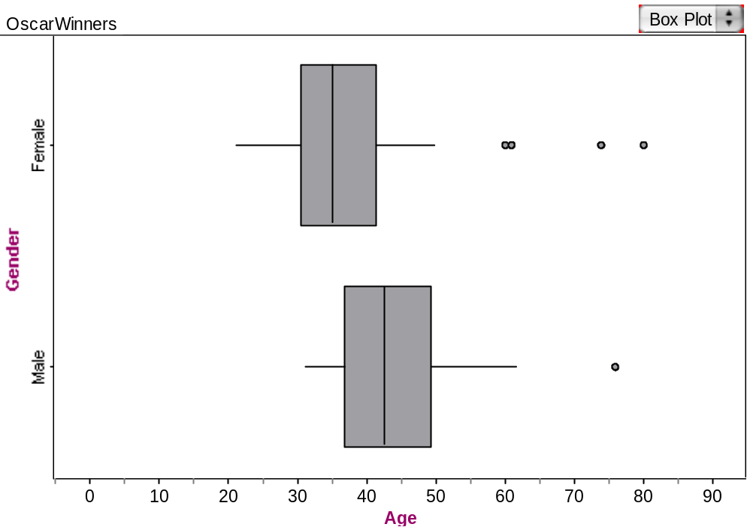

Use the graph to help answer the following questions.

- Estimate the percentage of female Oscar winners who are younger than 40.

- The oldest 50% of Oscar winners who are male are between which two ages?

- What is the shape of the distribution of male Oscar winners? Explain.

- Explain how to find the Inter-Quartile Range (IQR) for the female Oscar winners.

- Find the IQR for the female Oscar winners.

- What information does the IQR of the female Oscar winners offer us? Why would a statistician be more interested in the IQR than in the range?

- Compare the medians for male and female Oscar winners. What do you conclude about the ages of male and female Oscar winners? Explain.

- Compare the IQR for the male and female Oscar winners. What do you conclude about the ages of male and female Oscar winners now? Explain.

Part II

In the next problem, you will be given a descriptive scenario and a graph that shows two box plots. Use the graphs to make an informed comparison of the groups.

  - Be sure to compare shape, center and spread of the distributions.
  - Also, be sure that you are comparing the groups using the context of the data and not just comparing two (or more) numbers.

Stephen wants to investigate differences in spending habits of males and females. He compares the amounts spent per week on reading materials by males and females in a random sample of college students by generating the following plots.
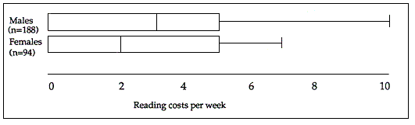

Help Stephen by comparing the two distributions.

Reference

Garfield, J., Zieffler, A., & Lane-Getaz, S. (2005). EPSY 3264 Course Packet, University of Minnesota, Minneapolis, MN.

