Matching Histograms to Boxplots
Consider all of the graphs below, the histograms and the boxplots, to be on the same scale. Match each histogram with its corresponding boxplot, by writing the letter of the box plot in the space provided.
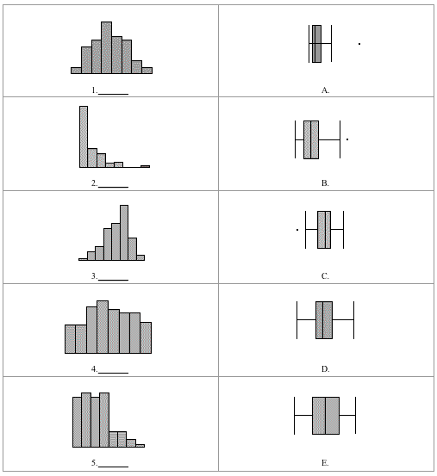
Reference
Scheaffer, R.L., Watkins, A., Witmer, J., & Gnanadesikan, M. (2004a). Activity-based statistics: Instructor resources (2nd edition, Revised by Tim Erickson). Key College Publishing.

