Reese’s Pieces

Part 1: Making Conjectures about Samples

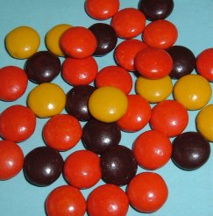
Reese’s Pieces candies have three colors: Orange, brown, and yellow. Which color do you think has more candies (occurs more often) in a package: Orange, brown or yellow?

- Guess the proportion of each color in a bag:

Color | Orange | Brown | Yellow
Predicted  Proportion | 10 | 8 | 7

- If each student in the class takes a sample of 25 Reese’s Pieces candies, would you expect every student to have the same number of orange candies in their sample? Explain.

No, we expect some variation.

- Make a conjecture: Pretend that 10 students each took samples of 25 Reese’s Pieces candies. Write down the number of orange candies you might expect for these 10 samples:

8 | 11 | 10 | 7 | 12 | 13 | 12 | 10 | 9 | 15

These numbers represent the variability you would expect to see in the number of orange candies in 10 samples of 25 candies.

You will be given a cup that is a random sample of Reese’s Pieces candies. Count out 25 candies from this cup without paying attention to color. In fact, try to IGNORE the colors as you do this.

- Now, count the colors for your sample and fill in the chart below:

 | Orange | Yellow | Brown | Total
Number of candies | 13 | 4 | 8 | 25
Proportion of candies  (Divide each number by 25) | .52 | .16 | .32 | 1

Record both the number and proportion of orange candies on the board.

- Now that you have taken a sample of candies and see the proportion of orange candies, make a second conjecture: If you took a sample of 25 Reese’s Pieces candies and found that you had only 5 orange candies, would you be surprised? Do you think that 5 is an unusual value?

Having seen several samples of 25 Reese's Pieces candies in the class, I think that a sample with only 5 orange candies is unusual.

- Record the number AND the proportion of orange candies in your sample on two dotplots on the board. Recreate both dotplots in the two figures below.

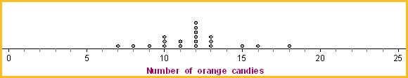
Figure 1: Dot plot for the number of orange candies.
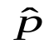
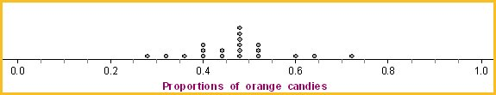
Figure 2: Dot plot for the proportion of orange candies.

Part 2: Compare Sample Statistics to the Population Parameter

Discuss the following Things to Consider questions with your group. Be prepared to report back to the class.
Things to Consider

The proportions you have calculated are the sample statistics. For example, the proportion of orange candies in your sample is the statistic that summarizes your sample.

- Did everyone in the class have the same number of orange candies? No.
- How do the actual sample values compare to the ones you estimated earlier? The actual sample values were similar to the ones we estimated earlier and fell in the same range: .3 to .7.
- Did everyone have the same proportion of orange candies? No.
- Describe the variability of the distribution of sample proportions on the board in terms of shape, center, and spread. The distribution looks somewhat like a unimodal (symmetric) distribution with a center close to .5 with most values between .2 and .7.
- Do you know the proportion of orange candies in the population? No. In the sample? Yes.
- Which one can we always calculate? The sample statistic. Which one do we have to estimate? The population parameter.
- Does the value of the parameter change, each time you take a sample? No.
- Does the value of the statistic change each time you take a sample? Yes.
- How does this sample proportion compare to the population parameter (the proportion of all orange Reese’s Pieces candies produced by Hershey's Company that are orange)? The sample proportion is an estimate for the population parameter.

Part 3: Simulate the Sampling Process
You will now simulate additional data and tie this activity to the Simulation Process Model (SPM).

  - Access the Resources page of the course website.
  - Click on the Web Applet: Reese’s Pieces link.

You will see a big container of colored candies that represents the POPULATION of Reese’s Pieces candies.

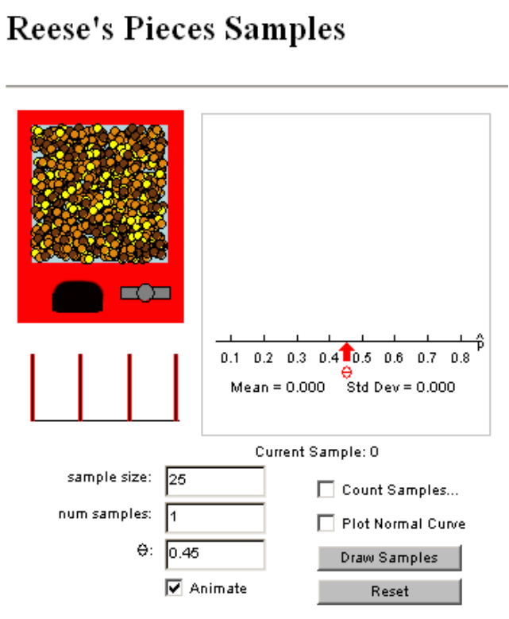
Figure 3: Reese's Pieces Samples Web applet

- What is the proportion of orange candies in the population? (Note: In class we didn’t know the parameter value but one catch in running a computer simulation is that we have to assume a value.)

0.45.

You will see that the proportion of orange is already set at 0.45, so that is the population parameter. (People who have counted lots of Reese’s Pieces candies came up with this number.)

- How does 0.45 compare to the proportion of orange candies in your sample? Explain.

The population parameter 0.45 is smaller than the 0.55 in my sample. I only took a random sample from the population and therefore would not expect my sample proportion to be the same as the population parameter. However, I do expect that the two proportions would not be too dissimilar.

- How does it compare to the center of the class’ distribution? Does it seem like a plausible value for the population proportion of orange candies? Explain.

They happened to be almost identical. The center of the class’s distribution is a reasonable value for the population proportion of orange candies because it is the average of many different random samples instead of just one.

Simulation
  - Click on the “Draw Samples” button in the Reese's Pieces applet. One sample of 25 candies will be taken and the proportion of orange candies for this sample is plotted on the graph.
  - Repeat this again. (Draw a second sample.)

- Do you get the same or different values for each sample proportion?

I got different values for each sample proportion.

- How do these numbers compare to the ones our class obtained?

These numbers are similar to the ones our class obtained.

- How close is each sample statistic (proportion) to the population parameter?

The first sample statistic (.6) is .15 higher than the population parameter (.45) and the second statistic (.52) is .07 higher than it.

Further Simulation
- Uncheck the “Animate” box.
- Change the number of samples (num samples) to 500.
- Click on the “Draw Samples” button, and see the distribution of sample statistics (in this case proportions) build.

- Describe the shape, center and spread of the distribution of sample statistics.

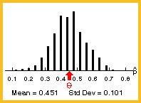

The distribution of sample proportions is symmetrical, unimodal, with the center close to the population parameter (.45) with most values between .2 to .7.

- How does this distribution compare to the one our class constructed on the board in terms of shape? Center? Spread?

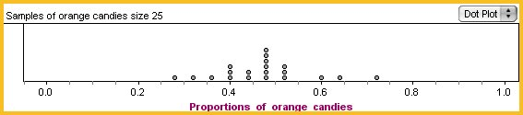
Class distribution | Applet distribution

The class distribution of sample statistics is generally similar in shape and center but is less symmetrical than the graph produced by the applet, and has fewer gaps.

- Where does the value of 0.2 (i.e., 5 orange candies) fall in the distribution of sample proportions? Is it in the tail or near the middle? Does this seem like a rare or unusual result?

The value of .2 falls in the tail of the distribution of sample proportions. The sample proportion .2 seems like a rare result.

Part 4: Examine the Role of Sample Size
Next we consider what will happen to the distribution of sample statistics if we change the number of candies in each sample (change the sample size).

Make a Conjecture
- What do you think will happen to the distribution of sample proportions if we change the sample size to 10? Explain.

The distribution will become wider. We expect to get more variability in the proportions for each sample of size 10 because outliers would play a more prominent role in a data set with 10 numbers as opposed to a larger data set.

- What do you think will happen if we change the sample size to 100? Explain.

The distribution will become narrower. We would be quite certain to get a little less variability in the proportions for each sample of size 100 because outlier effects would be diminished in a data set with 100 data values compared to a smaller data set.

Test your conjecture
- Change the “sample size” in the Reese's Pieces applet to 10.
- Be sure the number of samples (num samples) is 500.
- Click on the “Draw Samples” button.

- How close are the sample statistics (proportions), in general, to the population parameter?

The sample statistics seem to be further apart from the population parameter.

- Change the “sample size” in the Reese's Pieces applet to 100, and draw 500 samples.
- Be sure the number of samples (num samples) is 500.
- Click on the “Draw Samples” button.

- How close are the sample statistics (proportions), in general, to the population parameter?

The sample statistics are closer to the population parameter. The population parameter is .45 and the sample statistics mean I got is 0.447.

- As the sample size increases, what happens to the distance the sample statistics are to the population parameter?

The sample statistics are closer to the population parameter.

- Now, describe the effect of sample size on the distribution of sample statistics in terms of shape, center and spread.

The distribution of the sample statistics gets narrower and more normal looking. The following figures were taken from the Reese's Pieces Samples Web applet. Note the smaller variability (standard deviation) in the distribution of sample proportions when we change the sample size from10 to 100.

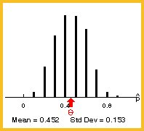 | 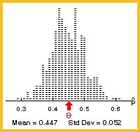
n=10 | n=100
When we generate sample statistics and graph them, we are generating an estimated sampling distribution, or a distribution of the sample statistics. It looks like other distributions we have seen of raw data.

Reference
Rossman, A., & Chance, B. (2002). A data-oriented, active-learning, post-calculus introduction to statistical concepts, applications, and theory. In B. Phillips (Ed.), Proceedings of the Sixth International Conference on Teaching of Statistics, Cape Town. Voorburg, The Netherlands: International Statistical Institute. Retrieved September 28, 2007, from http://www.stat.auckland.ac.nz/~iase/publications/1/3i2_ross.pdf

Please note the possible student answers may not, in some cases, be IDEAL student answers.

