Body Temperatures

Part 1: Consider Human Body Temperatures
Turn to your neighbor, and discuss, then sketch below what you think the distribution of human body temperatures (the population) looks like. Think about shape, center and spread.

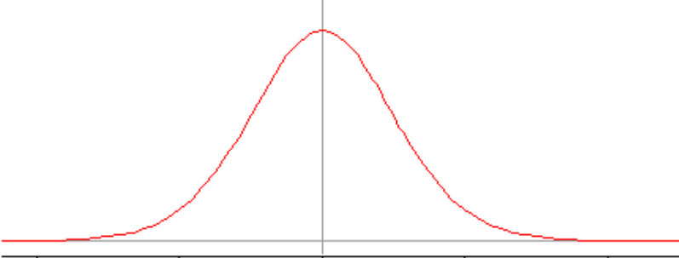
 | 97.6 | 98.1 | 98.6 | 99.1 | 99.6
Human body temperature (◦F)

The shape of the distribution is approximately normal, center (mean, median, mode) at 98.6 degrees Fahrenheit, and spread is small, maybe half a degree from the center.

- Where would the following values be on your graph? 99.0ºF? 98.0ºF? 97.2ºF?

99.0ºF is to the right of the mean; 97.2ºF and 98.0ºF are to the left of the mean.

- Are these values unusual or surprising? Explain.

97.2ºF is certainly rare in this graph.

- What about a temperature of 96ºF?

96.0ºF would be even rarer in this graph!

- How do we determine what is a surprising or unusual body temperature?

If a data value is far from the center, or in one of the tails of the distribution, it is considered “unusual.” We could count how many standard deviations the value deviates from the mean of the distribution.

Much of statistical work has to do with looking at samples from populations and determining if the results are surprising or not, given particular hypotheses. If they are surprising, we often call that a “statistically significant” result.

We will be looking at what leads to a sample (or a research result) that is “statistically significant”. Let us begin by looking at z-scores. First we need to know the mean (µ) and standard deviation (σ) for all body temperatures. Let’s use these values:

µ = 98.6ºF | σ = 0.6ºF

- Find z-scores for the body temperatures listed below:

Temperature | 99.0ºF | 98.0ºF | 97.2ºF
z-score | 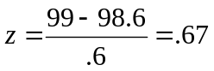 | 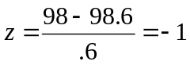 | 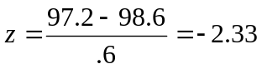

Think about z-scores that would be more or less surprising, if they represent an individual’s body temperature:

- What would an unlikely z-score be? (Give a range.)

A z-score above 2 or a z-score below –2.

- What would a likely z-score be? (Give a range.)

Anything between –2 and 2.

- Is it enough to know only the highest and lowest normal human body values in order to determine if a particular temperature is likely (in the range) or unlikely (out of the range)? Why or why not?

These extreme values may be outliers and will not give a sense of the distribution.

- Consider the situation where we have 10 adults and took the average body temperature for this sample. Would any of the following values be unusual for a mean of the 10 temperatures? Why or why not?

Average body temperature | Is the value unusual for a mean of the 10 temperatures?  Why or why not?
99.0ºF: | This value seems usual for an individual but less for a sample mean, even though it is close to the population mean.
98.0ºF: | This value is less usual than the previous one. This sample mean is further away from the population mean.
97.2ºF: | This value is very “unusual” for a sample mean of healthy people.

- Would any of these values be “normal” or “not unusual” for one person’s temperature but unusual for a sample mean of 10 temperatures?

97.2ºF would be “normal” for one person’s temperature but “unusual” for a sample mean of 10 temperatures.

Part 2: Move from Individual Values to Random Samples and Averages of These Samples

Consider a random sample of 10 students (n = 10) at a local college who have their temperatures taken using the same method.

- Write down plausible values for10 students’ body temperatures.

97.18 | 98.08 | 98.46 | 99.54 | 98.38 | 100.51 | 98.99 | 98.56 | 98.57 | 98.46

- Would you predict the AVERAGE TEMPERATURE for this sample to be exactly 98.6 degrees? Why or why not?

No, we would expect some variability in individual body temperatures.

- Would you expect it to be close to 98.6 degrees?

We would expect the sample mean temperature of ten people to be closer than some of the individuals in that sample but a larger sample size might be closer; i.e., we would expect it to deviate even less from the population mean.

- What about another random sample of 10 different students? Would you expect them to have the same mean as the first sample of 10 students? Would it have a different mean?

Not necessarily, we would expect some variability from sample to sample.

- Why might different samples of 10 students produce different sample mean body temperatures?

Natural variability in people as well as sampling randomness might produce different sample mean body temperatures. This question illustrates an important statistical property known as sampling variability: Values of sample statistics vary from sample to sample.

- Then, write down plausible values of sample mean body temperatures for five random samples of ten college students (n = 10).

98.7 | 98.6 | 98.8 | 98.4 | 98.3

- How would you expect these two sets of temperatures to compare? Which would have more variability? Why?

We would expect more variability in the individual measures than in the sample means. This is because the sample means are averages of individual body temperatures and therefore would not be expected to vary as much.

- What if we took random samples of 100 students? What would you expect to see for five samples of 100 students? Why?

We would expect less variability in the sample means of 100 students. Such large samples will usually produce means that are closer to the population mean. Extreme values in these samples will have less of an impact.
Part III: Computer Demonstration for Normal Body Temperature

Open the Normal Body Temperatures demonstration (Fathom file: “Body_Temps_Demo”). You will first see a screen like the one that appears in Figure 1. This screen shows a random sample of 100 body temperatures from a normal distribution with a mean of 98.6ºF and standard deviation of .6. The upper right graph shows the distribution for this sample and the graph below will be used to graph the sample means for many random samples of 100 body temperatures from this population.

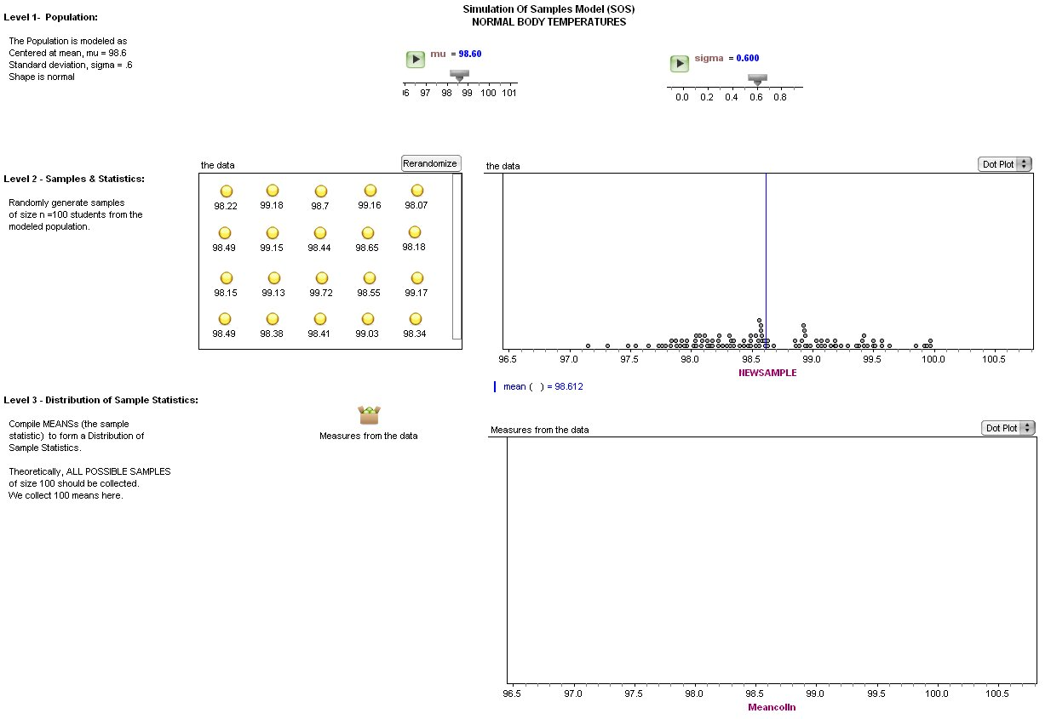

Figure 1: Fathom screen for the body temperatures demonstration.

Click the “Randomize” button on the top right corner of the data window to generate a new sample of 100 body temperatures from the population. Watch where the sample statistics is shown on the bottom graph (Level 3). Look at the distribution of the sample (Level 2) in the new sample window.

- How well does the sample resemble the population in terms of shape, center and spread?
Figure 2 displays the distribution of one sample of 100 body temperatures from the population generated by Fathom. The distribution looks fairly symmetrical, one measure of center – the mean – is at 98.62ºF (not far from the population parameter 98.6ºF) and is spread out from its mean with a standard deviation that looks to be slightly larger than .6 (the population standard deviation).

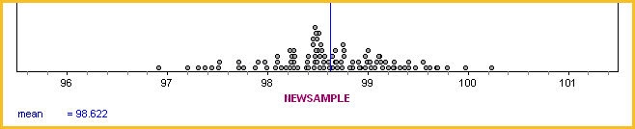
Human body temperature (◦F)
Figure 2: The distribution of a sample of 100 students.

- If you consider the sample to be representative of the population, how does it compare to your earlier conjectures about the shape, center and spread of the distribution of body temperatures in Part 1?

My conjecture in Part 1 was: The shape of the distribution is approximately normal, the center is at 98.6 degrees Fahrenheit, and the spread is small, maybe half a degree from the center. The current distribution produced by Fathom is indeed approximately normal, centered at approximately 98.6 degrees Fahrenheit, but the spread is larger than I expected.

- What are the high and low values?

The highest value in this sample is 100.24ºF, and the lowest value is 96.92ºF.

- How likely would a temperature of 97ºF be?

A temperature of 97ºF would be an “unusual” value.

Now generate many new samples by clicking several times on the “Randomize” button. Watch the bottom graph (Level 3) develops as you add more sample statistics to it.

- When the shape, center and spread do not appear to be changing any more but are relatively stable, describe these characteristics.

The shape has stabilized and became clear after we generated about 100 random samples of size 100 (see Figure 3).

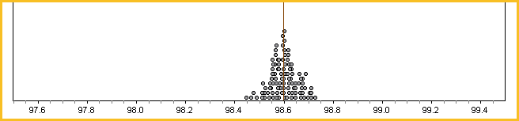
Figure 3: Sampling distribution of 100 samples of 100 students each.

The shape of this sampling distribution is approximately normal, center at exactly 98.6 degrees Fahrenheit, and spread is very small, may be tenth a degree from the center.

- What are the high and low values of these sample means?

The highest value in this sampling distribution of sample means is 98.72ºF, and the lowest value is 96.54ºF.

- Compare this to your earlier conjecture about the means of samples sized 100.

My conjecture was: "Such large samples will produce means that are closer to the population mean." We were surprised to see how close the mean of the sample means is to the population mean.

- Discuss how this activity is modeled by the Simulation Process Model (SPM).

We began at level 1 of the SPM model (the population level), by looking at the population of individual body temperatures, and realized it was normally distributed. We asked what would be considered an “unusual” body temperature if the population mean is 98.6 degrees. Next, at level 2 of the SPM model (the samples and sample statistics level), we calculated and considered means of samples, and their variability. We realized that sample means tend to vary less than individual body temperature values. At the third level (the distribution of sample statistics level) we found that when we took more samples and plotted their means, the distribution of sample means followed approximately normal distribution, was centered at µ, and its spread narrowed. Using the distribution of sample means, we can determine if a sample mean is “unusual” or surprising, by locating its position in the distribution (near the middle or the tails of the distribution).

Reference

Garfield, J., Zieffler, A., & Lane-Getaz, S. (2005). EPSY 3264 Course Packet, University of Minnesota, Minneapolis, MN.

Please note the possible student answers may not, in some cases, be IDEAL student answers.

