Sampling Words from the Gettysburg Address

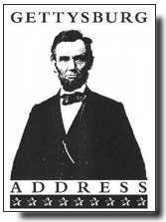
- Access the Sampling Words applet: http://www.rossmanchance.com/applets/GettysburgSample/GettysburgSample.html
- Uncheck “Show Long”
- Uncheck “Show Noun”

- First, describe the population of word lengths shown in the upper graph. Explain why the shape of this population distribution looks the way it does.

The distribution of word length population is approximately normal, skewed to the right, with mean 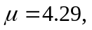 and standard deviation 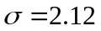. The shape of the distribution reflects the fact that the frequency of short words (2-4 letters) is much higher than long words (five letter and longer).

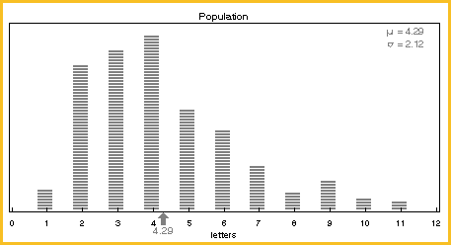

Use the applet to sample 5 words. Do this by choosing sample size = 5 and number of samples = 1. Click on the “Draw Samples” button.

- List the five word lengths that you sampled:

3 | 8 | 3 | 2 | 4

- Describe the variability of these values by finding the range.

The range of this sample is 6.

Click the “Reset” button. Now take 5 samples of 5 words by choosing sample size = 5 and number of samples = 5. Click on the "Draw Samples" button. To read the exact value of any sample mean, click on a dot in the lower graph. The sample mean will show below the black arrow in the "Population" graph above.

- List the sample means:
3.6 | 3.8 | 4.3 | 5.4 | 6.4

- How much do these five sample means vary? Again, find the range.

The range of the five sample means is 2.8. These five sample means vary less than the five individual words.

- What would be an “unusual” (surprising) value for a sample mean (n = 5)?

According to these five samples, an “unusual” value for a sample mean (n = 5) would be smaller than 3 and larger than 7 letters.

- How would we determine what is an unusual value for a sample mean and what is not an unusual value for a sample mean of size 5 from this population?

If we drew more samples of size 5 and compiled a distribution of sample means (n = 5), we can gauge which sample means are unusual and what values would not be unusual.

NOTE:
- Turn off the “Animation” before proceeding.
- Before you draw each new set of samples, first click “Reset”.

Now, take 500 random samples (number of samples), each of size 5 (sample size).
- Where does your “unusual” value fit on the resulting distribution of sample means?

My “unusual” values fit on tails of the resulting distribution of sample means.

- Draw and describe this distribution of 500 sample means size 5 (think shape, center and spread).

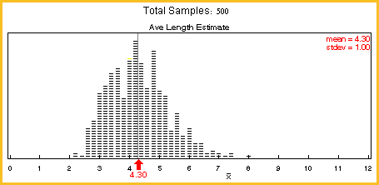

The shape is approximately normal, a bit skewed to the right (much less skewed than the population), with a mean of 4.30 (which is close to the population mean), and with less variability than the population distribution.

- What happens if we change the sample size? Will a distribution of 500 sample means for samples of size 10 look the same or different?
When we increase the sample size from 5 to 10, the distribution shape becomes more normal and variability in sample means decreases.

- What about samples of size 20 or 50?

The distribution will become narrower (i.e., less variability in the sample means) and more normal-looking. The means of these sampling distributions would be equal to or closer to the population mean.

Run each of these simulations using the applet. Sketch each distribution and label the mean and list the standard deviation (shown in the upper right corner of the lower graph). Remember to click on the “Reset” button before each simulation!

- Graph of 500 sample means, sample size 10 (n = 10):

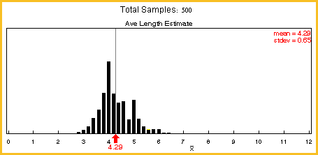

- Graph of 500 sample means, sample size 20 (n = 20):

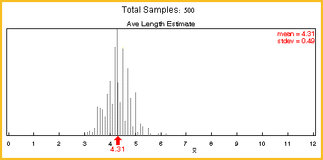

- Graph of 500 sample means, sample size 50 (n = 50):

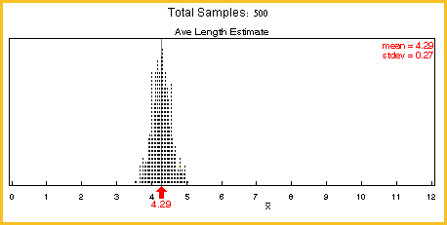

Things to Consider

- How do these distributions compare to each other (think shape, center and spread)? The center stays about the same (close to the 4.29 population mean, the parameter), but there is less variability in sample means as sample size increases. The shape gets more normal looking, too.
- What’s different about them? Essentially, there is less variability in the sample means as the sample size increases.
- Where does your “unusual” value fit on each distribution? The “unusual” value becomes more “unusual” as the sample size increases. It is positioned even further from the center of the distribution of sample means – in terms of standard deviation units.
- What would you expect if we changed the sample size again, to a larger number? Is there a predictable pattern? What is it? We can expect the center to stay about the same and the sampling distribution of the sample means will have less variability as the sample size increases. The shape should get more normal looking.

Do you think this pattern would result if we took samples and make distributions of sampling statistics for other types of populations, besides word lengths?

A similar pattern would apply to other types of populations (skewed, bimodal, etc.).

Do you think this pattern would result if we took samples and make distributions of sampling statistics for other types of populations, besides word lengths?

Yes.

Reference

Garfield, J., Zieffler, A., & Lane-Getaz, S. (2005). EPSY 3264 Course Packet, University of Minnesota, Minneapolis, MN.

Please note the possible student answers may not, in some cases, be IDEAL student answers.

