Sampling Pennies


The Sampling Pennies applet simulates the sampling of the dates on pennies from a large population of pennies that were collected in the year 1999.

- Access the Sampling Pennies applet: http://www.rossmanchance.com/applets/SampleData/SampleData.html

- First, describe the population of dates on pennies shown in the upper right graph.

The population distribution is skewed negative (to the left), the sample mean is 1986.74 and the standard deviation is 9.61 (see the graph below).

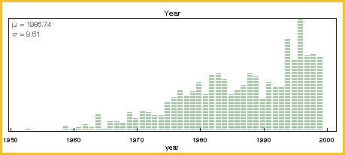

- Why do you think the graph has this shape?

Older pennies are not in as wide a circulation when compared to the new pennies.

- Generate 500 samples of 10 pennies each to determine how surprising a sample mean of 1980 would be.

A sample mean of 1980 is in the left tail of the distribution of sample means (see the figure below). Therefore we consider it to be a rather “unusual” value for a sample mean from the population.

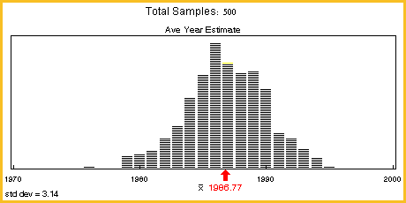

- Compare the distributions of sample means for different sample sizes (choose your own values of n). Each time generate 500 samples.

- Use the applet, starting with small sample sizes and increasing to large sample sizes. For each distribution, try to see and describe the predictable pattern that emerges as the sample size increase.

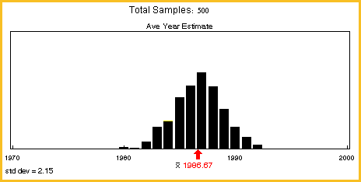

Distribution of 500 samples of 20 pennies (generated by the Sampling Pennies applet)

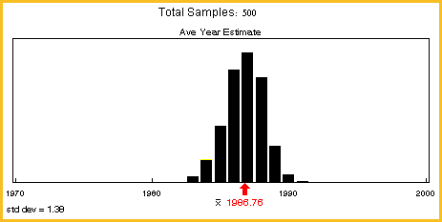
Distribution of 500 samples of 50 pennies (generated by the Sampling Pennies applet).

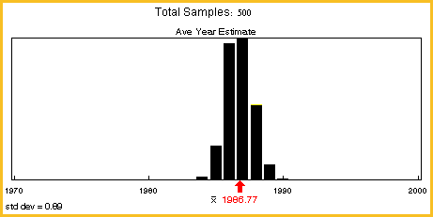
Distribution of 500 samples of 100 pennies (generated by the Sampling Pennies applet).

As we show above, increasing the sample size makes the distribution of sample means more normal looking and much narrower, with a mean right where the population mean is.

- Based on the Fathom simulation of body temperatures and the applets of Sampling Words and Sampling Pennies, describe the predictable pattern that you saw in the distribution of sample means.

Each of the distributions we created using the Fathom simulation and the Web applets approximates the sampling distribution of the sample mean from a population for a specific sample size. When the sample size is fairly large, the distribution of sample means follows an approximately normal distribution. The sampling distribution becomes more and more normal as the sample size increases, regardless of the shape, center and spread of the population distribution. Only the body temperature population is normal, while the two other populations are skewed. However in all cases the sampling distribution of sample means becomes normal as the sample size increases. The means of these sampling distributions are all equal to the population mean (the parameter), but the variability in sample means decreases as the sample size increases.

Reference

Garfield, J., Zieffler, A., & Lane-Getaz, S. (2005). EPSY 3264 Course Packet, University of Minnesota, Minneapolis, MN.

Please note the possible student answers may not, in some cases, be IDEAL student answers.

