Central Limit Theorem

Meet the Distributions

This activity is designed to develop your understanding of how sampling distributions behave by making and testing conjectures about distributions of means from different random samples from three different theoretical populations. One population is Normal (N), one is skewed (S), and one is quite irregular and multimodal (M).

There are three distributions that we will be using to make predictions about distributions of sample means. For each distribution you will be asked to make a prediction about which picture (from a page of stickers) is most likely to represent 500 sample means for a particular sample size. After each prediction you will get to see how accurate your prediction was, by simulating data using the Sampling SIM program. After making three predictions for each distribution you can add up your score to see how many predictions were correct. Here are the three population distributions with pictures to show you how to access these using the software program.

Normal Distribution (N) | 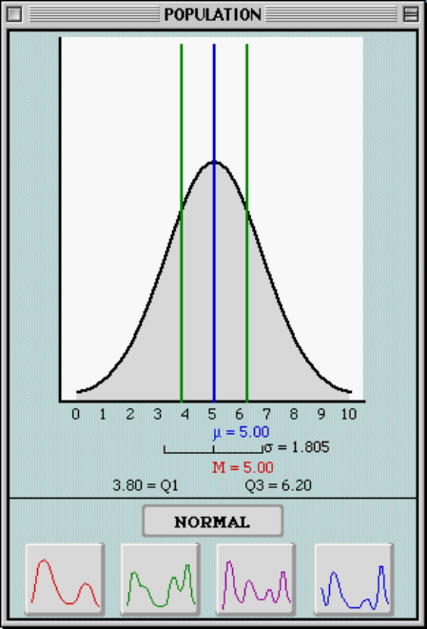
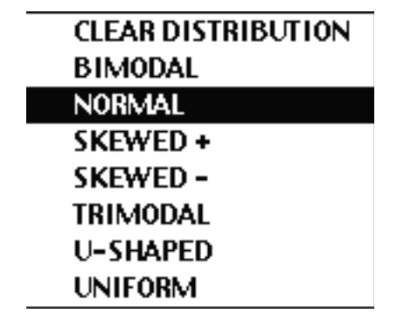
Population Mean = μ = 5
Standard Deviation = σ = 1.805

Skewed Distribution (S) | 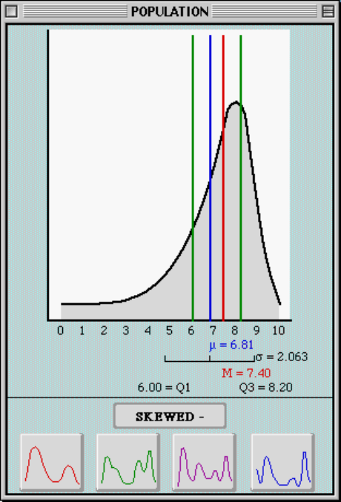
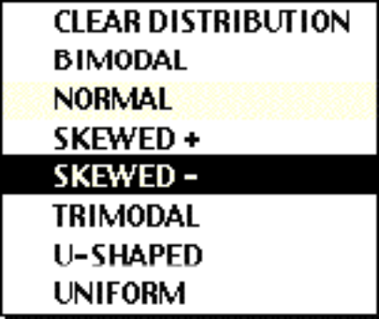
Population Mean = μ = 6.81
Standard Deviation = σ = 2.063
Multimodal Distribution (M) | 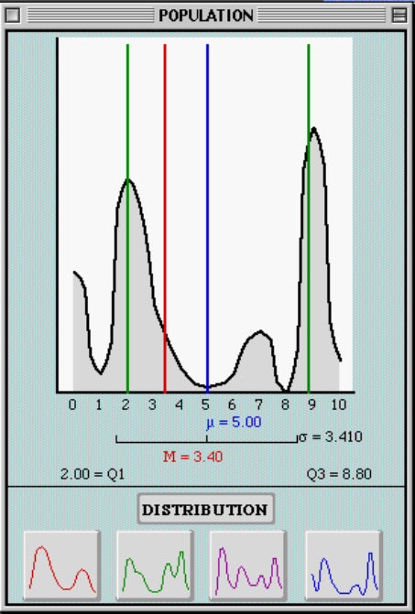
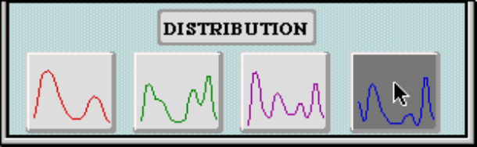
Population Mean = μ = 5.0
Standard Deviation = σ = 3.41
Note: This distribution is selected by clicking on 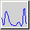 in the "Population" window.

The instructor will guide you as you make and test your predictions, using the sheet of stickers and the sampling distributions scrapbook. After the first set of predictions (for the Normal Distribution) you can work in pairs as you discuss your predictions and results.

Understanding the Central Limit Theorem (CLT)

Compare and contrast the following three characteristics of the sampling distributions for the different sample sizes:

The shape of the sampling distribution:
- Compare the shape of the sampling distribution for each of the three sample sizes. Were they the same or different?

If the population was normally distributed, the shape of the distributions of sample means looked normally distributed. If the population was not normally distributed, the shape changed, and became more normal-looking as the sample size increases.

- How did the shape of each sampling distribution compare to the population shape?

They became more normally distributed with a narrower spread than the population.

The center (mean) of the sampling distribution:
- Compare the mean of the sampling distribution for each of the three sample sizes. Were they the same or different?

Stayed the same.

- How did the center of each sampling distribution compare to the population mean?

It was approximately the same as μ. So, the mean of the sample means was
always approximately equal to the population mean, μ.

The variability (standard deviation) of the sampling distribution:
- Compare the variability of the sampling distribution for each of the three sample sizes. Was it the same or different?

It changed.

- How did the variability of each sampling distribution compare to the population standard deviation?

It got smaller and smaller as the sample size is increased.

Now go back to the same three populations (Normal, Skewed, and Multimodal) and predict what you would expect to find if you took samples of size 50. The sampling distributions would be:

Population | Predicted Shape | Predicted Center | Predicted Spread
Normal (N) | Normal | 5 | 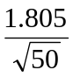
Skewed (S) | Normal | 6.81 | 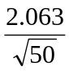
Multimodal (M) | Normal | 5 | 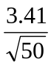

Test these predictions using Sampling SIM to see if you were correct.

In the following table we present simulation results of 500 sample means for sample size 50. We compare these results to the predicted values in terms of center and spread.

Population | Mean of sample mean | Predicted Center | Standard deviation of sample means | Predicted Spread
Normal (N) | 5.01 | 5 | 0.256 | 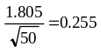
Skewed (S) | 6.81 | 6.81 | 0.298 | 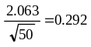
Multimodal (M) | 5.0 | 5 | 0.481 | 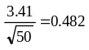

Using the CLT and Applying the Empirical Rule to Sample Means and Sampling Distributions

Recall the Empirical Rule (68-95-99.7% rule) for a Normal Distribution. Think about a population of data that has a Normal Distribution.

- What percent of the values will be between one standard deviation below the mean and one standard deviation above the mean?
68%

- What percent of the values will be between two standard deviations below the mean and two standard deviations above the mean?
95%

Use the Empirical Rule (when appropriate) in answering the following questions.
Look back at the population of body temperatures from the previous lesson. If you assume that the population of body temperatures is normally distributed, then we can also assume that the sampling distribution of mean body temperatures will be normally distributed, and can apply the Empirical Rule.

First, consider individual body temperatures.

- What values include the middle 95% of the distribution of individual body temperatures?

The center and spread values for the distribution of individual body temperatures are :

µ = 98.6ºF | σ = .6ºF
The middle 95% of the values will be between 2 standard deviations below the mean and 2 standard deviations above the mean, i.e., between 97.4ºF and 99.8ºF (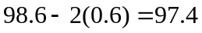; 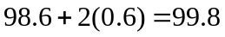).

- What values include the middle 68 % of normal body temperatures?

The middle 68% of the values will be between 1 standard deviation below the mean and 1 standard deviation above the mean, i.e., between 98.0ºF and 99.2ºF (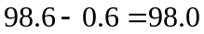; 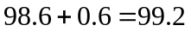).

- Would a body temperature of 98 degrees be surprising or unusual for a single student? Answer this by changing it to a z-score and showing where it would be in the population distribution.

Since the z score for a body temperature of 98.0ºF is –1 (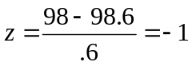), it is not a surprising value for a single student. It falls within the 68% of values in the center of the population distribution.

Now consider random samples of 10 students and their sample mean body temperatures.

- What values of the sample mean include the middle 95% of the distribution of sample means of body temperatures? Remember that to find this out, and to avoid getting the same answer you got for part (a), you need to first find the standard deviation of the sample means and use that instead of sigma.

The standard deviation of the sample means is 0.19 (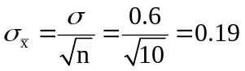). In the distribution of sample means of body temperatures, 95% of the values of the sample mean are between 98.22ºF and 98.98ºF, according to the following calculation:

- What values include the middle 68% of sample mean body temperatures?

68% of the values of the sample mean are between 98.41ºF and 98.79ºF, according to the following calculation:

- Would a sample mean body temperature (for a sample of size 10) of 98 degrees be surprising? Find the z-score and show where this value would be on the sampling distribution.

Since the z-score for a sample body temperature (for a sample size of 10) of 98.0ºF is –3.16 (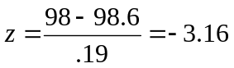), it is a surprising value for a sample mean. It falls in the left tail of the distribution of sampling means.

Look back at samples of words from the Gettysburg Address, which was a skewed distribution.

- Why is it not appropriate to use the Empirical Rule to estimate the values that include the middle 95% of word lengths?

The distribution of word length population is skewed to the right (see Figure 2), with mean 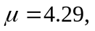 and standard deviation 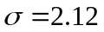. Since it is not a Normal Distribution, we cannot apply the Empirical Rule to estimate the values that include the middle 95% of word lengths.

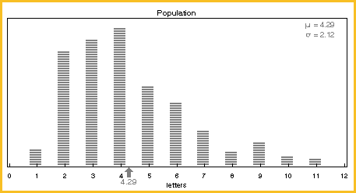

- Why is it appropriate to use the Empirical Rule to estimate values of sample means from random samples of size 50 that include the middle 95% of the distribution of sample means? What is this interval?

The Empirical Rule applies only to Normal Distributions. The CLT assures us that the sampling distribution of the sample mean is approximately normal. Therefore we can apply the Empirical Rule for this question.
The word length population mean is 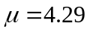 and the standard deviation is . The sampling distribution standard deviation for sample size 50 is 0.3 (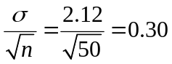). Therefore the interval that includes the middle 95% of the distribution of sample means is (3.69, 4.89).

- What would be the interval that includes the middle 95% of the mean word lengths for samples of 100 words?

For samples of 100 words, the interval that includes the middle 95% of the mean word lengths would be narrower. The sampling distribution standard deviation for sample size 100 is only 0.21 (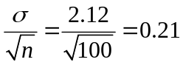). Therefore the interval that includes the middle 95% of the distribution of sample means is (3.87, 4.71), according to the following calculation: .

- Why and how is this interval different than the one for 50 words?

The interval that includes the middle 95% of the mean word lengths for sample size 100 is smaller than the one for 50 words, since the standard deviation of the sampling distribution of sample mean for samples size 100 is smaller than the one for sample size 50: 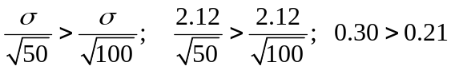.

- Is a word length of 6 letters unusual in the population? Is it unusual for a value of a sample mean of 50 values? Is it unusual for a sample mean based on 100 values? Explain your answers.
Let's calculate the z-scores for each one of the situations to determine if word length of 6 letters is unusual.

Situation | Mean  ( ) | Standard deviation (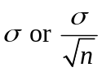 ) | Z score | Result
Individual word of 6 letters | 4.29 | 2.12 | 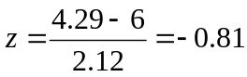 | Not unusual
A sample mean (n=50) of 6 letters | 4.29 | 0.30 | 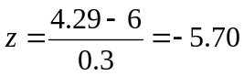 | Rare
A sample mean (n=50) of 6 letters | 4.29 | 0.21 | 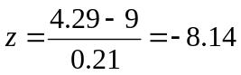 | Extremely rare

Reference

Garfield., delMas, R., & Chance, B. (2000). Tools for Teaching and Assessing Statistical Inference (NSF project). http://www.tc.umn.edu/~delma001/stat_tools/

Please note the possible student answers may not, in some cases, be IDEAL student answers.

