Reese’s Pieces

Part 1: Making Conjectures about Samples

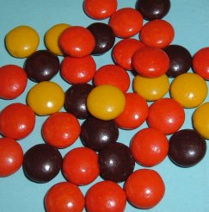
Reese’s Pieces candies have three colors: Orange, brown, and yellow. Which color do you think has more candies (occurs more often) in a package: Orange, brown or yellow?

- Guess the proportion of each color in a bag:

Color | Orange | Brown | Yellow
Predicted
Proportion

- If each student in the class takes a sample of 25 Reese’s Pieces candies, would you expect every student to have the same number of orange candies in their sample? Explain.

- Make a conjecture: Pretend that 10 students each took samples of 25 Reese’s Pieces candies. Write down the number of orange candies you might expect for these 10 samples:

These numbers represent the variability you would expect to see in the number of orange candies in 10 samples of 25 candies.

You will be given a cup that is a random sample of Reese’s Pieces candies. Count out 25 candies from this cup without paying attention to color. In fact, try to IGNORE the colors as you do this.

- Now, count the colors for your sample and fill in the chart below:

 | Orange | Yellow | Brown | Total
Number of candies
Proportion of candies
(Divide each number by 25)

Record both the number and proportion of orange candies on the board.

- Now that you have taken a sample of candies and see the proportion of orange candies, make a second conjecture: If you took a sample of 25 Reese’s Pieces candies and found that you had only 5 orange candies, would you be surprised? Do you think that 5 is an unusual value?

- Record the number AND the proportion of orange candies in your sample on two dotplots on the board. Recreate both dotplots in the two figures below.

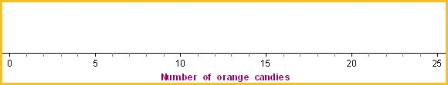
Figure 1: Dot plot for the number of orange candies.

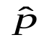
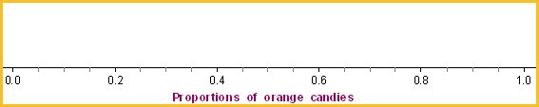
Figure 2: Dot plot for the proportion of orange candies.

Part 2: Compare Sample Statistics to the Population Parameter

Discuss the following Things to Consider questions with your group. Be prepared to report back to the class.

Things to Consider

The proportions you have calculated are the sample statistics. For example, the proportion of orange candies in your sample is the statistic that summarizes your sample.

- Did everyone in the class have the same number of orange candies?
- How do the actual sample values compare to the ones you estimated earlier?
- Did everyone have the same proportion of orange candies?
- Describe the variability of the distribution of sample proportions on the board in terms of shape, center, and spread.
- Do you know the proportion of orange candies in the population? In the sample?
- Which one can we always calculate? Which one do we have to estimate?
- Does the value of the parameter change, each time you take a sample?
- Does the value of the statistic change each time you take a sample?
- How does this sample proportion compare to the population parameter (the proportion of all orange Reese’s Pieces candies produced by Hershey's Company that are orange)?

Part 3: Simulate the Sampling Process
You will now simulate additional data and tie this activity to the Simulation Process Model (SPM).

  - Access the Resources page of the course website.
  - Click on the Web Applet: Reese’s Pieces link.

You will see a big container of colored candies that represents the POPULATION of Reese’s Pieces candies.

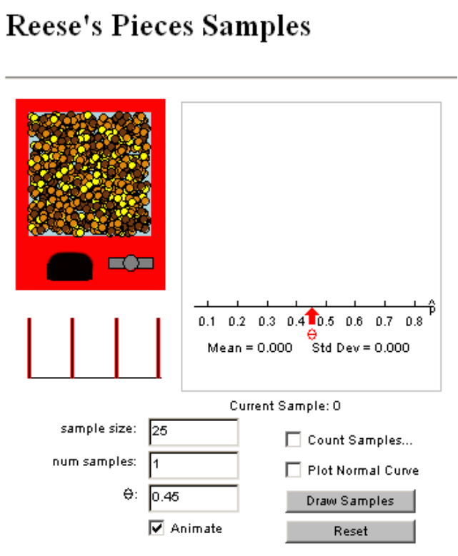
Figure 3: Reese's Pieces Samples Web applet

- What is the proportion of orange candies in the population? (Note: In class we didn’t know the parameter value but one catch in running a computer simulation is that we have to assume a value.)

You will see that the proportion of orange is already set at 0.45, so that is the population parameter. (People who have counted lots of Reese’s Pieces candies came up with this number.)

- How does 0.45 compare to the proportion of orange candies in your sample? Explain.

- How does it compare to the center of the class’ distribution? Does it seem like a plausible value for the population proportion of orange candies? Explain.

Simulation
  - Click on the “Draw Samples” button in the Reese's Pieces applet. One sample of 25 candies will be taken and the proportion of orange candies for this sample is plotted on the graph.
  - Repeat this again. (Draw a second sample.)

- Do you get the same or different values for each sample proportion?

- How do these numbers compare to the ones our class obtained?

- How close is each sample statistic (proportion) to the population parameter?

Further Simulation
- Uncheck the “Animate” box.
- Change the number of samples (num samples) to 500.
- Click on the “Draw Samples” button, and see the distribution of sample statistics (in this case proportions) build.

- Describe the shape, center and spread of the distribution of sample statistics.

- How does this distribution compare to the one our class constructed on the board in terms of shape? Center? Spread?

- Where does the value of 0.2 (i.e., 5 orange candies) fall in the distribution of sample proportions? Is it in the tail or near the middle? Does this seem like a rare or unusual result?

Part 4: Examine the Role of Sample Size
Next we consider what will happen to the distribution of sample statistics if we change the number of candies in each sample (change the sample size).

Make a Conjecture
- What do you think will happen to the distribution of sample proportions if we change the sample size to 10? Explain.

- What do you think will happen if we change the sample size to 100? Explain.

Test your conjecture
- Change the “sample size” in the Reese's Pieces applet to 10.
- Be sure the number of samples (num samples) is 500.
- Click on the “Draw Samples” button.

- How close are the sample statistics (proportions), in general, to the population parameter?

- Change the “sample size” in the Reese's Pieces applet to 100, and draw 500 samples.
- Be sure the number of samples (num samples) is 500.
- Click on the “Draw Samples” button.

- How close are the sample statistics (proportions), in general, to the population parameter?

- As the sample size increases, what happens to the distance the sample statistics are to the population parameter?

- Now, describe the effect of sample size on the distribution of sample statistics in terms of shape, center and spread.

When we generate sample statistics and graph them, we are generating an estimated sampling distribution, or a distribution of the sample statistics. It looks like other distributions we have seen of raw data.

Reference
Rossman, A., & Chance, B. (2002). A data-oriented, active-learning, post-calculus introduction to statistical concepts, applications, and theory. In B. Phillips (Ed.), Proceedings of the Sixth International Conference on Teaching of Statistics, Cape Town. Voorburg, The Netherlands: International Statistical Institute. Retrieved September 28, 2007, from http://www.stat.auckland.ac.nz/~iase/publications/1/3i2_ross.pdf

