Body Temperatures

Part 1: Consider Human Body Temperatures
Turn to your neighbor, and discuss, then sketch below what you think the distribution of human body temperatures (the population) looks like. Think about shape, center and spread.

- Where would the following values be on your graph? 99.0ºF? 98.0ºF? 97.2ºF?

- Are these values unusual or surprising? Explain.

- What about a temperature of 96ºF?

- How do we determine what is a surprising or unusual body temperature?

Much of statistical work has to do with looking at samples from populations and determining if the results are surprising or not, given particular hypotheses. If they are surprising, we often call that a “statistically significant” result.

We will be looking at what leads to a sample (or a research result) that is “statistically significant”. Let us begin by looking at z-scores. First we need to know the mean (µ) and standard deviation (σ) for all body temperatures. Let’s use these values:

µ = 98.6ºF | σ = 0.6ºF

- Find z-scores for the body temperatures listed below:

Temperature | 99.0ºF | 98.0ºF | 97.2ºF
z-score

Think about z-scores that would be more or less surprising, if they represent an individual’s body temperature:

- What would an unlikely z-score be? (Give a range.)

- What would a likely z-score be? (Give a range.)

- Is it enough to know only the highest and lowest normal human body values in order to determine if a particular temperature is likely (in the range) or unlikely (out of the range)? Why or why not?

- Consider the situation where we have 10 adults and took the average body temperature for this sample. Would any of the following values be unusual for a mean of the 10 temperatures? Why or why not?

Average body temperature | Is the value unusual for a mean of the 10 temperatures?  Why or why not?
99.0ºF:
98.0ºF:
97.2ºF:

- Would any of these values be “normal” or “not unusual” for one person’s temperature but unusual for a sample mean of 10 temperatures?

Part 2: Move from Individual Values to Random Samples and Averages of These Samples

Consider a random sample of 10 students (n = 10) at a local college who have their temperatures taken using the same method.

- Write down plausible values for10 students’ body temperatures.

- Would you predict the AVERAGE TEMPERATURE for this sample to be exactly 98.6 degrees? Why or why not?

- Would you expect it to be close to 98.6 degrees?

- What about another random sample of 10 different students? Would you expect them to have the same mean as the first sample of 10 students? Would it have a different mean?

- Why might different samples of 10 students produce different sample mean body temperatures?

- Then, write down plausible values of sample mean body temperatures for five random samples of ten college students (n = 10).

- How would you expect these two sets of temperatures to compare? Which would have more variability? Why?

- What if we took random samples of 100 students? What would you expect to see for five samples of 100 students? Why?

Part III: Computer Demonstration for Normal Body Temperature

Open the Normal Body Temperatures demonstration (Fathom file: “Body_Temps_Demo”). You will first see a screen like the one that appears in Figure 1. This screen shows a random sample of 100 body temperatures from a normal distribution with a mean of 98.6ºF and standard deviation of .6. The upper right graph shows the distribution for this sample and the graph below will be used to graph the sample means for many random samples of 100 body temperatures from this population.

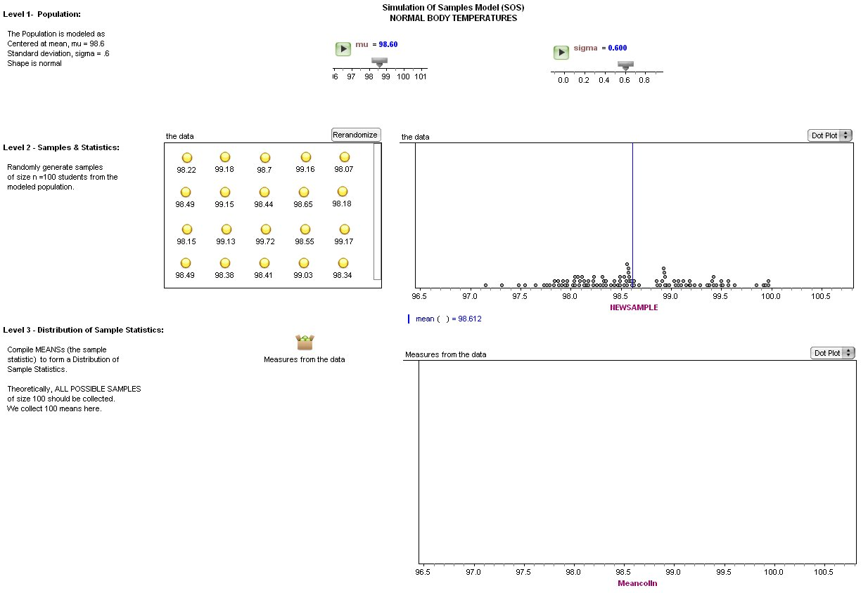

Figure 1: Fathom screen for the body temperatures demonstration.

Click the “Randomize” button on the top right corner of the data window to generate a new sample of 100 body temperatures from the population. Watch where the sample statistics is shown on the bottom graph (Level 3). Look at the distribution of the sample (Level 2) in the new sample window.

- How well does the sample resemble the population in terms of shape, center and spread?

- If you consider the sample to be representative of the population, how does it compare to your earlier conjectures about the shape, center and spread of the distribution of body temperatures in Part 1?

- What are the high and low values?

- How likely would a temperature of 97ºF be?

Now generate many new samples by clicking several times on the “Randomize” button. Watch the bottom graph (Level 3) develops as you add more sample statistics to it.

- When the shape, center and spread do not appear to be changing any more but are relatively stable, describe these characteristics.

- What are the high and low values of these sample means?

- Compare this to your earlier conjecture about the means of samples sized 100.

- Discuss how this activity is modeled by the Simulation Process Model (SPM).

Reference

Garfield, J., Zieffler, A., & Lane-Getaz, S. (2005). EPSY 3264 Course Packet, University of Minnesota, Minneapolis, MN.

