Sampling Pennies

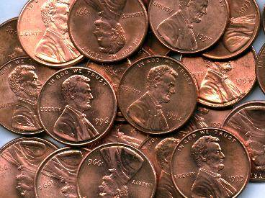
The Sampling Pennies applet simulates the sampling of the dates on pennies from a large population of pennies that were collected in the year 1999.

- Access the Sampling Pennies applet: http://www.rossmanchance.com/applets/SampleData/SampleData.html

- First, describe the population of dates on pennies shown in the upper right graph.

- Why do you think the graph has this shape?

- Generate 500 samples of 10 pennies each to determine how surprising a sample mean of 1980 would be.

- Compare the distributions of sample means for different sample sizes (choose your own values of n). Each time generate 500 samples.

- Use the applet, starting with small sample sizes and increasing to large sample sizes. For each distribution, try to see and describe the predictable pattern that emerges as the sample size increase.

- Based on the Fathom simulation of body temperatures and the applets of Sampling Words and Sampling Pennies, describe the predictable pattern that you saw in the distribution of sample means.

Reference

Garfield, J., Zieffler, A., & Lane-Getaz, S. (2005). EPSY 3264 Course Packet, University of Minnesota, Minneapolis, MN.

