Modeling Coin Tosses

Part I: Looking at the variation for sets of coin tosses

What do we expect when we toss a coin? What if everyone in the class tossed a fair coin ten times, what kinds of results would you expect toget? Discuss with your neighbor (remembering our unit on sampling) and write down possible numbers of heads you might get for 8 sets of 10 tosses of a fair penny (e.g., list the number of heads out of 10 for eight repetitions of this experiment).

7 5 4 8 3 7 6 5

Did you expect to get 5 heads each time, or did you expect some variability between results of each set of 10 tosses? How variable did you expect them to be?

I did not expect to get 5 heads every time. There should be some variability in the number of heads for 8 sets of 10 tosses. The number of heads for a fair coin could result in 2 to 8 heads in 10 tosses.

What outcomes would you consider to be less likely if you are using a “fair” coin? Why?

0, 1, 9, and 10 heads would be less likely if a “fair” coin was used. This is because the chances of getting 0, 1, 9, and 10 heads are less than 1% if we indeed had a “fair” coin and the tosses were independent.

Part II: Modeling the Balancing of Ten Coins through Simulation

We can model the “fair” process of obtaining heads 50% of the time when balancing ten coins using simulation. It turns out that the normal distribution is a good model for the distribution of the proportion of heads you would expect. The model is shown below.

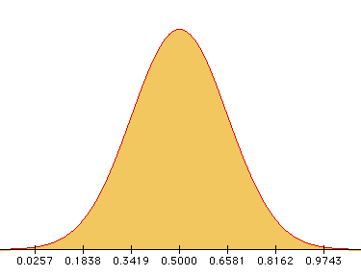

- Describe the distribution of the expected proportion of heads in terms of shape, center and spread.

The distribution of sample proportions looks symmetric, normal, and has its mean value at 0.5 and a spread in terms of standard deviation of .1581.

- Now, shade in areas of the distribution that include surprising results, so that if you got one of those results, you might question the assumption that the coin is equally likely to land heads up or down (probability of heads is 0.5).

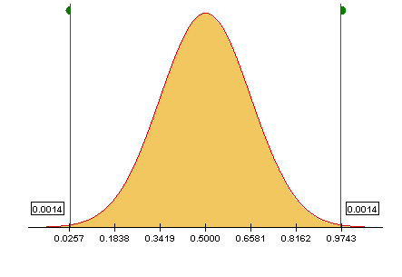

The shaded areas are those that fall to the left and right of the green flags in the tails of the distribution.

What will happen if we balance sets of 10 coins? What will you expect to get if you balance ten coins on their edge and let them fall? Do you expect the same number of heads and tails as when you flip a coin (p = 0.5)? Explain.

Answers may vary here depending on whether students think that a balanced coin has an equal probably of landing heads up. Make sure and ask them for their reasoning.

Reference

Garfield, J., & Zieffler, A. (2007). EPSY 3264 Course Packet, University of Minnesota, Minneapolis, MN.

Please note the possible student answers may not, in some cases, be IDEAL student answers.

