Balancing Coins

Part 1: Testing Statistical Hypotheses

After talking to several expert coin balancers, we are under the impression that balancing a coin and letting it fall is an “unfair” process. In other words, this does not produce results that are 50% heads and 50% tails. We will test the hypothesis that the proportion of heads when balancing a coin repeatedly on its edge is not 0.5.

We will design an experiment in order to be able to make a decision about the two hypotheses. In order to make a decision about the research question, we need four things:

- A hypothesis to test
- A sample of data which gives us a sample statistic
- A sampling distribution for the sample statistic that we obtained. This is the model we would expect if the null-hypothesis is true. We can use the sampling distribution to see how unusual or surprising our sample result is. If our sample result is in one of the tails of the distribution, it would lead us to suspect that our result is surprising given that particular model. This would therefore be evidence against the null-hypothesis.
- A decision rule: How far in the tails does our sample result have to be? The decision rule tells us how far in one of the tails our sample result needs to be for us to decide it is so unusual and surprising that we reject the idea stated in the null-hypothesis.

Writing statistical hypotheses
We basically want to know if we can expect an average of 50% heads if we repeatedly balance a coin ten times, each time counting the number of heads that show or not. We can write those two ideas as follows:

Idea 1: Balancing a coin is a “fair” process.
Idea 2: Balancing a coin is an “unfair” process.

We can also write these ideas using more mathematical ideas, as shown below:

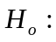 The proportion of heads when we balance a coin repeatedly is 0.5.
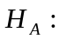The proportion of heads when we balance a coin repeatedly is not 0.5.
(In other words the proportion is more, or less, than 0.5.)

We call these ideas 'statistical hypotheses'. The first idea states that the coin is just a likely to land heads as it is to land tails, or that there will be an equal number of heads and tails when we balance a coin. This statement is called the 'null hypothesis' because it represents an idea of no difference from the norm or prior belief or no effect (e.g., getting the same results as tossing fair coins). The null-hypothesis is labeled by the symbol 'H₀'.

The second idea states that there will not be an equal number of heads and tails, something different than the first idea, so it is called the 'alternative hypothesis'. The symbol used for the alternative hypothesis is 'H_{a}'. Note that this was our original hypothesis about the proportion of heads.

We gather evidence (data) to see if we can disprove the null hypothesis. If we do, then we will accept that the alternative hypothesis is true. The decision between the two hypotheses is usually expressed in terms of H₀ (idea # 1). If our data lead us to believe the second idea is true, then we usually say that 'we reject H₀'.

Gathering evidence (data) to make the decision whether or not to reject H₀
Balance a penny coin. Make sure the head side of the coin is facing you. When it is standing upright on its edge, hit the under-side of the table (right underneath the balanced coin). Record if you got a head or tail. Repeat this process ten times.

Trial | Result (H or T)
1 | H
2 | T
3 | H
4 | T
5 | H
6 | H
7 | T
8 | H
9 | H
10 | T

How many Heads did you get? 6

Your sample statistic is the proportion of heads (divide the number of heads by 10).

Write that here: 0.6

Record the number of heads you obtained when balancing the coin ten times on the board.

Find an appropriate sampling distribution
What shall we use? Remember that the sampling distribution is consistent with the idea expressed in the null-hypothesis. Since the null-hypothesis is that the proportion of heads is 0.5, we can refer to the sampling distribution we created earlier.

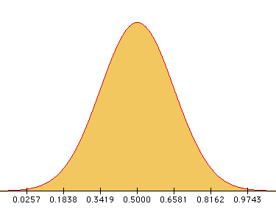

This sampling distribution allows you to compare your sample proportion of heads, based on ten trials, to other sample proportions of heads based on ten trials that you could have obtained, given that the null-hypothesis is indeed true (that balancing a coin repeatedly on its edge produces 50% heads).

Use your sketch to determine whether or not your result is in a tail. Mark your result on your graph. Does your result seem surprising? Explain.

My result is actually not in a tail. This would seem to suggest that a sample proportion of 0.6 is not unlikely when the population proportion is actually 0.5.

Decision Rule
How unlikely is your sample result? To determine this, do the following:

- Open the Normal Distribution applet.
- Enter in the mean and standard deviation for the model (sampling distribution) that is consistent with the null-hypothesis. (For this example, these are 0.5 and 0.1581 respectively.)
- Be sure that the 2-tail box is checked.
- Move the flags in the sampling distribution as close to your sample result as you can.
- Sum the probabilities that are given by the applet in each tail.

This sum is called the p-value. It is an index of the likelihood of your sample result or a more extreme sample result under the model of the null-hypothesis.

Write your p-value here: 0.55.

This probability of getting the result we got or a more extreme one is called the p-value. We can use the p-value to help make a decision about which of our hypotheses seems more likely. A typical decision rule for p-values is to see if they are smaller than 0.05. If your p-value is less than 0.05, then it would be evidence against the null hypothesis - you would reject the null hypothesis. If your p-value is greater than or equal to 0.05, then it would be evidence for the null hypothesis - you would fail to reject the null hypothesis.

How does your p-value compare to 0.05? Is it evidence for or against the null hypothesis?

My p-value is much larger than 0.05. This means that it is quite likely to get such a result if the null hypothesis is true. I fail to reject the null hypothesis.

What does this suggest about the “fairness” of the process of balancing a coin?

From our balancing coin task, it would appear that balancing a coin is a fair process.

Did all your classmates come to the same conclusion? If not, why did we get different decisions in the same experiment?

No, not every group came to the same conclusion. This is due to the fact that every group decided whether Idea 1 or Idea 2 is true based on just their own experiment. Sampling variation could the reason for why different results are obtained, and therefore different conclusions reached.

What does the p-value tell us? To summarize our results we would say that the probability of getting a sample proportion such as the one we got or a more extreme sample proportion, when the null hypothesis that heads and tails are equally likely is really true is _____. (Fill in the blank with the p-value.)

Part 2: Research Question: Is flipping the Euro coin a “fair” process?

Someone recently collected data using the new Euro coin. This person tossed it 100 times and got 49 heads. How would we test a hypothesis that the chance of getting heads when flipping one of these coins is not 0.5?

Four things we would need:

A hypothesis to test: Write both of the hypotheses, or ideas, to test.

Idea 1: Flipping a Euro coin is a “fair” process.
Idea 2: Flipping a Euro coin is an “unfair” process.

A sample of data which gives us a sample statistic: What is the sample statistic?

The sample statistic is the sample proportion (written as).

A sampling distribution for that statistic (based on the null-hypothesis) so we can see how unusual or surprising it is, by seeing if it is in one of the tails (surprising) or in the middle of the distribution (not surprising): Use the Normal Distribution applet to create an appropriate sampling distribution (mean = 0.5; standard deviation = 0.05) and sketch it here.

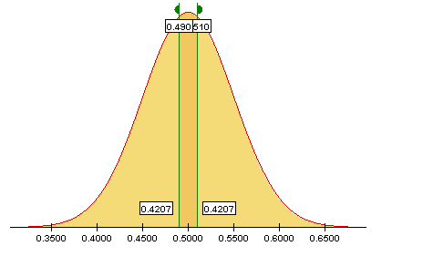

A decision rule: What is the decision rule we will use? Use that decision rule to draw a conclusion about whether the process of tossing a Euro is “fair”.

We will use the usual decision rule for p-values; i.e., if it is smaller than 0.05, then we would reject the null hypothesis. If our p-value is greater than or equal to 0.05, then you would not to reject the null hypothesis. Based on this result of flipping 100 Euro coins, we would say that tossing the Euro coin is fair.

References

Scheaffer, R.L., Watkins, A. Witmer, J., & Gnanadesikan, M., (2004a). Activity-based statistics: Instructor resources (2nd edition, Revised by Tim Erickson). Key College Publishing.
Scheaffer, R.L., Watkins, A., Witmer, J., & Gnanadesikan, M., (2004b). Activity-based statistics: Student guide (2nd edition, Revised by Tim Erickson). Key College Publishing.

Please note the possible student answers may not, in some cases, be IDEAL student answers.

