P-values

Part 1: Research Question

Is balancing the Euro also fair? A person balanced a Euro 100 times and got 31 heads. Go through the four-step process to test the hypothesis that the chance of getting heads when balancing one of these coins repeatedly is not 0.5? (Use the sampling distribution with a mean of 0.5 and a standard deviation of 0.05.)

Four things we would need:

Ideas to test:
Idea 1: Balancing a Euro coin is a “fair” process.
Idea 2: Balancing a Euro coin is an “unfair” process.

We can express the ideas above as:

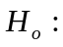 The proportion of heads when we balance a Euro coin repeatedly is 0.5.
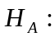The proportion of heads when we balance a Euro coin repeatedly is not 0.5.

The sample statistic here is the sample proportion (written as).

Here is a sketch of a sampling distribution for the sample proportion (created using the Normal Density Curve applet) assuming that the null hypothesis is true. Now, we can see how unusual or surprising the value of the sample statistic is, by seeing if it is in one of the tails (surprising) or in the middle of the distribution (not surprising).

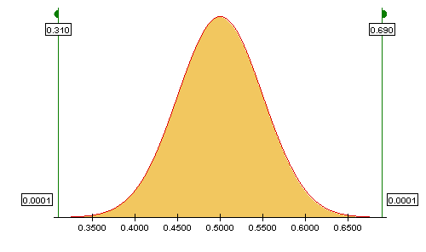

We will use the usual decision rule for p-values; i.e., if the p-value is smaller than 0.05, then we would reject the null hypothesis. If our p-value is greater than or equal to 0.05, then you would not reject the null hypothesis. Based on this person’s sample, we do not think that balancing a Euro is “fair” in the sense that heads will land face up half the time.

Part 2: Using Fathom to find a p-value

We can also use Fathom to test hypotheses and obtain a p-value without simulation. Fathom will take our class data, calculate the sample statistic, and compare our sample mean to the appropriate sampling distribution, to see how surprising it is. It will then provide us with the p-value.

- List the p-value from the simulation of balancing the Euro 100 times given in the Normal Distribution applet in the chart below (Found in Part 1).

Open the data file called Euro.ftm from the course website. This file contains the data that the researcher collected on balancing the Euro from Part 1. To run a hypothesis test for a proportion in Fathom, follow these steps:

- Drag Test down from the shelf.
- Change “Empty Test” to “Test Proportion” (since we are interested in testing the hypothesis that the population proportion is not equal to 0.5.)
- Drag the coin attribute into the Test window.
- Right click the Test window and uncheck the “Verbose” command.

- Based on the p-value given in Fathom, what is the decision about the two hypotheses? Explain.

Because our p-value is less than .05, we will reject our null hypothesis.

- Now, record the two p-values (one from Fathom and one from the Normal Distribution applet) in the chart below.

 | Estimated P-value (from the Normal Distribution applet) | P-value from Fathom
Balancing the Euro 100 times | 0.0002 | 0.00014

- How does the p-value from Fathom compare to the one you got in the applet? Why are they different?

The p-values are not that different. In the Normal Distribution applet, it is sometimes difficult to drag the flags to exactly the right spot, and this could explain differences. There could also be slight differences in rounding that might account for the minor differences.

- Explain how our decision rule relates to the area in the normal distribution.

Our decision is based on the p-value which is the area in the distribution more extreme than our observed statistic.

Part 3: Review the thinking process of testing a hypothesis

Notice that the way we arrived at a conclusion to our research question can be summarized in the following steps.

- Identify the research question. Can we expect the proportion of heads to differ from 0.5 when we repeatedly balance a fair coin?
- Identify a quantity related to the research question whose value we don't know. In this case the quantity of interest is the true proportion of heads produced when a coin is balanced. In general that quantity is called a 'parameter'. Remember that parameters relate to populations.
- Write the statistical hypotheses in terms of that parameter of interest. In the example the statistical hypotheses were:

H₀: The population proportion of heads when balancing a Euro repeatedly is 0.5.
H_{a}: The population proportion of heads when balancing a Euro repeatedly is not 0.5.

- Collect data and calculate a sample statistic. An experiment was conducted and data were collected and the proportion of heads was computed.
- Find the p-value. The probability that we would get a result at least as extreme as the one we got just by chance given that the null hypothesis is true.
- Make a decision based on if the p-value is small or large. In this case we decided to reject the null-hypothesis and concluded that the population proportion of heads when balancing a Euro repeatedly is not 0.5.

This thinking procedure is called 'hypothesis testing' or “significance testing” and can be applied to many situations in which a research question is asked and data are collected (through a survey or experiment) in order to answer the research question.

Reference

Seier, E., & Robe, C. (2002). Ducks and green – an introduction to the ideas of hypothesis testing. Teaching Statistics, 24(3), 82-86.

Please note the possible student answers may not, in some cases, be IDEAL student answers.

