Gummy Bears Revisited

Research Question: Is there a difference in the average flight lengths for all Gummy Bears launched from two different heights?
How can we gather data to determine if there is a difference in flight lengths for Gummy bears launched from different heights? Based on our first examination of this research question earlier in the course, does it seem like there is a difference in flight distances for the two conditions for all bears? Recall the importance of a good experiment and what needs to be included so we can gather data to infer cause and effect.

Comparing the data with boxplots
- Use Fathom to open the data for the two conditions using side by side boxplots. What do the boxplots suggest about the differences in flight distances for the two conditions? Explain. 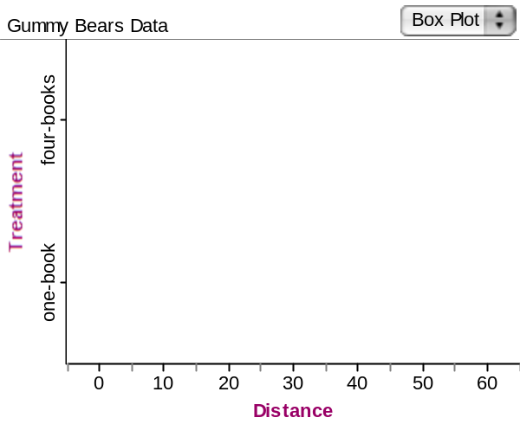

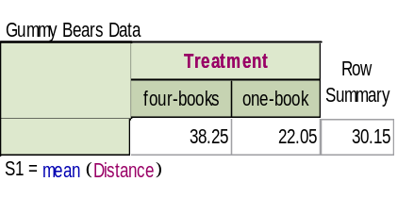

The boxplots suggest that there is more variability in the four-book condition. The IQR is larger and so is the overall range. Both conditions appear to be skewed, and the median distance is larger in the four-book condition.
- Find the difference between the two sample means for the two conditions.

38.25 – 22.05 = 16.20

Conduct a hypothesis test to compare two means

Is there a statistically significant difference in the average flight length between the two heights for all bears? How can we tell if there is a statistically significant difference? In other words, that the difference in average launch distances is not just due to chance variation, but due to a true difference in the heights of the launching pads? We will have to test whether those differences are due to chance or not.
- Write the null and alternative hypotheses to examine if there is a statistically significant difference in the average distances for the two conditions.

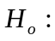 The mean distances for gummy bear flight paths from a 1-book and a 4-book launching pad are the same.

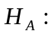 The mean distances for gummy bear flight paths from a 1-book and a 4-book launching pad are not the same.

We can use Fathom to conduct a hypothesis test to compare the two mean flight lengths. To do this, follow these steps:

- Drag down Test. Click on “Empty Test” in the upper corner of the Test Box to pop-up the list of available tests and choose “Compare Means”.
- Either type summary statistics directly into the Test Box or drag attributes from a collection to have Fathom compute the statistics from existing attributes. We’ll do the latter.
- Drag the Distance attribute to the Test Box area for “First Attribute...” Notice that this is the quantitative variable.
- Drag the Height attribute to “Second Attribute...” to define the two categories. Notice this is a categorical variable
- Test results are displayed in “Verbose” mode – with lots of textual explanations. For a more concise report (as below) choose Test>Verbose to toggle verbose off. By default, Fathom conducts a two-tailed test. Fill in the results on the table on the next page.

- Fill in the chart below with the Fathom results.

 | Two-tailed Test
 | Heights
 | 1 Book | 4 Books
Count | 20 | 20
Mean | 22.05 | 38.25
Standard Deviation | 9.41 | 13.60
Standard Error | 2.10 | 3.04
Student’s t | 4.381
df | 33.788
P-value | 0.00011

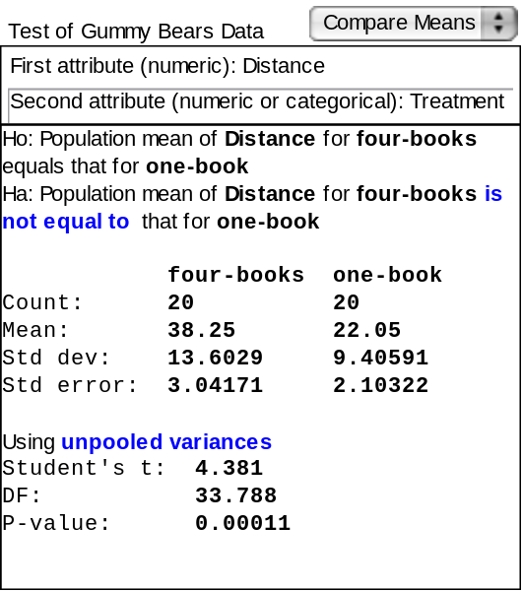
- What do the results of the hypothesis test suggest about the difference in average distance the bear traveled for the two heights? Is there a difference? Explain.

The results suggest that there is a difference in the average flight distances of the gummy bears when launched from 2 different heights. The p-value, which is the probability that we would get a result at least as extreme as the one we got just by chance if there is actually no difference is only 0.011%, which is very small.

One-tailed tests
When we are testing a research hypothesis that is not equal, it is called a two-tailed test, because the parameter could be in either tail of the sampling distribution. We could instead have a research hypothesis that is a one-tailed test. For instance, we might test whether one condition yields greater results than the other. Suppose we had the following research question.

Research Question: Is the average flight length for all Gummy Bears launched from the higher stack of book greater than the average flight length for all Gummy Bears launched from the shorter stack of books?

- Write the null and alternative hypotheses to examine this research question.

The mean distances for gummy bear flight paths from a 1-book and a 4-book launching pad are the same.

The mean distance for gummy bear flight paths from a 1-book launching pad is less than that from a 4-book launching pad.

- Use Fathom to run the one-tailed test that corresponds to the following research question of interest.
- Set up a test in the same fashion as you did to test the original research question
- Click on the (blue) “not equal to” in H_{a} and change it to run the one-tailed test that corresponds to your alternative hypothesis

- Fill in the chart below with the Fathom results.

 | One-tailed Test
 | Conditions
 | 1 Book | 4 Books
Count | 20 | 20
Mean | 22.05 | 38.25
Standard Deviation | 9.41 | 13.60
Standard Error | 2.10 | 3.04
Student’s t | 4.381
df | 33.788
P-value | < 0.0001

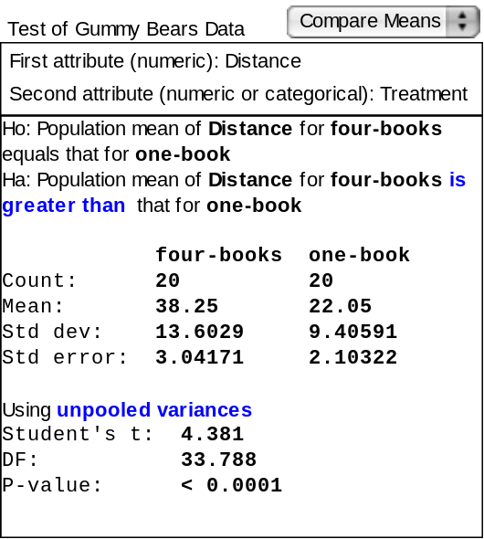

- What do the results of the hypothesis test suggest about the difference in average flight distance between the two heights? Explain.

The results suggest the mean flight distance of the gummy bears when launched from a 4-book launch pad is greater than that for the 1-book launch pad. The p-value, which is the probability that we would get a result at least as large as the one we got just by chance if there is actually no difference is less than .0001, a small number indeed.

References

Scheaffer, R.L., Watkins, A. Witmer, J., & Gnanadesikan, M., (2004a). Activity-based statistics: Instructor resources (2nd edition, Revised by Tim Erickson). Key College Publishing.
Scheaffer, R.L., Watkins, A., Witmer, J., & Gnanadesikan, M., (2004b). Activity-based statistics: Student guide (2nd edition, Revised by Tim Erickson). Key College Publishing.

Please note the possible student answers may not, in some cases, be IDEAL student answers.

