Research Questions Involving Statistical Methods

Use the BodyMeasures.ftm data located on the course website to answer the following research questions. For each research question:
- Choose an appropriate statistical method to help answer the question,
- Provide the Fathom results and your interpretation of those result, and
- Answer the research question.

Research Question 1: What is a good interval estimate for the hand span for all 3264 students?

To help you decide which type of statistical method would we could use to help answer this question, answer the following:

- Are we describing only the sample of data we have?
- Are we using the sample data we have to make an inference about a larger population?

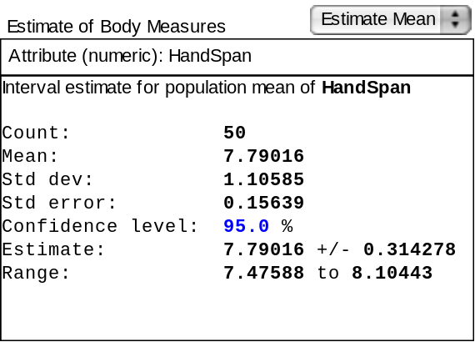

We just have a sample of data here, and we are trying to make an estimate of a population parameter. A confidence interval should be constructed. We are 95% confident the interval between 7.48” to 8.10” will include the average hand span for all 3264 students.

Research Question 2: Is the average height for all female 3264 students significantly greater than 64 inches?

To help you decide which type of statistical method would we could use to help answer this question, answer the following:

- Are we describing only the sample of data we have?
- Are we using the sample data we have to make an inference about a larger population?

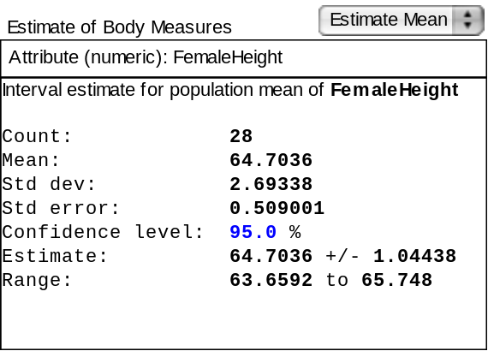

Here, we have a sample of data and we are trying to make an inference about a population. We could use a hypothesis test here OR a confidence interval. We cannot be certain that the true mean height for female 3264 students is greater than 64” because the 95% confidence interval for the mean height includes 64”.

Research Question 3: Is there a significant difference between all 3264 males and females in average head circumference?

To help you decide which type of statistical method would we could use to help answer this question, answer the following:

- Are we describing only the sample of data we have?
- Are we using the sample data we have to make an inference about a larger population?

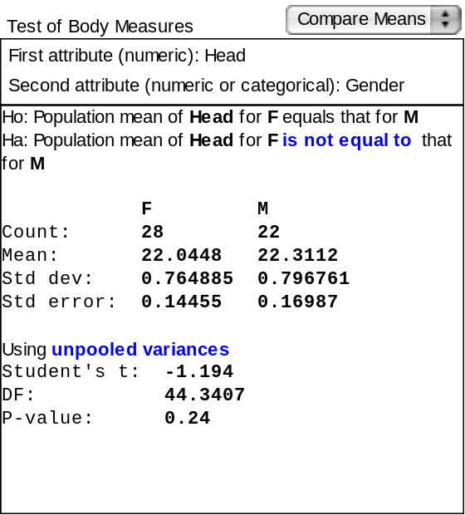

We are attempting here to use a sample of data to make an inference about a population, and we need to conduct a hypothesis test. We cannot be certain that there is a different between all 3264 males and females in average head circumference since we do not reject the null hypothesis of “no difference” at the 5% level for this particular sample.

Research Question 4: Is there a significant relationship between hand length and head circumference for all 3264 students?

To help you decide which type of statistical method would we could use to help answer this question, answer the following:

- Are we describing only the sample of data we have?
- Are we using the sample data we have to make an inference about a larger population?

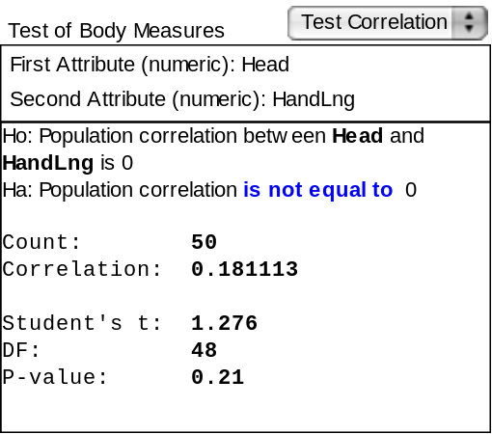

We are using a sample of data here to make an inference about a population. We need to conduct a hypothesis test here. Since we reject our test of no correlation between hand length and head circumference for this sample of 3264 students, we cannot conclude that such a relationship exists in the population at the 5% significance level.

Research Question 5: What is a good interval estimate for the proportion of males who have taken 3264?

To help you decide which type of statistical method would we could use to help answer this question, answer the following:

- Are we describing only the sample of data we have?
- Are we using the sample data we have to make an inference about a larger population?

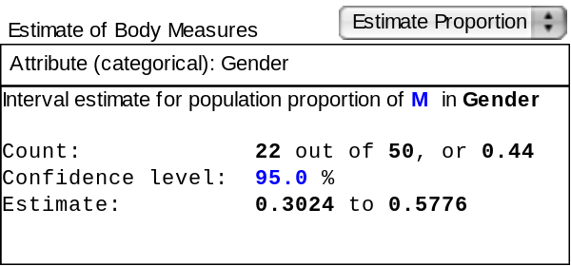

Here, we are using a sample of data to make an inference about a population, and we will need to use a confidence interval. We are 95% confident the interval between .30 and .58 includes the proportion of males in 3264 classes (in the past).

Reference

Garfield, J., & Zieffler, A. (2007). EPSY 3264 Course Packet, University of Minnesota, Minneapolis, MN.

Please note the possible student answers may not, in some cases, be IDEAL student answers.

