Modeling Coin Tosses

Part I: Looking at the variation for sets of coin tosses

What do we expect when we toss a coin? What if everyone in the class tossed a fair coin ten times, what kinds of results would you expect toget? Discuss with your neighbor (remembering our unit on sampling) and write down possible numbers of heads you might get for 8 sets of 10 tosses of a fair penny (e.g., list the number of heads out of 10 for eight repetitions of this experiment).

___ ___ ___ ___ ___ ___ ___ ___

Did you expect to get 5 heads each time, or did you expect some variability between results of each set of 10 tosses? How variable did you expect them to be?

What outcomes would you consider to be less likely if you are using a “fair” coin? Why?

Part II: Modeling the Balancing of Ten Coins through Simulation

We can model the “fair” process of obtaining heads 50% of the time when balancing ten coins using simulation. It turns out that the normal distribution is a good model for the distribution of the proportion of heads you would expect. The model is shown below.

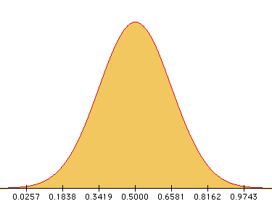

- Describe the distribution of the expected proportion of heads in terms of shape, center and spread.

- Now, shade in areas of the distribution that include surprising results, so that if you got one of those results, you might question the assumption that the coin is equally likely to land heads up or down (probability of heads is 0.5).

What will happen if we balance sets of 10 coins? What will you expect to get if you balance ten coins on their edge and let them fall? Do you expect the same number of heads and tails as when you flip a coin (p = 0.5)? Explain.

Reference

Garfield, J., & Zieffler, A. (2007). EPSY 3264 Course Packet, University of Minnesota, Minneapolis, MN.

