What does the 95% mean?

A confidence interval gives an interval estimate for a population parameter at a particular level of confidence, often 95% confidence. What does the 95% mean? What affects the size of the confidence interval? We will use Sampling SIM to help answer these questions.

Open the Sampling Sim software. Now, set the population to match the population distribution of word lengths for the Gettysburg Address, by doing the following:
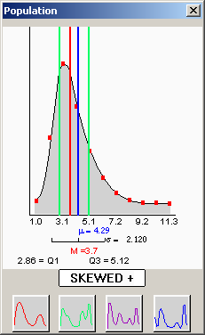
- Click on the measurement menu and make sure the measurement is set to “continuous” (even though we have discrete data, we can only input our population values in this program with continuous data)
- Click on the “distribution” button and set the distribution to “right skewed”
- Go to the window menu and click on “population settings”.
- Set the population mean to 4.29 and the standard deviation to 2.12 (See below).
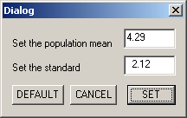

This should create the distribution shown on the right:

Selecting Sample Size and Number of Samples

- Go again to the window menu and select “confidence intervals”. This part of the software is designed to draw X number of samples that you specify of size N, which you also specify. We will start off by replicating the confidence interval that we calculated for the entire class a large number of times.
- Set the Sample Size to “25”. This is the sample size we used to calculate the confidence interval for average word length of the Gettysburg Address.
- Set the Number of Samples to “10” for now.
- Make sure that level of confidence is “95%”.
- Be sure the boxes below “Confidence interval” are set to:
    - two sided confidence intervals
    - sigma unknown and
    - t-value to estimate the interval.
- Just below the box labeled t-value, set the speed to 3.
- Now click the big orange/red box to “draw samples”.

- The software is sampling from the population distribution that was specified and using these ten samples to create ten confidence intervals. Was the true population mean (μ = 4.29) NOT included in any of the confidence intervals?

- Now that you know how the computer is sampling, set the speed to F to get the next results faster. Also, set the number of samples to 100. This will have the program draw 100 samples each of size 25. Now how many intervals do NOT include the true population mean? What percentage of the 100 intervals drawn is this?

- How many intervals DO include the 4.29? What percentage of all 100 intervals drawn is this?

- How do these numbers and percents relate to the meaning of “95% confident”? Explain.

Use the results from Sampling SIM to help answer the following questions:

- Does the level of confidence, 95%, refer to the number of word lengths in the interval? Explain.

- Does the level of confidence, 95%, refer to the locating the sample mean or locating the population mean? Explain.

- Does the level of confidence, 95%, refer to a single interval (e.g., the one you found in Fathom) or to the process or creating many intervals (e.g., all possible intervals)? Explain.

Reference

Garfield, J., delMas, R., & Chance, B. (2000). Tools for Teaching and Assessing Statistical Inference (NSF project). http://www.tc.umn.edu/~delma001/stat_tools/

