Credit Questions

Part I

How are the length of time a college student has been in school and the number of credits he/she has accumulated related? Imagine if you could track 100 students for 6 consecutive semesters. What would the distribution of these students’ cumulative number of credits look like for each of those six semesters?

- Draw box plots of what you believe the distribution of cumulative credits would look like for each of the six semesters. The students are all incoming freshmen (no transfer students) for the Fall 2002 semester and all 100 stay enrolled throughout the six semesters (no dropouts). [Hint: You should have six different boxplots…one for each semester from Fall 2002 (their first semester at the University) to Spring 2005 (after their third year at the university).] Don’t forget to consider variation and shape in each of the box plots.

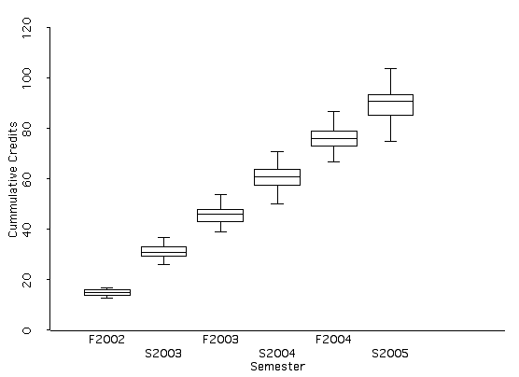

- Are the shapes of the distributions consistent over time? Do we expect that given the data? Why or why not?

Yes, the distributions seem fairly symmetrical in shape over time. We expected this because this data set comes from the same set of 100 students over the course of 5 semesters although skewness comes into play in Spring 2005.

- Is the center consistent over time? Do we expect that given the data? Why or why not?

No. We expect the center, which represents the cumulative credit-hours that students have accrued, to increase over the course of 5 semesters.

- Is the variability consistent over time? Do we expect that given the data? Why or why not?

No. We expect the variability, which represents the different cumulative credit-hours, not to be the same for different students. Students are different in the number of courses they take each term.

- By examining the box plots, write down how you would explain to another person how the length of time a college student has been in school and the number of credits he/she has accumulated are related.

Students seem to accumulate a midpoint of 15 credit-hours per semester from Fall 2002 to Spring 2005. However, different students are accruing credit-hours at different rates, as can be seen in the box plot above, since each box plot seems wider than the previous one.

- Are you willing to generalize about the relationship you found to the population of all students at the University of Minnesota? Why or why not?

No. We do not know if these students were a random sample from the population of all students at the University of Minnesota.

- Does the change in semester cause the increase in cumulative credits?

No, we cannot say that the change in semester causes the increase in cumulative credits. However, a change in semester is associated with an increase in cumulative credits which we would expect if a student kept enrolling every term.

- Describe a variable that would be negatively related to semester. In other words, this variable would decrease as semester increased.

“Time to Graduation” would decrease as semester increased.

Reference

Cook, R.D., & Weisberg, S. (1999). Applied regression including computing and graphics. (Wiley Series in Probability and Statistics). New York: Wiley-Interscience.

Please note the possible student answers may not, in some cases, be IDEAL student answers.

