Interpreting Scatterplots

Biologists study different characteristics of animals to see if they can use them as predictors for other characteristics. One of these relationships that they study is between gestation period (length of pregnancy) and lifespan. Examine the scatterplot between gestation period and lifespan for these 62 different mammals. The gestation period (on the x-axis) is given in days, while the lifespan (on the y-axis) is given in years. Use the plot to answer the following questions.
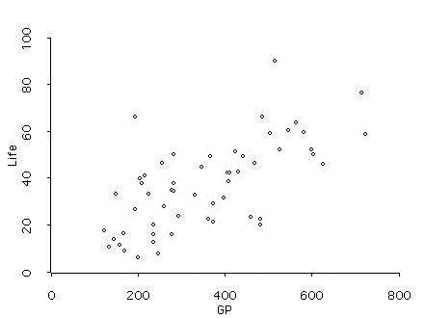

When examining and describing a scatterplot it is sometimes easier if you separate it into several different distributions so you can determine how the centers and spread of those distributions are changing.

- To do this, either draw in, or imagine vertical line separators for every 100 days of gestation. (You will have a vertical line at 100, 200, 300, etc.) You should have about 7 slivers of data, which you can now imagine as different distributions.

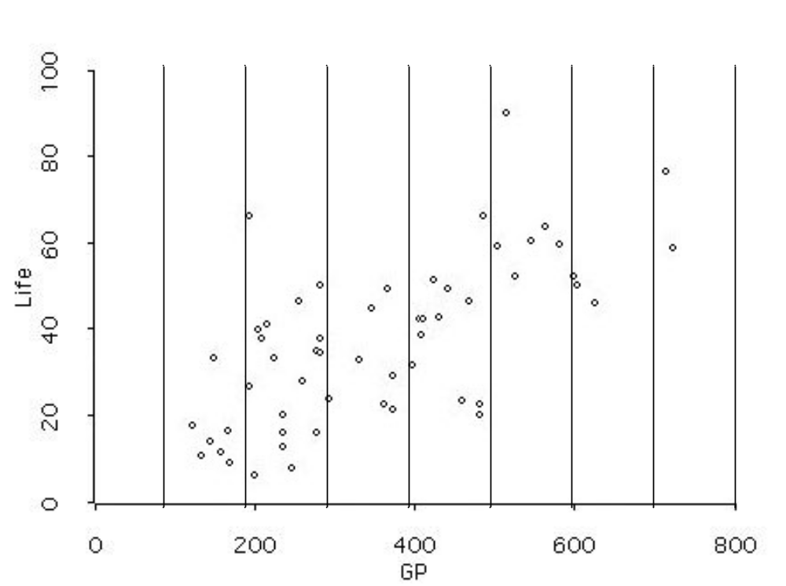
- Provide a full description of the relationship depicted in the scatterplot. To do this describe each of the following pieces:
  - Identify the variables and cases
  - Describe the overall shape of the relationship
      - Linearity
      - Clusters
      - Outliers
    - Describe the trend or direction of the relationship
    - Describe the strength of the relationship
      - Strong/Weak
      - Constant/Varying
    - Does the relationship generalize to all other cases?
    - Are there plausible explanations for the pattern? Lurking variables?

- The variable GP refers to the gestation period of mammals, whereas the “Life” is the lifespan of these mammals. Each case is represented by a marker in the scatterplot.
- There appears to be a linear relationship in lifespan and gestation period for mammals that have a gestation period between 100 and 600 days. The lifespans for mammals who gestate between 500 and 600 days seem more tightly clustered than the lifespans for mammals with other 100-day gestation periods. The outliers are markers for mammals who are not within each cluster – there are 4 likely candidates.
- The trend is that mammals with a longer gestation period also tend to live longer.
- This trend is fairly constant and moderate for mammals with a gestation period between 100 and 600 days, while it is weak for mammals that have a gestation period more than 600 days.
- Since we don’t know if the mammals were a random sample of all mammals, we cannot generalize to all other mammals.
- It is possible that the mammals with larger gestation periods also live in an environment where there is plenty of food available during their lifespan.

Reference

Cook, R.D., & Weisberg, S. (1999). Applied regression including computing and graphics. (Wiley Series in Probability and Statistics). New York: Wiley-Interscience.

Please note the possible student answers may not, in some cases, be IDEAL student answers.

