Guessing Correlations

- Open the link on the Resources page of the course webpage called Web Applet: Guessing Correlations.
- Click the “New Plots” button.
- Match the four correlations to the four scatterplots. When you think you have correctly matched them, click on “Answers.”
- Click “New Plots” to continue matching correlations to scatterplots.

- Go through the Guessing Correlations exercise several times. For each scatterplot think about whether or not the relationship between the two variables could be characterized as linear. Write down the actual correlations for those relationships in the table below:

Correlations that match to “Linear” Scatterplots | Correlations that match to “Non-Linear” Scatterplots
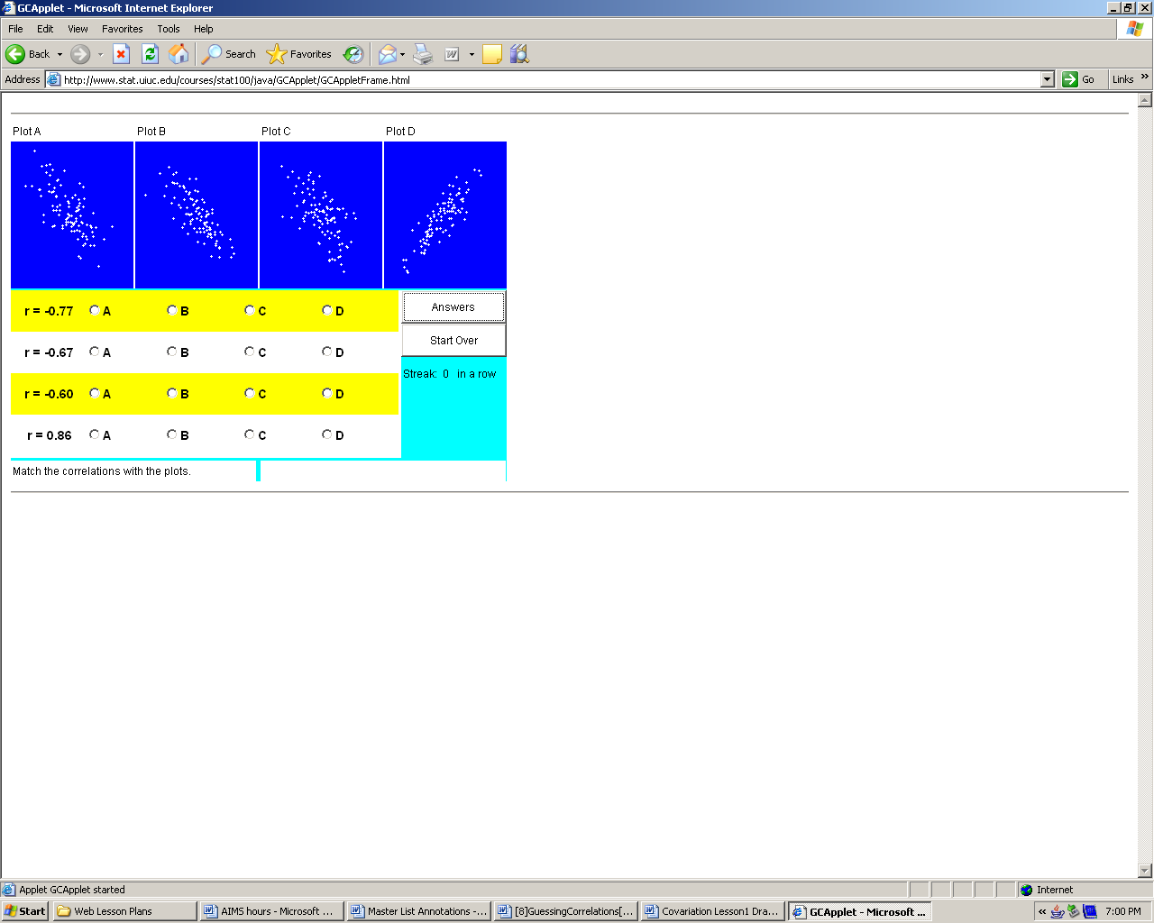 Answers will vary. | 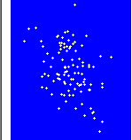 Answers will vary.  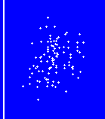

Go through the Guessing Correlations exercise several more times. Pay attention to the trend of the scatterplot. Is the trend from lower-left to upper-right? From upper-left to lower-right? Use your observations to answer the following questions.

- When the correlation is positive, what does the scatterplot look like?

The trend is from lower-left to upper-left with dots close to the trend line.

- When the correlation is negative what does the scatterplot look like?

The trend is from upper-left to lower-right with dots forming a general “cloud” around the trend line.

- When were the correlations and scatterplots easy to match? When were they more challenging to match?

It was easy to match correlations and scatterplots if the all the data points lie close to the line.

- Use the knowledge you acquired matching correlations and scatterplots to guess the correlations associated with the following two plots.

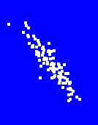

r = about -0.9

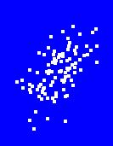

r = about 0.4

Reference

Garfield, J., & Zieffler, A. (2007). EPSY 3264 Course Packet, University of Minnesota, Minneapolis, MN.

Please note the possible student answers may not, in some cases, be IDEAL student answers.

