Diamond Rings

The following scatterplot contains the prices of ladies' diamond rings and the carat size of their diamond stones. All of the rings are made with gold of 20 carats purity and are each mounted with a single diamond stone. A line of best fit has also been added to the scatterplot. The equation for this line is as follows:

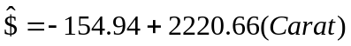

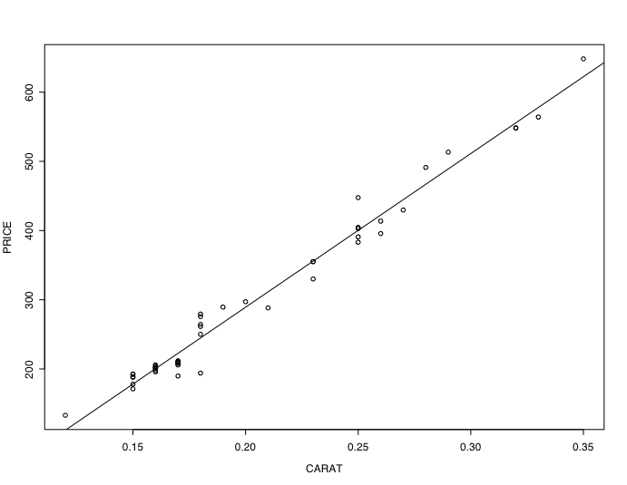

1. Does the line of best fit seem like a good model for the data? Explain.

Yes, all the data seem to be around that line.

2. What is the slope for the line of best fit depicted in the scatterplot?

The slope for the line of best fit is 2220.66.

3. What does the slope tell us? (Hint: Interpret what the number means given the data that you are looking at.)

It means that we expect the cost of the diamond ring to increase by $2220.66 if the size is one carat more on average.

4. What is the y-intercept for the line of best fit depicted in the scatterplot?

The y-intercept for the line of best fit is -154.94.

5. What does the y-intercept tell us? (Hint: Interpret what the number means given the data that you are looking at.)

The price for a ring without any diamonds on average would cost the retailer to lose $154.94.

6. Does this y-intercept make sense given your interpretation in Question 5? Explain.

No, this y-intercept does not make sense because people do not expect to receive $154.94 on average when they go in to buy a ring with no diamonds.

Reference

Chu, S. (2001, July). Pricing the C's of diamond stones. Journal of Statistics Education, 9(2). Retrieved December 6, 2006, from http://www.amstat.org/publications/jse/v9n2/datasets.chu.html

Please note the possible student answers may not, in some cases, be IDEAL student answers.

