Da Vinci and Body Measurements

Was Leonardo da Vinci Correct?

Leonardo da Vinci was a great Italian Renaissance painter, sculptor, architect, engineer, inventor, and scientist. One of the most famous images in the world is the figure known as the Vitruvian Man. which is actually named for the man who created him, the Roman architect Vitruvius. Leonardo was one of many artists who attempted to depict Vitruvius' perfect man, and the only one who succeeded. His version is considered to have the most accurate depiction of the human body. Leonardo kept many notebooks of describing the Vetruvian proportions that he used. Many artists today still use these proportions. Three of those proportions are as follows:
- Height is equal to the span of the outstretched arms
- Kneeling height is three-fourths of the standing height
- The length of the hand is one-ninth of the height

Open the Body Data set (BodyDat.ftm) from the course website.

(a) We want to examine Leonardo’s rule that kneeling height is equal to three-fourths of the standing height. Create a scatterplot of this relationship and sketch it below. (Be careful…which of these variables has to be on the x-axis?)

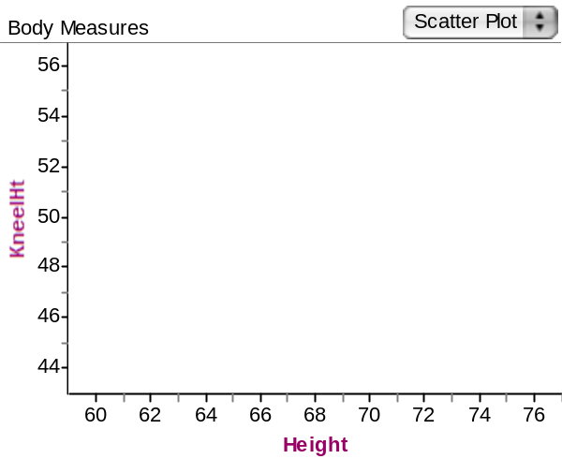
(b) Give a full description of the scatterplot you created in part (a).

It appears that as standing height increases, the kneeling height tends to increase as well. There is a moderate relationship between the two variables.

(c) In Fathom, right click on your scatterplot and use the moveable line to estimate the line of best fit by moving it around so that it best models the data. Add this line to your plot in part (a).

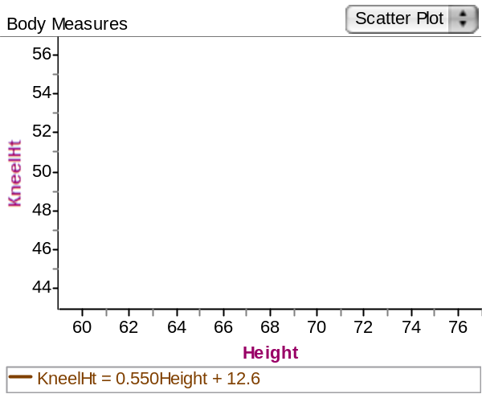

(d) What does the line represent?

This is the line of best fit to the current dataset by minimizing residuals.

(e) Use your line to find the predicted kneeling height of someone who is 6’0” (182.88cm).

For someone who is 72” tall, the kneeling height is predicted to be .55(72) + 12.6 = 52.2”

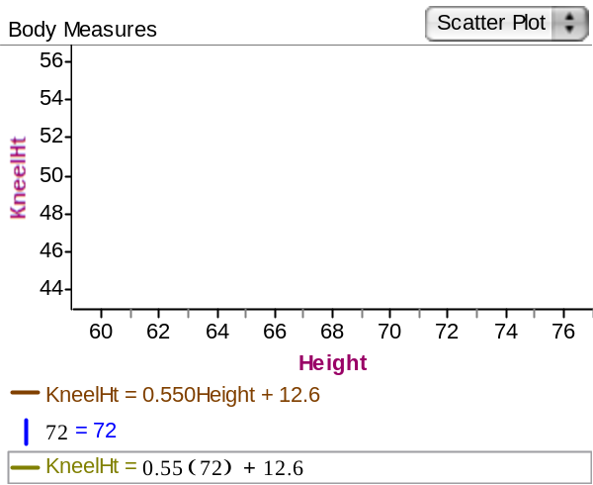

(f) Interpret the slope in the context of the data.

The slope represents the average gain in kneeling height of .55 inches if a person’s height increases by an inch.

(g) Interpret the y-intercept in the context of the data.

The y-intercept (12.6”) is the average kneeling height for a person of 0” (!) tall, which does not make sense.

(h) Did we accurately predict everybody’s kneeling height based on their height? Were we close? How can we tell?

If we used our moveable line of best fit, we would be about 3 inches off in our prediction for the average kneeling height. We can see this by noting that the line does not pass through all the data points.

(i) What does it mean to have a negative residual? How about a positive residual?

If the predicted average kneeling height is greater than the actual data value, then we have a positive residual. If it is less than the actual kneeling height, we have a negative residual.

Reference

Watkins, A.E., Scheaffer, R.L., & Cobb, G.W. (2004). Statistics in action: Understanding a world of data. Emeryville, CA: Key Curriculum Press.

Please note the possible student answers may not, in some cases, be IDEAL student answers.

