Testing Relationships: Admissions Variables

Open the data set called Admissions.ftm from the course website. This is a data set that includes admissions data on 400 CLA students selected at random from all CLA students. The variables include various academic indicators such as the students: high school percentile rank, ACT scores (composite as well as subtest scores), and GPA after one semester at the University of Minnesota. Use this data set to help answer the following research question.

Research Question: What is the relationship between ACT Reading scores and ACT English scores for these 400 CLA students?

To begin to answer this question we will need to obtain both graphical and numerical evidence about this relationship. We can obtain graphical evidence of the relationship by examining a scatterplot. Numerical evidence of a relationship is usually provided by a correlation coefficient. This is a summary statistic much like a mean or median, but it summarizes a relationship between two variables.

- Use Fathom to obtain both graphical and numerical evidence about the relationship between ACT Reading scores and ACT English scores for these 400 students.

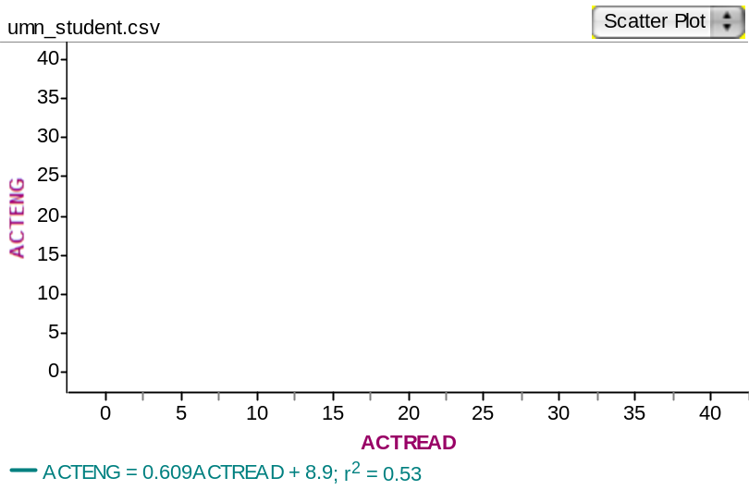

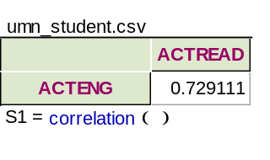

- Use the evidence you collected in question 1 to answer the research question. This means you will need to provide a full description of the relationship between ACT Reading scores and ACT English scores. (Remember a full description entails several pieces of information.)

From the plot of the ACT English scores (ACTENG) and ACT Reading scores (ACTREAD), it would appear that there is a strong positive linear trend (correlation is .73) between ACTENG and ACTREAD. Overall, the plot shows a football shaped clump to the scatter plot, which supports the fitting of a regression line.
The regression line predicts that on average, an increase of 1 unit of ACTREAD score is related to a .609 increase in the ACTENG score.

Reference

Garfield, J., & Zieffler, A. (2007). EPSY 3264 Course Packet, University of Minnesota, Minneapolis, MN.

Please note the possible student answers may not, in some cases, be IDEAL student answers.

