Testing Relationships: Baseball

Can you buy wins in baseball?
Research Question: Is there a relationship between payroll size and winning percentage for all baseball teams?

- Write down your conjecture about whether or not there is a relationship between these two variables.
I think there will be a positive relationship between payroll size and winning percentage. I think better players might get paid more, and this may then lead to more wins for a team.

Open the baseball.ftm dataset from the course website. These data are the player payrolls and won/lost records for the 16 National League baseball teams in 1999. Use this data to answer the following research question.

- Use both graphical and numerical evidence to provide a full description of the relationship between between payroll size and winning percentage for the baseball teams in the sample.

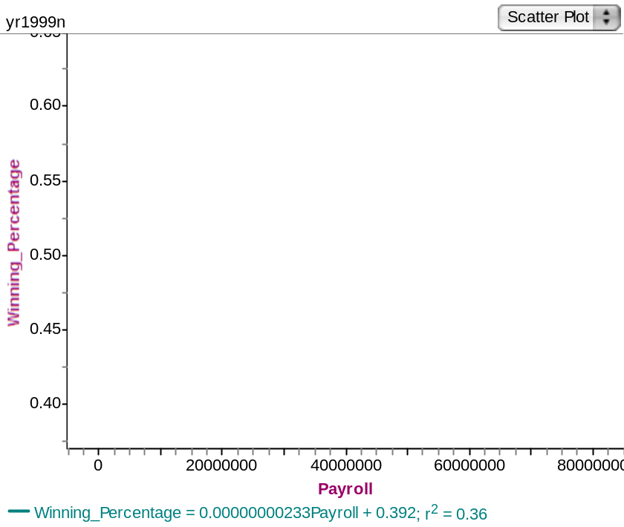

From the graph, it would appear that there is a moderate positive relationship between what the players get paid and the winning percentage of the team. We observe that the scattering of data is not that close to the regression line and the correlation coefficient is only 0.6.

- Do the sample data support your original conjecture? Explain.
Yes, the data support my conjecture that there is a positive relationship between these variables. As payroll size goes up, so does winning percentage.

Examining the relationship using a hypothesis test

When we look at this problem as a hypothesis test, we ask: Is there a statistically significant relationship between player payrolls and won/lost records for all baseball teams? (in the population?)
- Write the null and alternative hypotheses to examine if there is a statistically significant relationship between player payrolls and won/lost records for all baseball teams? (Recall that the alternative hypothesis should match the direction of the relationship that you speculated existed between these two variables from question 1.)

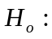 There is no relationship between payroll and won/lost records for all baseball teams.
 There is a positive relationship between payroll and won/lost records for all baseball teams.

Conducting a test of the correlation
We can use Fathom to test a population correlation. Use the following steps:

- Drag down Test. Click on “Empty Test” and choose “Test Correlation”.
- Drag the payroll attribute to the Test Box area for “First Attribute...”
- Drag the winning_percentage attribute to “Second Attribute...”
- Test results are displayed in “Verbose” mode – with a lot of textual explanations. For a more concise report (as below) choose Test>Verbose to toggle verbose off. By default, Fathom conducts a two-tailed test. Fill in the results on the table on the next page.

- Fill in the chart below with the Fathom results.
Count | 16
Sample Correlation | 0.60
Student’s t | 2.813
df | 14
P-value | 0.0069
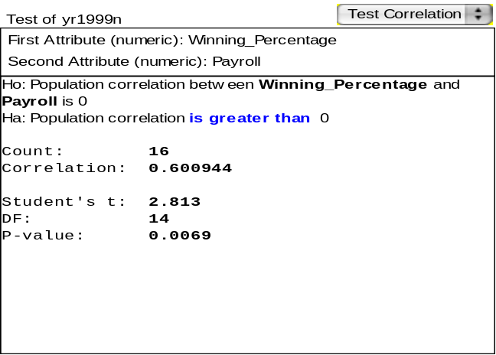
It would seem that there is a statistically significant correlation at the 5% level between payroll and the baseball team’s winning percentage.

- What do the results of the hypothesis test suggest about the relationship between player payrolls and won/lost records for all baseball teams? Explain.

Based on this sample of data, we can infer that there is a statistically significant positive relationship in the population.

- The four teams that made the playoffs in the National League in 1999 were Arizona, Atlanta, Houston and New York. Circle and label their points in the scatterplot. Do these teams seem to have both high payrolls and high winning percentages?

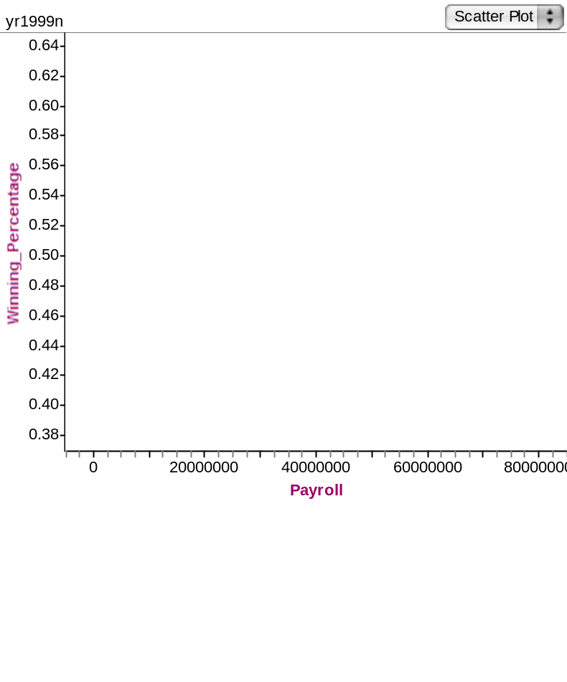

Yes, these four teams seem to have both high payrolls and winning percentages.

Reference

Garfield, J., & Zieffler, A. (2007). EPSY 3264 Course Packet, University of Minnesota, Minneapolis, MN.

Please note the possible student answers may not, in some cases, be IDEAL student answers.

