Credit Questions

Part I

How are the length of time a college student has been in school and the number of credits he/she has accumulated related? Imagine if you could track 100 students for 6 consecutive semesters. What would the distribution of these students’ cumulative number of credits look like for each of those six semesters?

- Draw box plots of what you believe the distribution of cumulative credits would look like for each of the six semesters. The students are all incoming freshmen (no transfer students) for the Fall 2002 semester and all 100 stay enrolled throughout the six semesters (no dropouts). [Hint: You should have six different boxplots…one for each semester from Fall 2002 (their first semester at the University) to Spring 2005 (after their third year at the university).] Don’t forget to consider variation and shape in each of the box plots.

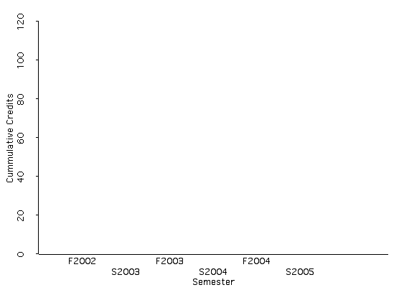

- Are the shapes of the distributions consistent over time? Do we expect that given the data? Why or why not?

- Is the center consistent over time? Do we expect that given the data? Why or why not?

- Is the variability consistent over time? Do we expect that given the data? Why or why not?

- By examining the box plots, write down how you would explain to another person how the length of time a college student has been in school and the number of credits he/she has accumulated are related.

- Are you willing to generalize about the relationship you found to the population of all students at the University of Minnesota? Why or why not?

- Does the change in semester cause the increase in cumulative credits?

- Describe a variable that would be negatively related to semester. In other words, this variable would decrease as semester increased.

Reference

Cook, R.D., & Weisberg, S. (1999). Applied regression including computing and graphics. (Wiley Series in Probability and Statistics). New York: Wiley-Interscience.

